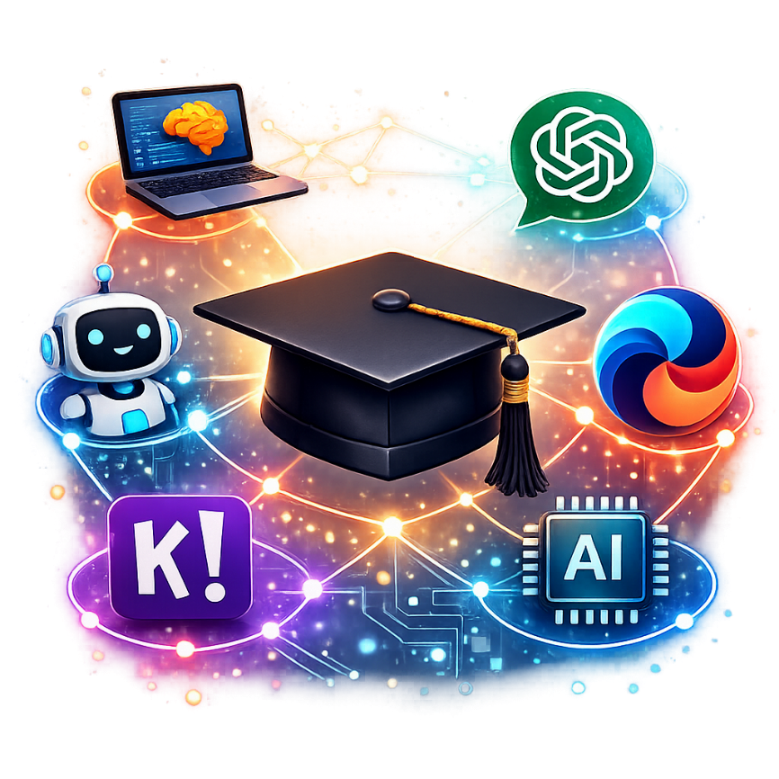








AI tools for teachers
Technical school Pirot
KA220-VET - Cooperation partnerships in vocational education and training
Project Title: AI tools for VET schools
Document Date: February 2026
This material has been compiled and prepared for purposes of Erasmus project by:
Technical school Pirot (author: Aleksandar Madić, co-authors: Bojan Ćirić, Boban Blagojević)
ICEP (author: Ladislav Mariš, co-author: Adelaida Fanfarova)
Agrupamento de Escolas Tomas Cabreira (author: Sandra Nobre, co-authors: Rui Dias, Gilherme Mota, Carla Lima)
Translated by: Bojana Stojanović

Address Information
Takovska 22, Pirot, Serbia
Web: https://book.tsp.edu.rs

Contents
1. Introduction to Artificial Intelligence 5
1.1 What is Artificial Intelligence? 5
1.2 A Brief History of AI 5
1.3 Key Areas in AI 7
1.4 Real-World Applications of AI 9
1.5 Ethical and Social Considerations 11
Conclusion 12
2. Why ethics and safety are important in the use of artificial intelligence in education 13
2.1 Ethical principles in the use of artificial intelligence in schools 14
2.2 Protection of pupil´s privacy and data 15
2.3 Biases and fairness in AI tools 15
2.4 Use AI safely and responsible in the classroom 16
Conclusion 17
3. AI tools for teachers: practical applications 18
3.1 Lesson Planning with AI Support 18
3.2 Creating Teaching Materials and Resources 19
3.3 Personal Organisation and Time Management 26
3.4 Communication with Pupils and Families 26
3.5 Pedagogical Differentiation and Inclusion 26
3.6 Assessment and Feedback with AI 34
3.7 Co-Creation and Projects with Pupils 36
3.8 Ethical Considerations and Good Practice 41
3.9 Teacher Training and Communities of Practice 42
3.10 AI Tools 42
Final Considerations 46
4. Personalized Learning With AI 47
4.1 What Is Personalized Learning? 47
4.2 How AI Enables Personalized Learning 49
4.3 Benefits of AI-Driven Personalized Learning 50
4.4 Challenges and Considerations of Personalized Learning 52
4.5 The Future of Personalized Learning 54
Conclusion 56
5. Interactive classroom activities with AI 57
5.1 Introduction 57
5.2 The Interactive Potential of AI 57
5.3 Types of Interactive Activities with AI 57
5.4 Strategies for Implementing AI Activities in the Classroom 62
5.5 The use of robots MBOT 63
5.6 Challenges and Considerations in Using AI for Interactive Activities 64
5.7 Success Stories and Best Practices 65
Final Considerations 65
6. AI in Student Assessment and Feedback 67
6.1 The potential of artificial intelligence to transform assessment 67
6.2 A practical guide to tools and strategies for teachers 68
6.3 Ethical challenges and responsible use in the school environment 71
Conclusion: The teacher as an architect and ethical guide for education in the AI era 72
7. Creating Simple AI Tools 73
7.1 Creating Simple AI Tools Without Coding 73
7.2 What Can You Build With No-Code AI? 74
7.3 Educational Example: AI for the Classroom 74
7.4 Limitations of No-Code AI 74
7.5 Why Use No-Code AI? 74
Conclusion 75
8. AI in Different School Subjects 76
8.1 Introduction 76
8.2 Mathematics 77
8.3 Languages 78
8.4 Natural Sciences (Physics, Chemistry, Biology) 79
8.5 History and Social Sciences 80
8.6 Visual and Technological Education 81
8.7 Physical Education 82
8.8 Music Education 83
8.9 Philosophy and Citizenship Education 84
Conclusion 85
9. The Future of education with AI 86
9.1 Introduction: A new partner in the staff room – AI and its arrival in education 86
9.2 AI as a teacher's assistant: Tools to streamline work 87
9.3 Revolution in the classroom: Personalization and support for every student 88
9.4 The New role of the teacher: From lecturer to facilitator and mentor 89
9.5 Ethical challenges and responsible use of AI 91
Conclusion: Education for the future 92
10. Outputs developed during the project life cycle 94
10.1 Tiny AI Prompt Generator (TinyMCE Plugin) 94
10.2. AI Tools for Teachers - Prompt Generator (Moodle Block) 97
10.3 CNN (Convolutional Neural Networks) - 3D Visualization & LIVE Training 101

1. Introduction to Artificial Intelligence

1.1 What is Artificial Intelligence?
Artificial Intelligence (AI) is a field of computer science that focuses on the creation of systems capable of performing tasks that typically require human intelligence. These tasks include learning, reasoning, problem-solving, understanding language, and perception. At its core, AI seeks to simulate aspects of human cognition using algorithms, data, and computational power.
AI systems can be designed to operate in very narrow domains—such as identifying objects in images, recommending products, or translating languages—or in broader, more general contexts. The goal is to develop machines that can learn from experience, adapt to new inputs, and perform tasks autonomously.
AI can be rule-based (symbolic), where the system follows explicitly programmed instructions, or data-driven (machine learning), where the system learns patterns from large datasets. Today, most modern AI is based on machine learning, especially deep learning, which uses layers of artificial neural networks to simulate the human brain’s ability to recognize patterns and make decisions.
The essence of AI is not about mimicking the human mind perfectly, but about enabling machines to make decisions and carry out functions that improve efficiency, accuracy, and decision-making across various industries. From self-driving cars to virtual assistants, AI is reshaping how we interact with technology.

1.2 A Brief History of AI
The history of Artificial Intelligence (AI) is a story of vision, progress, setbacks, and breakthroughs. While the idea of intelligent machines has existed for centuries in myths and literature, the scientific pursuit of AI began in the 20th century.
1940s–1950s: Theoretical Foundations
The conceptual groundwork for AI began with the development of early computing systems. Mathematician Alan Turing proposed the idea that machines could simulate any aspect of human reasoning. His 1950 paper ‘Computing Machinery and Intelligence’ posed the now-famous question, 'Can machines think?', and introduced the Turing Test as a way to evaluate machine intelligence.
1956: Birth of AI as a Field
The term 'Artificial Intelligence' was officially coined by computer scientist John McCarthy at the Dartmouth Conference. This event is widely considered the founding moment of AI as a formal academic discipline. Participants believed that human-level AI would be achievable within a generation.
1960s–1970s: Early Optimism and Expert Systems
AI research flourished with the development of early programs capable of solving algebra problems, proving theorems, and playing games. Rule-based systems, such as ELIZA (a natural language program) and SHRDLU (which interacted with a virtual world), demonstrated primitive forms of machine understanding.
1980s: The Rise of Expert Systems
In the 1980s, commercial interest in AI grew with the advent of expert systems—software that emulated the decision-making ability of a human expert. These systems found applications in medicine, engineering, and finance. However, their high cost and limited scalability led to another decline in AI interest.
1990s–2000s: Renewed Interest and Milestones
With increased computational power and better algorithms, AI began achieving impressive milestones. In 1997, IBM’s Deep Blue defeated world chess champion Garry Kasparov, showcasing the power of brute-force search algorithms.
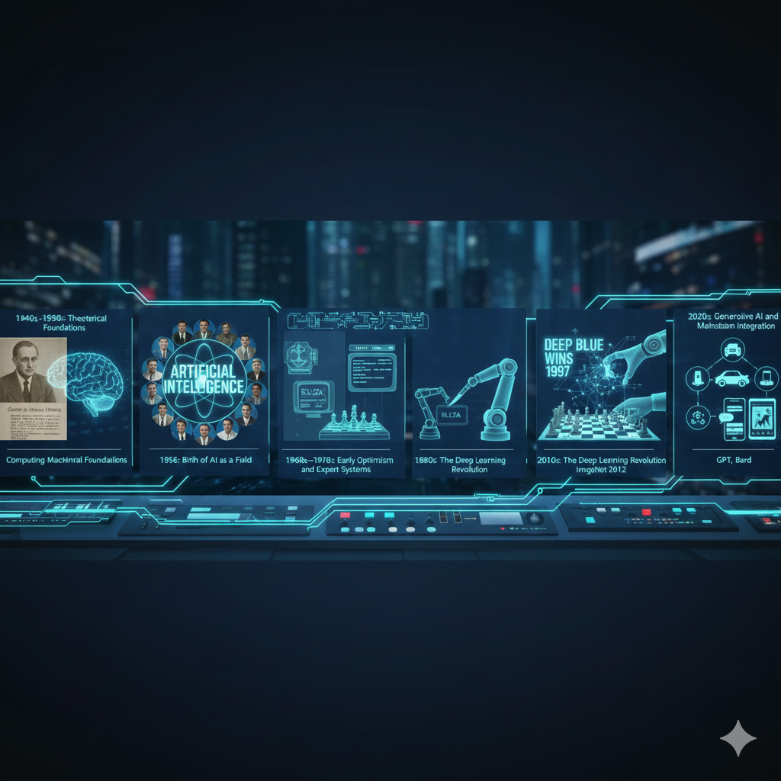
2010s: The Deep Learning Revolution
AI experienced a renaissance due to the rise of deep learning and the availability of big data. Neural networks became the foundation for advances in image recognition, speech processing, and natural language understanding. In 2012, a deep learning model from the University of Toronto won the ImageNet competition by a wide margin, marking a pivotal moment.
2020s: Generative AI and Mainstream Integration
Today, AI has become part of everyday life. Tools like Siri, Google Translate, facial recognition systems, and recommendation algorithms rely on AI. The launch of large language models like OpenAI’s GPT series and Google’s Bard has brought generative AI to the forefront, enabling machines to produce human-like text, images, and even code.
From its theoretical roots to its practical dominance in the digital age, AI's history reflects a dynamic interplay of ambition, innovation, and caution. As it continues to evolve, the lessons from its history guide the development of safer and more effective AI.

1.3 Key Areas in AI
Artificial Intelligence encompasses a wide range of subfields and specialized technologies that work together to enable machines to perform intelligent tasks. Understanding the key areas in AI helps clarify how it functions and where it is applied. Here are the major domains:
1. Machine Learning (ML):
Machine learning is the backbone of modern AI. It involves the development of algorithms that allow computers to learn from data and improve performance over time without being explicitly programmed. Types of machine learning include:
- Supervised Learning: Algorithms are trained on labeled datasets to make predictions (e.g., spam detection).
- Unsupervised Learning: Algorithms explore data without labels to identify patterns (e.g., customer segmentation).
- Reinforcement Learning: Agents learn by interacting with environments and receiving feedback (e.g., training AI to play games).
2. Deep Learning:
A subset of machine learning that uses multi-layered neural networks to model complex relationships in data. Deep learning has driven major breakthroughs in image and speech recognition, natural language processing, and autonomous systems. It mimics the human brain’s architecture, with layers of artificial neurons processing information hierarchically.
3. Natural Language Processing (NLP):
NLP enables machines to understand, interpret, and generate human language. Applications include:
- Text translation (e.g., Google Translate)
- Sentiment analysis (e.g., analyzing opinions on social media)
- Chatbots and virtual assistants (e.g., ChatGPT, Siri)
- Speech recognition and transcription
Modern NLP models like BERT and GPT have revolutionized human-machine communication.
4. Computer Vision:
Computer vision allows AI systems to interpret and make decisions based on visual inputs. It is widely used in:
- Facial recognition
- Autonomous vehicles
- Medical imaging diagnostics
- Industrial quality control
By converting pixels into meaningful data, AI can identify objects, classify images, and detect anomalies in real time.
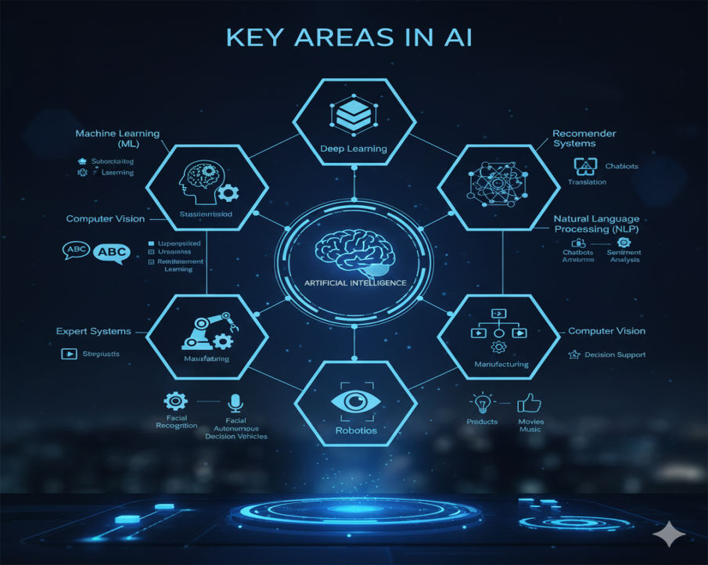
5. Robotics:
Robotics integrates AI with mechanical engineering to create intelligent machines capable of performing physical tasks. AI-driven robots are used in manufacturing, logistics, agriculture, and healthcare. These robots often include vision systems, motion planning, and adaptive behavior based on sensor input.
6. Expert Systems:
These are AI programs that simulate the decision-making abilities of a human expert. Expert systems use rule-based logic and inference engines to analyze data and provide recommendations in fields such as medicine, engineering, and law.
7. Recommender Systems:
AI-powered recommenders are used to suggest products, media, or information to users based on their preferences and behavior. Examples include:
- Netflix suggesting movies
- Amazon recommending products
- Spotify creating custom playlists
Together, these key areas form the foundation of AI, enabling applications that are transforming industries and daily life. They also continue to evolve as AI research pushes the boundaries of what machines can understand and accomplish.

1.4 Real-World Applications of AI
Artificial Intelligence is no longer a futuristic concept—it is embedded in many aspects of daily life and across virtually every industry. These applications demonstrate how AI improves efficiency, decision-making, and user experience. Below are some of the most impactful real-world applications of AI:
1. Healthcare:
- AI-driven diagnostic systems analyze X-rays, MRIs, and CT scans to detect anomalies such as tumors or fractures.
- AI tools help in drug discovery by predicting molecular behavior and optimizing compound selection.
- Virtual health assistants provide 24/7 patient support, answer medical questions, and assist with scheduling.
- Predictive analytics help hospitals manage patient admissions and resources during pandemics or flu seasons.
2. Finance and Banking:
- AI algorithms detect fraudulent transactions by analyzing spending patterns in real time.
- Robo-advisors manage investment portfolios by using algorithms to optimize returns based on user goals.
- Chatbots and virtual agents assist with customer service in banking apps.
- Credit scoring systems evaluate borrower risk by analyzing alternative data such as digital footprints.
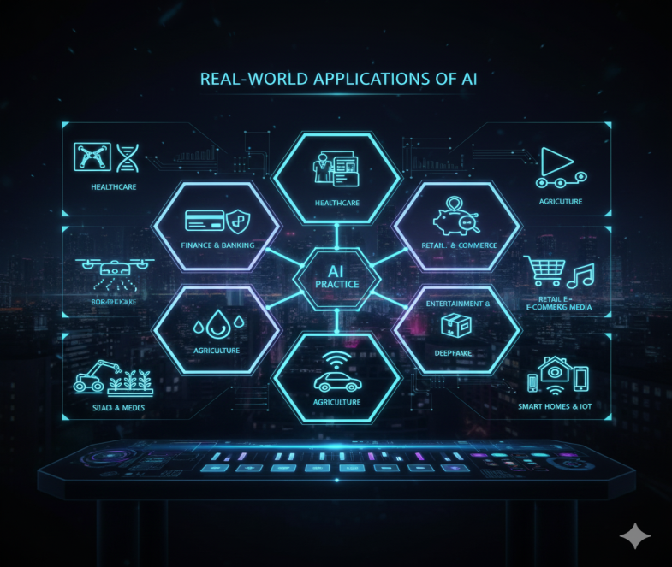
3. Education:
- AI personalizes learning by adapting content to individual student strengths and weaknesses.
- Intelligent tutoring systems provide targeted feedback and practice problems.
- Automated grading tools save teachers time and provide consistent assessment.
- AI-driven language learning platforms like Duolingo adapt exercises based on user progress.

4. Retail and E-Commerce:
- Recommendation engines suggest products based on browsing and purchase history.
- Chatbots handle customer service, returns, and FAQs on e-commerce websites.
- Inventory management systems forecast demand and optimize restocking.
- Computer vision helps in cashier-less stores (e.g., Amazon Go) that track items picked off shelves.
5. Transportation and Logistics:
- Self-driving vehicles use AI to detect objects, plan routes, and make driving decisions.
- AI helps airlines optimize flight schedules and routes based on weather and demand.
- Logistics companies use AI for route optimization, delivery tracking, and load planning.
- Predictive maintenance alerts operators about parts that need repair before breakdowns occur.
6. Agriculture:
- Drones equipped with AI scan fields to assess crop health and detect pests or disease.
- Precision agriculture tools adjust irrigation and fertilization based on soil and weather data.
- Harvesting robots identify ripe crops and pick them autonomously.
7. Entertainment and Media:
- Streaming platforms like Netflix and Spotify use AI to create personalized content experiences.
- AI-generated music and art open new possibilities in creativity and collaboration.
- Deepfake technology, while controversial, showcases AI’s ability to synthesize video content.
8. Public Safety and Security:
- AI is used in surveillance systems to detect suspicious activities in real time.
- Facial recognition helps law enforcement identify persons of interest.
- AI models predict crime patterns and assist in resource allocation for patrol units.
9. Smart Homes and IoT:
- AI-powered assistants (e.g., Alexa, Google Assistant) manage schedules, control appliances, and answer queries.
- Smart thermostats learn user habits to optimize heating and cooling.
- Security systems use AI to recognize faces and differentiate between family members and strangers.
These examples illustrate how AI transforms industries, boosts productivity, and enhances daily experiences. Its integration across sectors continues to grow, shaping a more connected and intelligent world.

1.5 Ethical and Social Considerations
As Artificial Intelligence becomes more powerful and integrated into society, it raises important ethical and social questions that must be addressed to ensure its responsible and fair use. These concerns span privacy, accountability, fairness, safety, and more.
1. Bias and Fairness:
AI systems can inherit and amplify biases present in their training data. For example, facial recognition algorithms have been shown to perform less accurately on individuals with darker skin tones due to underrepresentation in datasets. Biased AI can lead to unfair outcomes in hiring, lending, policing, and healthcare. Ensuring fairness requires diverse data, transparency, and continuous auditing.
2. Privacy and Surveillance:
AI often relies on large volumes of personal data to function effectively. This raises concerns about user privacy, especially when data is collected without consent or used for purposes not initially disclosed. AI-enabled surveillance systems and facial recognition technologies can be used by governments or corporations to track individuals, potentially infringing on civil liberties.
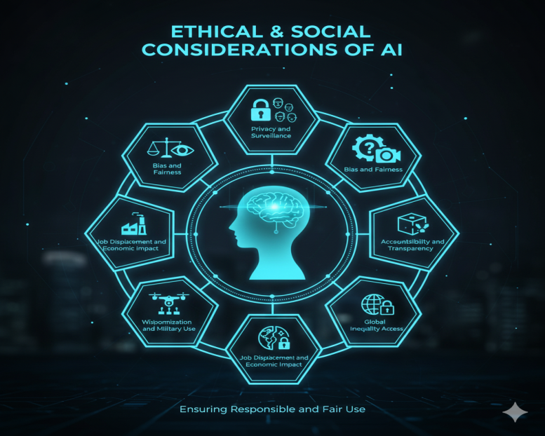
3. Accountability and Transparency:
When AI systems make decisions—such as denying a loan or recommending a medical treatment—who is responsible if something goes wrong? The 'black box' nature of some AI models makes it difficult to understand how decisions are made, reducing trust and accountability. Efforts to develop explainable AI (XAI) aim to make these systems more transparent and understandable.
4. Job Displacement and Economic Impact:
AI and automation are expected to replace certain types of jobs, particularly in manufacturing, transportation, and administrative sectors. While new jobs may emerge, there is concern about how workers will be retrained and whether job creation will match job losses. This transition has deep implications for income inequality, labor markets, and economic stability.

5. Weaponization and Military Use:
AI is increasingly being developed for military applications, including autonomous weapons systems and drone surveillance. This raises ethical concerns about the delegation of life-and-death decisions to machines and the potential for AI to be misused in conflict or oppression.
6. Misinformation and Manipulation:
Generative AI can produce deepfakes, fake news, and persuasive content at scale, making it easier to spread misinformation. This threatens democratic processes, public trust, and social cohesion. Policies and AI-based detection tools are needed to combat these risks.
7. Ethical Design and Value Alignment:
AI systems should be aligned with human values, rights, and ethical principles. This includes avoiding harm, promoting well-being, and respecting human dignity. Developers are increasingly urged to follow ethical frameworks and incorporate stakeholder perspectives in AI design.
8. Global Inequality and Access:
The benefits of AI are not distributed equally across the globe. Wealthier nations and tech corporations have greater access to AI infrastructure, while poorer regions may be left behind. Addressing digital divides and ensuring equitable access to AI tools is essential for global development.
Ethical AI development is not just a technical issue—it’s a societal one. It requires interdisciplinary collaboration among engineers, ethicists, policymakers, educators, and the public to ensure that AI serves humanity responsibly and inclusively.

Conclusion
Artificial Intelligence is no longer a distant vision of the future—it is a central part of the present and an ever-growing force in shaping the future. From enhancing medical diagnosis to revolutionizing how we interact with technology, AI is redefining industries, governments, and personal lives alike.
This technology holds enormous potential to address some of the world’s most pressing problems. It can assist in combating climate change, improving education access, delivering personalized healthcare, and optimizing resource use. However, realizing these benefits requires a deep understanding of both the capabilities and the limitations of AI.
It is crucial that AI be developed with a foundation of ethics, inclusivity, and responsibility. While innovation continues at an unprecedented pace, so too must our efforts to ensure that AI systems are fair, transparent, accountable, and aligned with human values. Interdisciplinary collaboration between technologists, policymakers, educators, and citizens is essential to guide AI’s development in a way that benefits all of humanity.
Furthermore, education and public awareness must play a pivotal role. Equipping people with knowledge about how AI works, where it is used, and what it can and cannot do empowers them to participate actively in conversations about its deployment.
In conclusion, Artificial Intelligence is not just a technological shift—it is a societal transformation. Navigating this transformation requires not only advanced tools and algorithms but also vision, care, and a commitment to shared progress. By making informed decisions today, we can ensure that the AI of tomorrow is not just intelligent, but also wise.

2. Why ethics and safety are important in the use of artificial intelligence in education
Artificial intelligence (AI) is also permeating education today. It helps teachers with assessment, monitors the progress of teaching, offers personalized recommendations for students and automatically records various data. These technologies have great potential to make schoolwork more efficient and improve student outcomes. But at the same time, they bring with them new challenges that relate not only to technology, but also to fundamental values such as justice, privacy and responsibility.
In the school environment, students and teachers are confronted with decisions that can be influenced by AI on a daily basis. It may happen that the system recommends a certain direction of study to a pupil only on the basis of the past results of similar students, which may unconsciously limit their options. It can also happen that the automatic rating system misinterprets an answer that was creative but different from the template. If these decisions are made without the supervision of a teacher, they can cause injustice or frustration.
Ethical issues are extremely important in the use of AI in education, as they affect people in a sensitive period of development – pupils. School should be a place where everyone feels respected, understood and motivated. If AI is to be part of this environment, it must be designed and used to support these values. We cannot rely only on the fact that technology "works". We have to ask how it works, for whom it is advantageous and whether it does not disadvantage anyone.
At the same time, it is important to remember about safety considerations. AI often works with large amounts of data – test scores, class behavior, even personal preferences. This data can be sensitive and leaked can have serious consequences. Young people often don't realise that every click, every response and every delay in online work can be recorded. Therefore, it is essential that schools pay attention to secure data processing, use proven systems and inform pupils and parents about what is happening with their data.
Without an ethical and secure approach, the use of AI in education can do more harm than good. That's why it's not enough to just master technology – we need to learn to think about its implications, understand its limits, and ask questions that will protect the people it's supposed to serve. Ultimately, it's not just about efficiency, it's about trust, fairness and the human dimension of education.
Imagine that a student has written an essay that is being evaluated by an artificial intelligence system. The text was original, but it did not contain some of the "keywords" that the system expected. He received a lower rating than his classmates, whose text was less elaborate, but technically "exemplary". How would this student feel? Who should judge whether the evaluation was fair?
Questions for discussion:
- Who should be responsible for the error caused by AI?
- Is it right for AI to decide about a student's grades, future, or capabilities?
- What data do you think an AI system should never collect?

2.1 Ethical principles in the use of artificial intelligence in schools
In the educational environment, the most important thing is not only what we teach, but also how we teach it and what values we promote in the process. With the advent of AI, educators, learners and educational technology developers alike face a new challenge: how to ensure that AI is used ethically, fairly and for the benefit of all involved. Ethics is not just a theoretical concept – it represents a set of values that protect the dignity, equality and freedom of the individual.
One of the basic ethical principles is justice. In practice, this means that AI should treat all students equally – regardless of their gender, ethnicity, language, performance or personal preferences. If the system provides recommendations for further study, it must not assume in advance who is "better" for technology and who is for the humanities. Justice means creating equal opportunities, not perpetuating existing inequalities.
Another important principle is transparency. Teachers and students should know how AI works – what data it uses to decide what it takes into account and what it doesn't. A computer "black box" that only announces the result without explanation can cause distrust or even harm to a student who does not know what he has done "wrong". Transparency also helps with feedback – when we know what the system is tracking, we can work on it in a targeted way.
Let us also not forget respect for privacy and dignity. Pupils, especially at a younger age, are often unaware that they are leaving a digital footprint when using digital tools. Therefore, it is important for AI systems to collect only the necessary data, protecting it from misuse while allowing the user to control what they share. This includes informed consent – no one should be part of a system they don't understand or agree with.
Finally, there is the principle of responsibility. Any system that affects people's lives must have a clearly identified bearer of responsibility. In a school setting, this means that the teacher should not trust AI recommendations unconditionally, but should see them as a tool. The responsibility lies with the person who uses the system – so they should know what they are doing, why they are doing it and what can come of it. Without this level of awareness, technology could become a tool that starts doing harm instead of helping.
Imagine that an online platform advises a student to engage in hands-on learning instead of theoretical learning. He justifies this by saying that his test results were below average. But you know that he just had a bad day and is usually strong in analysis.
If the teacher was only guided by the AI evaluation, he could recommend the student for another field of study.
The ethical question is: does technology have the right to decide without deeper context?
Questions to think about:
- How would you define fair decision-making in the school environment?
- Who should have the last word – AI, teacher or student?

2.2 Protection of pupil´s privacy and data
Modern technology and artificial intelligence are increasingly part of school life. While their benefits can be enormous – from personalized learning to automated assessments – they also bring with them serious questions about privacy and personal data security. These questions are all the more sensitive because they concern pupils – i.e. people who are not yet fully responsible for their digital decisions.
AI systems in education often collect and evaluate data on how a student learns, which tasks they do easily, where they make mistakes, how much time they devote to specific activities, and how they react during lessons. Sometimes it is also sensitive information, such as messages in chat tools, emotional reactions during online classes, or geographic location. This data can be useful to the system, as it helps to tailor the content to the needs of the individual. But they also pose a risk if they are not properly protected or if they are used without consent.
In schools, it should be a matter of course that no data is treated lightly. Every pupil – and in the case of minors also their parent – has the right to know what data is collected about them, what it is used for, how long it is stored and who has access to it. This right is not only moral, but also legally enshrined – for example, in the European GDPR regulation, which protects the personal data of all citizens, including students. The use of AI should never mean restricting privacy or the risk of information manipulation.
At the same time, it is important to emphasize that data protection is not only the responsibility of schools or system developers. Pupils themselves should also be taught digital literacy – the ability to recognize situations where data could be misused and to understand what it means to share personal information online. Ultimately, it's about working together—schools, teachers, students, developers, and parents—to create a secure environment where technology can serve its purpose without compromising privacy.
Did you know that digital school platforms collect data on their activity? Many think that it is just "clicking on tasks", but in reality, the time, frequency, type of answers and sometimes personal data are also tracked. That is why it is important to talk about data protection as well as the protection of personal space.
Questions to think about:
- Which data would you never want to share about yourself with the school system (e.g. MS Teams)? - Question to the teacher/student
- How should schools deal with students who don't want AI to collect their data?

2.3 Biases and fairness in AI tools
One of the most serious ethical challenges in the use of artificial intelligence in education is the issue of fairness. AI is not "neutral" or "objective" just because it is a technology. On the contrary, AI systems learn from the input data provided to them by humans – and these often contain various hidden biases, inequalities or stereotypes. These biases can then be passed on without the student or teacher realizing it.
Biases can already arise in the data that AI processes. For example, if the number of girls successful in math has historically been lower, the AI system may start to assume that girls are less likely to succeed in technical fields. However, this is not true – it is only a statistical reflection of the past, not a fair view of the future. If such assumptions become part of the system's decision-making, discrimination can occur without bad faith, but with a real negative impact on the future of individuals.
However, the problem is not only demographic prejudices. AI can be biased against learners who learn differently, who have special educational needs, or whose language skills do not correspond to the majority normative. Instead of supporting their development, AI can unfairly evaluate them as weaker, just because their expression differs from the average. In such cases, technology may inadvertently exacerbate the inequalities that it should help overcome.
Therefore, fairness in AI means actively seeking and eliminating these inequalities. It is not enough to believe that the system "will be fair" if we do not explicitly tell it so. Developers need to purposefully test how their tools work with different groups of students. Schools should monitor whether the results of assessments are balanced across genders, regions or language skills. And teachers must be prepared to intervene if they see that the AI system is making disproportionate or dishonest decisions.
When justice is not self-evident in one country, a system was deployed to recommend secondary schools. AI evaluated students according to a combination of grades, behavior, and interests. It was later found that the system systematically recommended technical majors to boys and humanities majors to girls, even though they had comparable results. The reason for this was data that reflected the historical distribution of professions, not the abilities of students.
Questions to think about:
- Do you think technology can be "biased"? Why yes or no?

2.4 Use AI safely and responsible in the classroom
The introduction of artificial intelligence into teaching is not just a technical matter. It is mainly a decision about how we want to educate and what responsibility we are willing to share with technology. Using AI in school means having a powerful tool at your disposal that can simplify a teacher's work, improve student learning, and bring new forms of support. At the same time, however, it requires that it be approached with prudence, critical thinking and an emphasis on safety.
Responsible use of AI in the classroom means that technology must not replace the teacher, but should complement him. The teacher remains the one who understands the context, knows the individual needs of the pupils and can distinguish when it is appropriate to follow the recommendation of the system and when not. At the same time, it is important for students to understand how AI works, what it is for, and what they can expect from it. If AI evaluates something, they should be able to ask, "Why did the system recommend this?" or "Is this really right for me/the student?"
Safe use also applies to the choice of tools themselves. Schools should only use proven systems that guarantee the protection of personal data, allow transparency of decision-making and do not work with any hidden mechanisms. Free apps without clear data protection policies or tools that collect data without the user's knowledge should be avoided. Trust between teacher, student and technology is only built when the rules are clear, open and fair.
No less important is the development of critical thinking in pupils. AI can suggest an answer, solve an example, or even write text – but not always correctly. Therefore, students should learn to check facts, compare multiple sources, and think about how the system arrived at the result. In this way, AI will become a tool for development, not just a helper to circumvent the effort. The teacher plays a key role in this process as a guide who guides students to responsible and active learning even in the digital age.
The digital balance of AI can be a great helper, but it is not appropriate for it to become the center of all learning. Some experts recommend the 80:20 rule – technology should encourage learning, but not drive it. The teacher should always be able to intervene in the decision-making process and explain to students when AI has "misunderstood" something.
Questions to think about:
- As a teacher, when would you reject an AI tool's recommendation?
- How would you recognize that a student is abusing AI instead of learning?

Conclusion
The use of AI in education brings great opportunities, but at the same time requires a sensitive and responsible approach. If AI is to help learners and teachers, it must be used fairly, transparently and with respect for everyone's rights. Ethical principles such as equality, privacy, responsibility, and critical thinking should be at the core of every technology-related decision. School remains a place where people should come first – and AI should be a tool, not a replacement. Creating a safe and fair digital environment is a shared task for teachers, learners and developers alike. If we approach AI wisely, it can become a valuable tool that empowers human capabilities, not replaces them.

3. AI tools for teachers: practical applications
Artificial Intelligence (AI) has increasingly established itself as a transformative force across various sectors of society, and education is no exception. For teachers, this technology represents an opportunity to reimagine pedagogical practice with greater creativity, efficiency, and student-centred focus. However, more than just an abstract promise, AI already offers a solid set of practical tools that can be integrated into everyday school life, even by teachers without advanced technical training.
In this chapter, we explore in a structured way how teachers can use these tools to plan, teach, assess, and communicate more effectively. The approach is centred on practical usefulness, with examples, platforms, and strategies that can be applied in real educational contexts.
Before exploring specific tools, it is important to recognise the areas of teaching practice in which AI can serve as a strategic ally. The main areas include:
- Lesson planning (support in creating content and activities);
- Formative and summative assessment (automated marking, personalised feedback);
- Time management (automation of repetitive tasks);
- Support for personalisation (activity recommendations based on student data);
- Professional development (access to personalised training and resources).
The integration of AI into the classroom should be seen as a partnership — it does not replace the teacher, but rather enhances their ability to teach more effectively, inclusively, and dynamically.

3.1 Lesson Planning with AI Support
Lesson planning requires time, reflection, and organisation. With the help of AI, this process becomes more efficient without compromising pedagogical quality.
Tools such as Eduaide.ai or LessonPlans.ai allow teachers to generate complete lesson plans, including objectives, content, methodological strategies, and forms of assessment. By providing parameters such as year group, topic, and duration, the teacher can receive an initial proposal to work from and adapt to their specific context.
In addition, tools like ChatGPT or Gemini are useful for structuring learning sequences, creating differentiated activities, and even suggesting curricular adaptations for pupils with special educational needs.
Another relevant example is MagicSchool.ai, which centralises features such as generating assessment rubrics, weekly plans, and motivational strategies for pupils — all based on simple inputs provided by the teacher.
These tools do not replace pedagogical reflection, but act as creative “co-pilots”, offering ideas that can be adapted and enriched with the teacher’s experience.

3.2 Creating Teaching Materials and Resources
Teaching requires a variety of materials that engage different learning styles. AI can support teachers in diversifying their resources quickly and with high quality.
Tools such as Canva with AI (using features like Magic Write or Text-to-Image) enable the creation of appealing presentations, worksheets, infographics, and even educational videos. Simply input a theme or topic, and the AI suggests visual elements, slide structures, and content tailored to the target audience.
In addition, Genially, with AI support, allows for the creation of interactive content such as quizzes, educational games, and virtual escape rooms — ideal for developing skills through play.
For audiovisual content, platforms like Synthesia, Pictory, or Lumen5 generate videos with narration and visuals, useful for introducing new topics or reviewing content in an engaging way. Text-to-Speech tools like Murf.ai or ElevenLabs help create accessible materials for students with reading difficulties, promoting inclusion.
For example, a science teacher might use AI to generate an explanatory video about the water cycle, complete with animated images and clear narration, while a history teacher could create an interactive timeline with AI support to help pupils better understand complex historical events.

NOTEBOOKLM - Practical Teacher's Guide
1. What Is It
NotebookLM is an artificial intelligence (AI) tool developed by Google designed to support teachers and researchers. It allows you to organize and transform your materials into a wide variety of pedagogical resources. From documents, articles, notes or web pages, the user can generate, with a few clicks, diversified content such as summaries and study guides, audio podcasts, video presentations, slides, mind maps, infographics, quizzes and study cards. In this way, NotebookLM allows you to save valuable time, enhance pedagogical creativity and simplify the work of preparing teaching materials, making classes more dynamic and appealing to students.
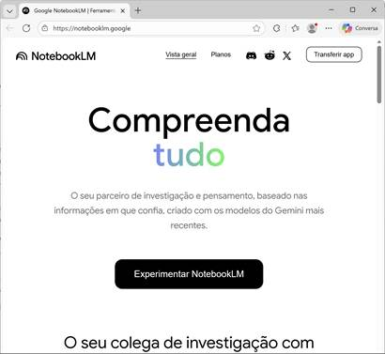
Figure 1- NotebookLM landing page

2. How It Works
Access the LM Notebook
- Open the browser (Chrome, Firefox, Safari, Edge...)
- Go to: https://notebooklm.google.com
- Click " Sign in"
- Use your Google account (Gmail)
3. Create Your First Notebook
- On the homepage, click the "+ Create New" button
- Give the notebook a descriptive name Example: "Science 6th grade - Photosynthesis"
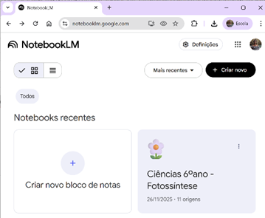
Figure 2- Screen for creating a new notebook.
Example given name: "Science 6th grade – Photosynthesis"
NotebookLM is structured into three main building blocks that guide the teacher's workflow
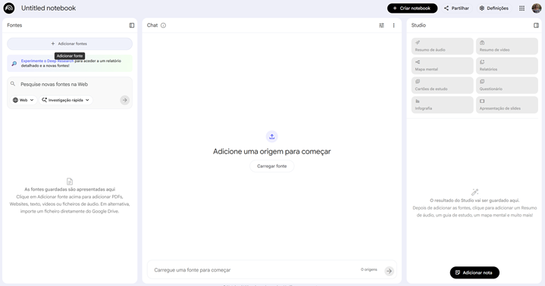
Figure 3- The three main blocks of NotebookLM: Fonts, Chat, and Features (Studio)

Block | Main Function
Sources | Provide the knowledge base. This Artificial intelligence only uses what is given to it.
Chat | Allows you to interact with the sources and create resources with specific prompts.
Resources (Studio) | Allows you to automatically generate multimodal materials (slides, podcasts, maps, quizzes).
Table 1 - Main Blocks: Fonts, Chat, and Resources (Studio)
4. Add Sources (Documents)
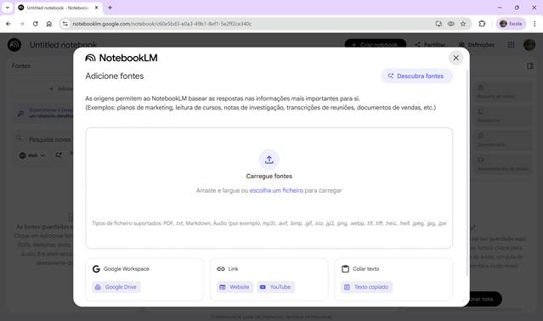
Figure 4- Add fonts – blank screen ready to upload documents
Option A: Upload files from your computer
Supported files: PDF, .txt, Markdown, Audio (e.g. mp3), .avif, .bmp, .gif, .ico, .jp2, .png, .webp, .tif, .tiff, .heic, .heif, .jpeg, .jpg, .jpe
Option B: Google Drive
Import documents directly from Drive.
Option C: Internet link
Add URL to web pages or YouTube videos
Option D: Paste text
Copy and paste notes, lesson plans, or parts of documents.
Option E: Web Search
Enter a context to investigate a topic and choose Figure 5- "Web Search" functionality that allows you to do quick search or in-depth investigation directly within the notebook
Quick search - immediate and general response.
In-depth investigation - more detailed research (takes longer)
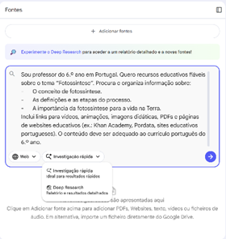
Figure 5- "Web Search" functionality that allows you to do quick search or in-depth investigation directly within the notebook
Fountain management
After adding it is possible
- Open to reading
- Rename
- Keep in source bank
- Permanently delete
5. Interact with sources (CHAT)
5.1 Auto-Resume
As soon as the fonts are loaded, NotebookLM generates an overall summary.
5.2 Ask questions in the chat
- In the chat box at the bottom of the screen
- Write your question in natural language
- Press Enter or click the send icon
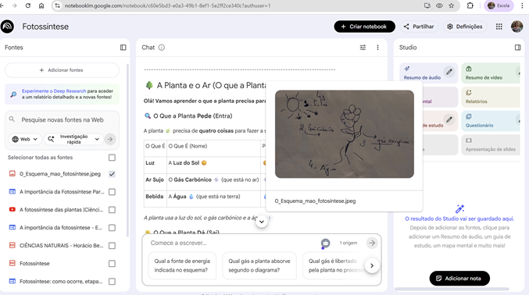
Figure 6- NotebookLM chat area with examples of source citations
Examples of prompts
Pedagogical Objective | Prompt example
Simple Summary | It summarizes in 3 paragraphs the main contents of these sources.
Accessible Language | Explain these sources as if I were 10 years old. It uses simple analogies, everyday examples, and pictograms to help visualize.
Pedagogical differentiation (NEE) | From this image, he creates a very easy-to-read summary, with pictograms, adapted to NEE students in the 6th grade. It also includes 3 consolidation exercises and 2 adapted challenges.
Structured evaluation | Prepares an evaluation test on the theme [Project Theme]. The test should include 10 text-only questions, with a variety of types: multiple choice, true/false, complete, order, relate columns, and 1 short answer question. Organizes the questions by difficulty levels: 3 easy questions, 4 questions of medium difficulty and 3 challenging questions. At the end, it presents a classification and correction grid.
Content in another Language | Generates an abstract in English, intermediate level (B1), with short sentences and accessible vocabulary.
Table 2- Examples of effective prompts for summaries, accessible language, pedagogical differentiation, and evaluation
6. Verify sources (citations)
Each LM Notebook response includes quotes:
Look for the numbers in parentheses in the response, example: [1], [2] Indicates which document the information comes from, to confirm that the AI is not responding with hallucinations
7. Create educational materials (Studio)
Studio automatically generates a variety of assets.
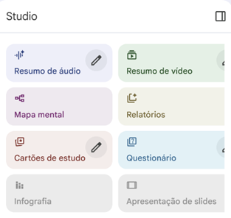
Figure 7 - Studio tab where the teacher can automatically generate Audio Summary, Video Summary, Mind Map, Study Cards, Quizzes, Infographic and Slideshow

Summary table of resources
Resource | Pedagogical Function | Examples
Audio Summary  | Converts the sources into an accessible, multilingual conversation-podcast. Excellent for auditory review, study on the go. | Allows you to download it to accompany a presentation. Personalized PowerPoint with personal content.
Video Summary   | Generates a video in presentation format with narrated slides, combining relevant text, diagrams, graphs, or images extracted from the sources, ideal for lessons, presentations, or visual material for students. | The video is generated in the background, this feature takes a few minutes, at the end it is possible to download it.  Ideal for classes or presentations.
Mind Map  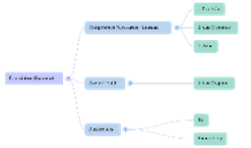 | Automatically creates a visual diagram with the main topics and sub-themes of the sources, allowing the teacher or student to have a clear view of the content structure, identify links between concepts, and organize ideas. | It can be expanded/collapsed and exported to PDF.
Reporting  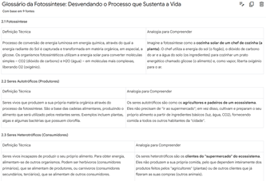 | Generates reports that can focus on a glossary of technical terms on the contents. | Generates an organized summary of the sources.
Study Cards  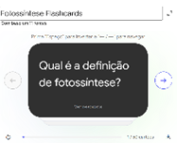  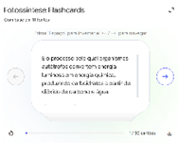 | It automatically generates review cards and self-assessment exercises based on the content of the sources, useful for assessment, active study or preparing worksheets for students. Excellent way to test knowledge and follow the study. | Allows pedagogical differentiation when selecting the level (Easy/Medium/Hard).
Questionnaires  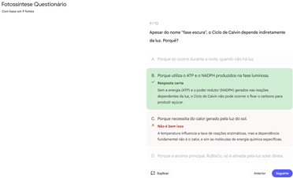 | It automatically generates multiple-choice questions and offers immediate feedback, showing the correct answer. Ideal for preparation of revision classes and for formative assessments.  Allows easy/medium/hard level. | Great for formative reviews or assessments. It generates several questions with immediate feedback.
Infographics  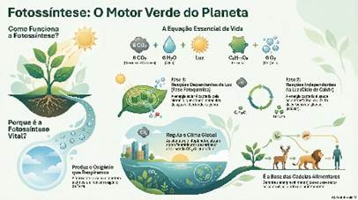 | Ideal for consolidating the search in a single image. Use for quick review of concepts or to post in the classroom. | Visual summary of a complex process  Create a poster that can be printed.
Slideshow  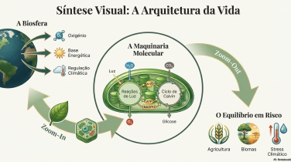 | Create visual slides with image integration powered by google's Nano Banana image generator | For lessons or visual syntheses
Notes  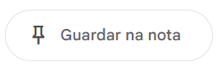 | Saves relevant information for future reuse. | They can be used as a new source.
Table 3- Studio features summary

8. Best Practice Tips
- The quality of the answers depends on the quality of the sources provided
- Be specific in your questions - the more context you give, the better the answers will be
- Always review AI-generated content before using it with students
- NotebookLM is a support, it does not replace pedagogical practice.
Important: NotebookLM only works with the sources it provides. It does not have access to the real-time internet or external databases. Make sure to upload all the materials relevant to the topic you want to work on.
9. Advantages For Educational Practice
- Adapts the same content to multiple learning styles (visual, auditory, textual).
- Significantly reduces material preparation time.
- Intuitive interface, accessible even for users with little technological experience.
- It allows you to centralize and organize all materials in a single notebook.
- It facilitates the reuse and continuous updating of educational resources.

3.3 Personal Organisation and Time Management
Work overload is one of the main causes of stress among teachers. AI offers solutions to make time management smarter.
Tools such as Notion AI allow teachers to organise their work in blocks: weekly planning, lesson logs, learning objectives by class group, project ideas, and more. AI also helps summarise information, generate task lists, and even anticipate deadlines.
Platforms like Trello with AI and ClickUp can be used to organise interdisciplinary projects, manage calendars, and set priorities. The use of automatic labels and categorisation suggestions saves time on organisation.
For scheduling meetings with parents or educational teams, Calendly, integrated with AI, makes it easy to synchronise availability, send automatic reminders, and avoid scheduling conflicts.
When well integrated, these tools help teachers free up time for what really matters: direct engagement with pupils and pedagogical reflection.

3.4 Communication with Pupils and Families
The relationship between school, pupils, and families is central to educational success. AI can facilitate this communication, making it clearer, more efficient, and more inclusive.
Platforms such as ClassDojo, with AI-powered features, enable the sharing of information with parents and guardians, showcasing pupils’ progress and sending automated and personalised messages.
Translation tools such as DeepL Translator with AI and Google Translate with neural support allow communication with families who are not fluent in Portuguese. This is particularly useful in multicultural contexts or in schools with a diverse student population.
To simplify lengthy or technical texts (such as circulars, regulations, and recovery plans), the use of automatic summarisation tools, such as TLDR This or Quillbot, allows the creation of more accessible versions tailored to the recipients’ literacy levels.

3.5 Pedagogical Differentiation and Inclusion
In an increasingly diverse educational system, personalised learning is an imperative. AI contributes tools that enable responses to pupils’ individual needs, promoting equity.
Tools such as Khan Academy, now integrated with AI (Khanmigo), offer adaptive content that adjusts in real time to pupils’ performance. Teachers can closely monitor each student’s progress and intervene more effectively.
Google’s Socratic app allows pupils to explore questions through images, voice, or text, with step-by-step explanations. This is particularly useful in fostering autonomous learning.
Other platforms, such as Curipod and Diffit, adapt content to different levels of linguistic and cognitive complexity, providing added value in inclusive teaching contexts.
AI-powered chatbots have also become valuable companions in differentiated education. These conversational tools simulate human interaction and can guide, support, and challenge pupils in real time. Chatbots such as ChatGPT, Copilot, or Mizou can act as virtual tutors, providing explanations, generating examples, or scaffolding problem-solving according to each learner’s level. Beyond content delivery, they promote dialogue, curiosity, and reflection, helping students articulate their reasoning and develop metacognitive awareness.
This use of AI enables teachers to accommodate different learning paces and styles, respecting each pupil’s individuality and avoiding a one-size-fits-all approach to learning.
Below, we will present how the Mizou chatbot works in practice.
How the Mizou Chatbot Works
1. Access the Platform
- Go to https://www.mizou.com

- Sign in or create a free account.
2. Select a Chat Mode
- Choose whether you want Mizou to act as a tutor, coach, lesson assistant, or student companion.
- Each mode offers different interaction styles and pedagogical aims.
3. Define the Topic or Learning Goal
- Enter a subject, question, or learning objective (e.g., “help students understand fractions” or “generate discussion prompts about ecosystems”).
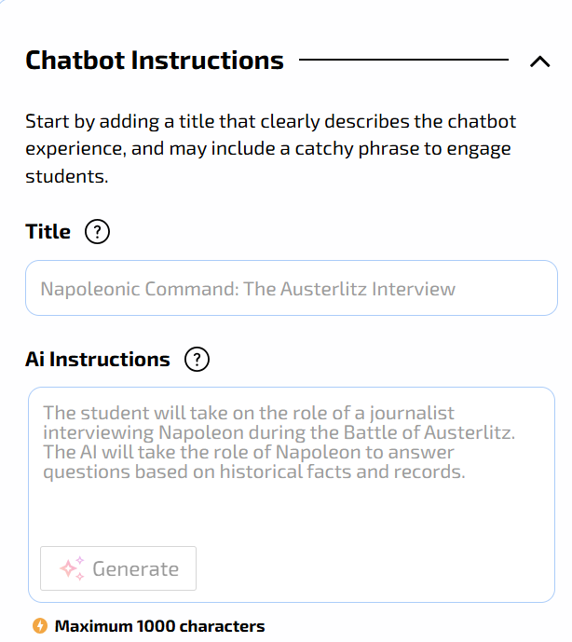
- Mizou adapts its responses to the chosen goal.
4. Interact in Real Time
- Engage in a text-based dialogue with the chatbot.
- Mizou provides explanations, asks guiding questions, or offers activities at different levels of difficulty.
5. Customise the Interaction
- Adjust the tone, complexity, and target age group.
- Teachers can request differentiated versions of the same content for diverse learners.
6. Export or Share the Output
- Save conversations, export activity drafts, or share prompts with students or colleagues.
- Ideal for lesson planning or in-class demonstrations.
With Mizou, mizou.com/explore, users can easily select from a growing library of community-shared chatbots. These AI tools are meticulously tailored to diverse learning goals, offering students various interactive formats such as engaging quizzes, dynamic role-plays, structured debates, and detailed historical-figure simulations. A core benefit of the platform is its seamless accessibility: students can begin interacting with any chosen chatbot simply by scanning a QR code or clicking a direct link, completely eliminating the need for any sign-up process, thus making it a truly frictionless tool for integrating AI into the classroom.
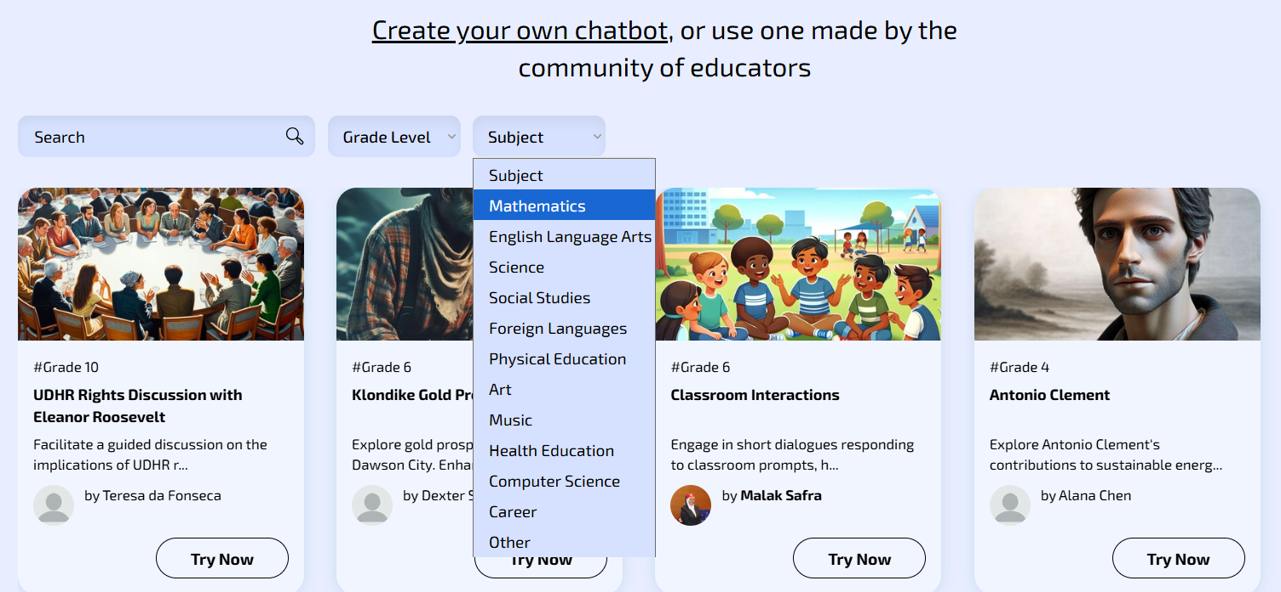
Pedagogical Advantages and Responsible Use
When thoughtfully integrated, Mizou can enrich classroom learning by promoting inquiry, supporting differentiation, and encouraging active engagement. Its adaptive design makes it particularly valuable for inclusive education, offering real-time feedback and scaffolding tailored to individual learners.
However, effective use requires teacher mediation and critical oversight. Educators should verify the accuracy of responses, ensure alignment with curricular goals, and safeguard student data and privacy. Chatbots should be seen not as replacements for human interaction, but as complementary tools that enhance creativity, reflection, and personalised learning experiences within a well-structured pedagogical framework.
Artificial Intelligence Tools for Foreign Students
- DEEPL
- Go to: https://www.deepl.com/en/translator
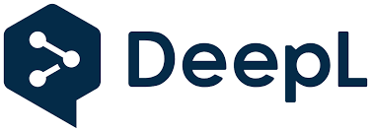
- High-quality translation: Accurately follows European Portuguese grammar.
- Paid. Free (with character/file limits).
- File translation: The free version allows full document translation (PDF, Word, PPT) while preserving the original formatting (limited to a few files per month).
- Teacher use: The teacher can quickly translate a worksheet into the student’s mother tongue so that they do not miss the subject content while learning the language.
- GOOGLE TRADUTOR
• Go to: https://translate.google.pt/?sl=auto&tl=zu&op=translate

- Text, voice and photo translation (worksheets, classroom posters, exercises).
- Useful for fast teacher–student communication.
- Works on mobile phone or computer.
- Completely free.
- Supports over 100 languages and allows offline translation, which is useful in schools with limited internet access.
- CHATGPT & GEMINI & COPILOT
- Go to: https://chatgpt.com/
- Go to: https://copilot.microsoft.com/
- Go to: https://gemini.google.com/
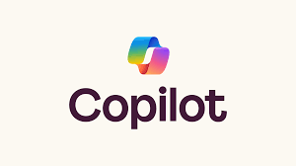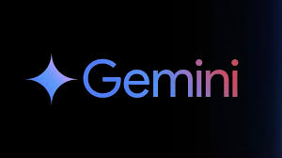
- Use generative AI chatbots not to create content from scratch, but to adapt existing content;
- Text Simplification: AI can take a complex History or Science text and rewrite, making it easier to read for those who are still learning the language;
- Glossary Creation: e.g., ask the AI to extract the 10 most difficult words from a text and instantly create a bilingual glossary;
- Free versions are sufficient.
- MICROSOFT TRANSLATOR
• Go to: https://www.microsoft.com/en-us/translator/education

- Real-time voice translation during lessons;
- Teacher speaks → student sees text in Portuguese, for exemple + translation in their language;
- Works on mobile phone or computer;
- Excellent for students who do not understand basic instructions;
- Completely free;
- For giving quick and direct instructions to a student who did not understand a task. The teacher speaks in Portuguese, for exemple, and the phone displays it in the student’s language.
Artificial Intelligence Tools for Students with Hearing Difficulties
- GOOGLE LIVE TRANSCRIBE
- Watch the video:
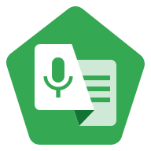
- The student places the phone on the desk → sees real-time captions;
- Excellent for classrooms and environments with moderate noise;
- Completely free (Android);
- Sound alerts: Notifies when a bell rings or someone knocks on the door (useful if the student is very focused on the task).
- CHATGPT – AUDIO TRANSCRIPTION AND SUMMARIZATION
• Go to: https://chatgpt.com/
- The student can record short explanations from the teacher; there is a ‘voice mode’ for voice messages in the app: voice messages can be recorded and transcribed into text;
- ChatGPT → creates a summary and explains it in simple language;
- The audio from these messages is retained while the conversation remains in the chat history. If the conversation is deleted, the audio clips are deleted within up to 30 days.
- MICROSOFT ONENOTE – TRANSCRIPTION
- Go to: https://support.microsoft.com/en-us/office/transcribe-your-recordings-7fc2efec-245e-45f0-b053-2a97531ecf57

- Allows recording of the class audio and generates a clear transcription;
- Students can then review, copy, and study at their own pace;
- Very useful for students who have difficulty hearing from a distance;
- Requires using the latest version of OneNote and being signed in to Microsoft 365 to use this feature;
- Audio files and transcriptions are saved in a specific folder in the user’s OneDrive.
Artificial Intelligence Tools for Students with Hearing Difficulties
- DIGITAL READING – IMMERSIVE READER (MICROSOFT)
• Go to: https://www.microsoft.com/en-us/edge/features/immersive-reader?form=MT0160

- An integrated tool in Microsoft Word, Edge (browser), OneNote, and Teams, designed to improve reading;
- Visual Adaptation: Allows the student to change the page background (e.g., black background with yellow letters for high contrast), greatly increase font size, and adjust word spacing;
- Read Aloud: Reads digital text with a very natural Portuguese neural voice;
- Free (integrated into Microsoft tools, many available via web for schools at no cost);
- Example: The teacher shares the class text in digital format (Word or PDF). The student opens it on the school computer, activates Immersive Reader, adjusts the contrast to what is most comfortable, and listens to the text while following along visually
- QUICK SCANNING – GOOGLE LENS
• Watch the video:

1. Uses the phone camera (integrated in the Google Photos app or Google app) to analyze images;
2. Reading the Board: If the student cannot read what is on the board, they can point the phone, take a photo with Lens, and use the "Read Aloud" function or simply zoom in on the captured image on the phone screen;
3. Text Extraction: Copy text from a sheet of paper to the phone to enlarge the font later;
4. Free.

- SEEING AI (MICROSOFT)
- Watch the video:
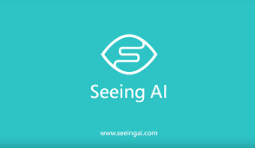
- A free app (iOS and now on some Androids) that uses the camera to "see" the world and describe it via audio;
- Instantly reads any text the camera is pointed at (e.g., a notice on a door, a title in a book);
- Takes a photo of a worksheet and reads the entire text aloud, allowing navigation by paragraphs;
- Describes the surroundings (e.g., "a classroom with desks and chairs");
- Completely free;
- Example: The teacher gives a paper worksheet. The student uses Seeing AI to photograph the worksheet and listen to the questions through headphones instead of straining their eyes to read.
- MAGNIFIER (GOOGLE)
- Watch the video:

- Magnifier is a free app (using artificial intelligence or other algorithms) for Android, developed by Google, that enlarges images, text, and symbols, making it easier for people with low vision to read and identify objects. The app allows adjustment of contrast, lighting, and zoom, making it a versatile tool for classroom use.
- It can be used to improve the quality of low-resolution photos, enlarge text, or inspect details of objects.

3.6 Assessment and Feedback with AI
Assessment is one of the areas where AI shows the greatest potential to support teachers, particularly in automating repetitive tasks and generating formative feedback.
With tools such as Gradescope, for example, it is possible to mark tests automatically, even with open-ended responses. The AI learns from the teacher’s decisions and suggests consistent scoring, saving time and ensuring fairness in marking.
Tools such as Formative, Google Forms with AI, or Ziplet enable the delivery of diagnostic or formative assessments with immediate feedback for pupils and organised data for teachers.
In addition, AI models such as ChatGPT can be used to generate personalised feedback suggestions based on pupils’ responses, helping teachers provide richer and more individualised feedback.
However, as explored in Chapter 2, it is essential to keep the teacher as the mediator in these processes, ensuring the pedagogical interpretation of data and the contextualisation of decisions.
Next, we will show you how to create an online assessment test in Moodle with the support of an AI assistant (ChatGpt) in practice.
Creating a quiz with chatgpt and moodle

Objective
The automatic creation of a set of questions on a subject topic, using ChatGPT, Gemini or another AI assistant and the import of these questions into Moodle, in a fast, practical and compatible way with any version of the platform.
Step 1 — Create the prompt in ChatGPT
ChatGPT can generate the questionnaire in a format that Moodle directly recognizes, such as GIFT (plain text) or Moodle XML (more complete).
The GIFT format is the simplest and widely compatible with all versions of Moodle.
In the example below, the topic of the questions is indicated directly in the prompt, but you can also send a file (PDF, Word, PowerPoint, etc.) with the study material for ChatGPT to create the questions based on that content.

Template prompt (to copy and adapt):
Generates a set of [indicate the number, e.g., 20] questions on the theme "[put here the theme or content of the subject]", suitable for students of the "[put here basic or secondary]" education of the subject of "[put here the subject and the year/class]".
The questions should be varied, including the following types:
▪ Multiple choice (with 4 options — A, B, C, D — and a correct answer);
▪ True/False;
▪ Short answer;
▪ Associação (matching/lista).
Rules and format:
▪ The set must be fully formatted in Moodle GIFT format, ready to import.
▪ The title of each question should start with "Q1 -", "Q2 -", etc.
▪ Always indicate the correct answer.
▪ Use language appropriate to the level of the students
▪ Questions should cover various aspects of the topic in a balanced way.
Generates a good mix of question types (approximately 50% multiple choice, 25% true/false, 15% short answer/fill-in, and 10% association).
In the end, don't write additional explanations — just the content in GIFT format.
Creates the . GIFT with the questions to import directly into Moodle.

Step 2 — Export the . GIFT do ChatGPT
- Save the file with the extension: Nome_do_Quiz.gift generated by ChatGpt on your computer.
- You can change the filename, but the extension must be .gift.
Step 3 – Import the file into Moodle
- Access your course in Moodle. In the side menu, click:
Course administration - Question databases - Create a new Question database with the name of the subject or use an existing one - Import button
- Under File format, select: GIFT format
- Upload the .gift file that was created by ChatGPT
- Click Import.
- Moodle will automatically read the content and add the questions to the subject's question bank.
Step 4 – Create the quiz in Moodle
- Go to the course home page .
- Turn on editing.
- Click Add an activity or resource → Quiz.
- Set:
▪ Name of the test;
▪ Opening and closing date (optional);
▪ Time limit (optional).
▪ Assessment (Attempts allowed – 1 if it is an assessment test)
▪ Structure (Insert new page – with each new question inserted)
▪ Question Behavior (Shuffle Within Questions - Yes / Information Displayed in Test Review - Deferred Feedback)
▪ Information displayed in the test review (Select according to what you want)
▪ Appearance (Decimal places in the test score – Select the ones you want)
▪ Safe Exam Browser – For a safe test without the use of AI by students
▪ Force Use Safe Exam Browser – Yes Configure Manually
▪ Leave everything as it is by default
▪ In the "Password to exit" option, you can add a password for students to leave the test with only the password
- Click Save and return to the course.
- To add the questions to the test:
▪ Enter the created test and click: Edit quiz → Add → From the question bank → Select the questions.
▪ Choose the questions you imported and add them to the test.
Step 5 - Test and make it available to students
- Use Preview mode to confirm that all questions appear correctly.
- Make sure the answers and feedback are appropriate.
- When you're ready, make the test available to students.

3.7 Co-Creation and Projects with Pupils
AI can also be integrated into creative projects developed by pupils, fostering skills such as critical thinking, collaboration, digital literacy, and problem-solving.
In writing projects, tools such as ChatGPT, Jasper, or WriteSonic can help pupils structure their texts, suggest vocabulary, or review grammar — always under teacher supervision to prevent plagiarism and encourage conscious authorship.
For design projects, Canva, Adobe Express, or Figma with AI enable the intuitive and professional creation of presentations, posters, brochures, or visual content.
In the STEAM field, using Scratch with AI, Teachable Machine, or Machine Learning for Kids allows pupils to build simple AI models, exploring basic concepts in a playful way.
These AI-supported co-creation environments promote not only curricular learning but also essential 21st-century skills.

TEACHABLE MACHINE - Practical Teacher's Guide to AI-powered STEAM Projects
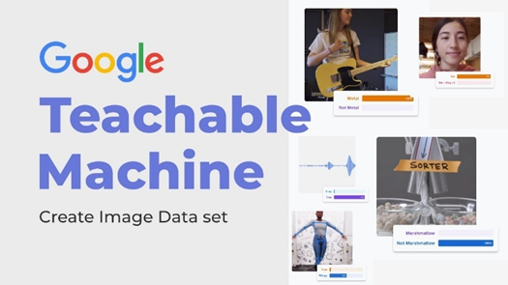
1. WHAT IT IS
Teachable Machine is a free tool developed by Google that allows anyone, including children from 7-8 years old, teenagers and teachers to create artificial intelligence models in a few minutes, without writing a single line of code (No-code)
It works with three types of input:
- Images (webcam or photos)
- Sounds (microphone)
- Poses (body posture by webcam)
It is especially suitable for STEAM (Science, Technology, Engineering, Arts and Mathematics) projects, as the teacher and students can train the computer to recognize gestures, objects, emotions, musical instruments or voice commands, and then export the model to platforms such as Scratch, PictoBlox, App Inventor, micro:bit or their own web pages.
2. HOW IT WORKS
1. Open your browser and go to: https://teachablemachine.withgoogle.com
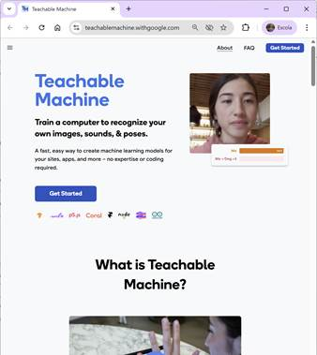
2. Choose the type of project, which are:
- Classify images
- Classify sounds
- Classify poses
Click "Get Started"
3. COMPLETE PRACTICAL EXAMPLE
STEAM Project 5th–9th grade: "My Bot of Likes and Dislikes"
Objective: Train an AI to recognize the Like 👍 and Dislike 👎 gesture and create an interaction in Pictoblox in which the character reacts to the image taken by the computer camera.
Step by step that the teacher can do with the students in the classroom
3.1 Create the classes
- Choose "Sort Images."
- Click on "Class 1" → change the name to "Like 👍".
- Click on "Class 2" → change the name to "Dislike 👎".
- (Optional) Class 3 → "Neutral" (closed hand or no gesture).
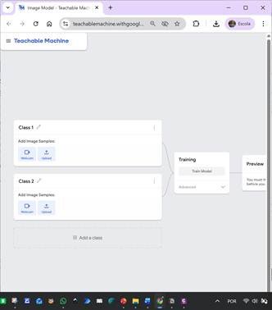
3.2 Registering the photos
- Click on "Webcam".
- Place your hand in front of the camera and make the gesture . 👍
- Hold down the "Hold to Record" button for 3-4 seconds (≈ 70-100 images).
- Repeat with the 👎 gesture.
- Each student in the duo/trio can record their own gestures (more diversity = more robust model).
- Tip: Also record with different light, different background and slight hand rotations.
3.3 Train the model
- Click the large "Train Model" button.
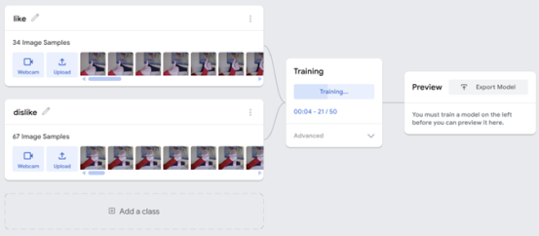
- In 10-15 seconds the model is ready.
3.4 Test the Model
- In the "Preview" section, make 👍 it and 👎 in front of the camera.
- Check the confidence percentage in real time.
- If you fail too much, add more samples and retrain.
3.5 Export the model created in TEACHABLE MACHINE to the Pictoblox program

- Click "Export Model".
- "Tensorflow.js" tab → "Upload (public or unlisted)".
- Copy or link that appears (ex: https://teachablemachine.withgoogle.com/models/abc123/).
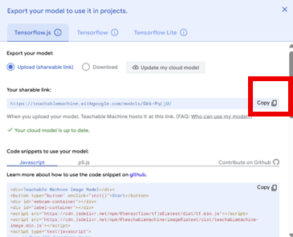
- Abra o Pictoblox
- Add the Machine Learning extension.
- Or directly use the "Teachable Machine" block from the official Champaign-Urbana extension: https://championteachablemachine.github.io/extension
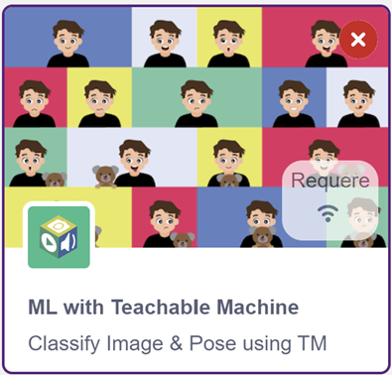
3.6 Programming code for Pictoblox
When green flag clicked
liga a webcam
forever
if (Teachable Machine class = "Like 👍") then
says [Like! ] for 2 seconds
if else (class = "Dislike 👎") then
says [DISLIKE... 😢 ] for 2 seconds
end
end
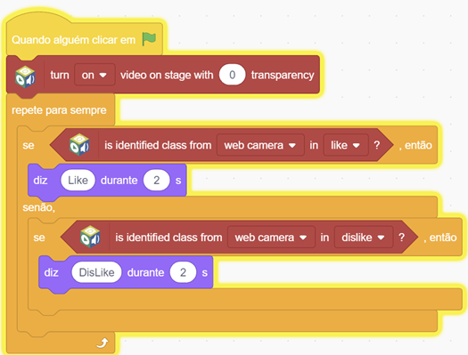

3.7 Running the Program
Press the green flag
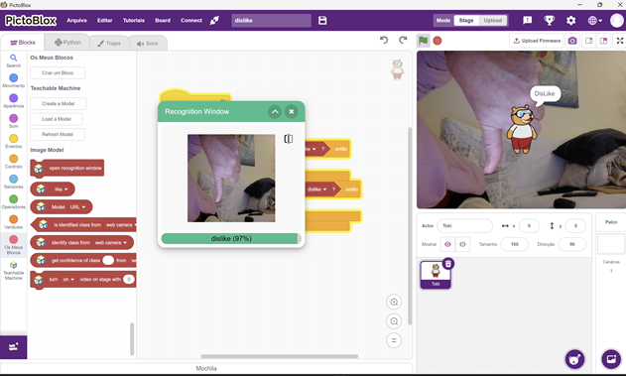

3.8 Project extension ideas (differentiation)
- Grade 5-6 → simple "Like/Dislike" game of healthy vs. unhealthy foods
- 7th-8th grade → a video game controller (Like = jump, Dislike = crouch)
- 9th grade or secondary → real-time opinion analysis in a presentation by colleagues (votes with gestures)
- Visual Education → recognize facial emotions (happy, sad, angry)
- Music → recognize clapping vs. snapping fingers to change instrument
- Physical Education → recognize correct exercise posture
4. PEDAGOGICAL ADVANTAGES
- Zero code to create AI works on any computer/tablet with camera and microphone
- Promotes computational thinking (model data → → testing → improvement)
- It demystifies the "black box" of AI: students see that the machine only learns from the examples they give
- Inclusive: works with sign language (Makaton, LGP) or voice commands for students with motor difficulties
- Completely free and no registration required
5. GOOD PRACTICE TIPS
- Always use many examples (minimum 50-70 per class) and varied.
- Train the model with multiple people to avoid bias.
- Test with people who did not participate in the training (generalization).
- Teach ethics: "AI only knows what we teach it – if we only put white faces, it doesn't recognize black faces."
- Save the link to the shared template to reuse in other years.
6. SUMMARY
With Teachable Machine, in less than one class, students go from being consumers to creators of artificial intelligence.
It is one of the simplest and most powerful ways to bring AI into the STEAM curriculum, arousing curiosity and critical thinking from 1st cycle to secondary school.

3.8 Ethical Considerations and Good Practice
While rich in potential, AI tools require responsible use. Teachers should maintain a critical stance, reflecting on:
- The security of the data used: avoiding the input of pupils’ personal information or sensitive data into platforms without adequate protection guarantees.
- Verification of the accuracy of generated responses: AI can produce factual errors that appear authoritative.
- Promoting pupils’ autonomy, ensuring that AI does not become a crutch or a source of ready-made answers.
- Respecting authorship and preventing plagiarism, particularly in written work produced with the help of AI.
Ethical reflection should accompany technical experimentation, as will be explored further in Chapter 2 of this book.

3.9 Teacher Training and Communities of Practice
For the use of AI to be truly transformative, it is essential to invest in the continuous professional development of teachers and to foster communities of practice.
Strategies such as:
- In-person workshops in schools with practical demonstrations;
- Free MOOCs (Coursera, edX, Udemy, FutureLearn) on AI and education;
- Sharing through educational social networks (such as Facebook groups, Reddit forums, LinkedIn communities);
- Group-based action-research projects centred on the practical use of tools; are fundamental to equipping teachers with confidence, critical thinking, and autonomy.
- AI, no matter how powerful, is only truly effective when integrated into a carefully considered, adapted, and reflective pedagogical approach by educators.

3.10 AI Tools
1. AI Tools for Content Creation
a) ChatGPT (OpenAI)
ChatGPT is one of the most powerful assistants for generating textual content. It can be used to:
- Create personalised lesson plans;
- Generate multiple-choice questions, quizzes, and adaptive tests;
- Simplify complex texts for pupils with comprehension difficulties;
- Draft emails, assessment rubrics, or pedagogical reports.
b) Canva with AI
Canva integrates AI tools such as Magic Write and Text to Image, which help to create:
- Interactive presentations;
- Visually appealing worksheets;
- Infographics, posters, and visual content for school displays or social media.
Practical example: A History teacher can use Canva to generate a visual timeline of the French Revolution with AI-generated images, incorporating QR codes linking to videos.
c) Khanmigo (Khan Academy)
Khanmigo is Khan Academy’s AI-powered educational assistant. It acts as a tutor for pupils and as an assistant for teachers:
- Suggests lesson plans based on the curriculum;
- Explains concepts step by step;
- Proposes differentiated activities according to difficulty level.
Practical example: A teacher can ask Khanmigo for suggestions for algebra reinforcement activities for pupils with specific difficulties.
2. Tools for Automated Assessment and Feedback
a) Gradescope (by Turnitin)
Gradescope uses AI to assist in marking written exams and assignments based on rubrics defined by the teacher:
- Detects patterns in responses;
- Provides consistent scoring;
- Enables instant and transparent feedback.
Practical example: A secondary school Mathematics teacher can scan exam papers and receive automatic marking along with suggestions for individual feedback.
b) EdPuzzle with AI
EdPuzzle allows teachers to embed questions into videos (for example, from YouTube) and now integrates AI to:
- Automatically generate questions based on the video;
- Provide detailed performance reports;
- Assess understanding of audiovisual content.
Practical example: After selecting a video on climate change, the tool automatically generates comprehension questions, and the teacher can view which pupils answered correctly.
c) Formative
This platform enables continuous assessment with real-time feedback, where AI suggests automatic improvements to assessment tools:
- Supports multiple response formats;
- Allows questions to be adapted according to pupils’ performance;
- Detects plagiarism or off-topic responses.
Practical example: During a language lesson, pupils write short responses about a text, and the AI suggests rewordings to improve clarity or accuracy.
3. Personal Assistants and Task Management Tools
a) Google Bard / Gemini
Google’s AI tool can be used for:
- Weekly lesson planning;
- Suggesting data-driven pedagogical strategies;
- Creating materials based on national or international curricula.
Practical example: A Geography teacher can ask Bard to organise weekly teaching content, with suggestions for visual resources and practical activities.

b) Notion AI
Notion is an organisational platform which, with integrated AI, allows users to:
- Create resource databases;
- Organise ideas for school projects;
- Generate meeting minutes or summarise academic articles.
Practical example: A department coordinator uses Notion AI to keep the annual plan up to date and to delegate tasks clearly to the teaching team.
c) Trello with AI (Planyway, Butler)
With the help of AI-based extensions, Trello enables teachers to:
- Automate recurring tasks;
- Create personalised school calendars;
- Visualise the progress of classes or working groups.
Practical example: A teacher managing a school club uses Trello with AI to organise the annual plan of extracurricular activities, notifying pupils and colleagues.
4. Personalisation and Inclusion with AI
a) Curipod
An AI-based platform for creating interactive lessons and inclusive presentations:
- Generates presentations based on a chosen topic;
- Suggests interactive activities (e.g. quizzes, debates);
- Adapts the level of complexity.
Practical example: A Citizenship teacher can create, in minutes, a presentation on the topic “Misinformation on social media”, with activities differentiated by reading level.
b) Scribbr / Grammarly / Quillbot
These linguistic AI tools help to:
- Improve written texts (for both pupils and teachers);
- Rewrite content for greater clarity;
- Ensure grammatical accuracy and linguistic appropriateness.
Practical example: A Year 13 pupil submits an essay and uses Grammarly to ensure linguistic accuracy. The teacher, in turn, might use Quillbot to simplify instructions before sharing them with the students.
c) Speechify / Read Aloud
These tools convert text into audio, making them very useful for pupils with reading difficulties, dyslexia, or to promote accessibility:
- Automatic reading of PDFs, web pages, or documents;
- Adjustable speed, intonation, and voice;
- Support for pupils with special educational needs.
Practical example: A teacher provides a supporting text in PDF format and recommends that pupils use Speechify to listen to it at home before the lesson.
5. Support for Programming and Computational Thinking
a) Scratch with AI (Extensions)
Scratch is already widely used to introduce programming in school contexts. With new extensions and APIs, it is now possible to:
- Simulate intelligent behaviours;
- Create educational games with adaptive logic;
- Work on concepts such as decision-making, repetition, and interaction.
Practical example: Pupils create a game where an avatar provides personalised hints based on the players’ responses.
b) Teachable Machine (Google)
An AI-based tool for creating image, sound, or pose recognition models without the need for coding:
- Train a model with real-time examples;
- Create educational applications with visual recognition;
- Develop interdisciplinary projects using AI.
Practical example: A Science teacher uses Teachable Machine to create a model that recognises the leaves of different plants for a botany project.
6. AI in Communication with Parents and Guardians
a) Educational Chatbots (e.g. Botsify, ChatCompose)
Teachers and schools can create personalised chatbots that:
- Answer frequently asked questions;
- Provide information about school events;
- Share report cards or personalised messages.
Practical example: The school leadership team uses a chatbot to answer questions about exam timetables, parent-teacher meetings, or school regulations.
b) Zoom with AI (Otter.ai, Fireflies)
The integration of AI with video conferencing platforms enables:
- Automatic transcription;
- Meeting summarisation;
- Real-time translation.
Practical example: During a meeting with parents from abroad, Zoom uses AI to translate the teacher’s speech into the parents’ native language.
7. Good Practice and Limitations in the Use of AI
Despite its transformative potential, it is essential that teachers follow sound ethical and pedagogical principles:
- Verification of information: AI tools can produce incorrect content ("hallucinations"). Always verify.
- Data privacy: Avoid using pupils’ names or sensitive data on unauthorised platforms.
- Transparency: Explain to pupils when and how AI is being used.
- Inclusion and accessibility: Ensure that the use of AI does not exclude pupils with lower digital skills or limited access to technology.
8. Strategies for Gradual Integration
Teachers who do not yet feel confident with AI can start with simple actions:
- Using Canva with AI to prepare presentations;
- Creating quizzes with automatic marking in Google Forms;
- Asking ChatGPT for activity suggestions;
- Using Notion to organise ideas and plans;
- Exploring Curipod for classroom activities.
The key is to start with something that offers a clear and tangible benefit, building motivation to explore further.

Final Considerations
The integration of AI tools into teaching practice is not a passing trend, but an irreversible step towards a more efficient, personalised, and pupil-centred education. However, technology only makes sense when it serves pedagogical principles and respects the dignity of all those involved in the educational process.
AI tools are transforming education not merely through innovation, but through their potential to democratise and personalise learning. Yet the true impact of these technologies depends on the teacher’s critical, ethical, and creative mediation. AI does not replace pedagogy; it enhances it.
In this chapter, we have shown how AI can support teachers across various aspects of their work — from planning to assessment, from resource creation to communication with the educational community. When used thoughtfully and creatively, AI can become a genuine “pedagogical superpower”.
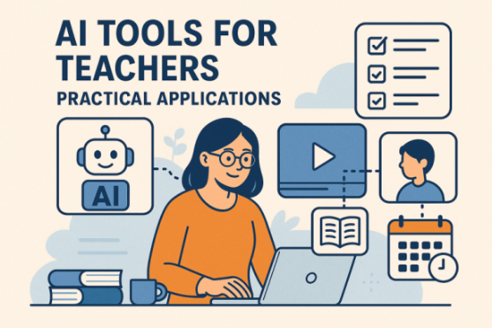
By adopting these tools consciously and aligning them with curricular objectives, we can foster a richer, more dynamic, and more inclusive education. In the chapters ahead, we will explore how this integration deepens — in personalised learning (Chapter 4), interactive activities (Chapter 5), assessment and feedback (Chapter 6), and even in the creation of new tools by both teachers and pupils (Chapter 7).
The AI-driven educational revolution has already begun — and teachers are at the heart of this transformation.

4. Personalized Learning With AI
Education is undergoing a digital transformation — and at the center of this revolution is Artificial Intelligence (AI). Among the most promising applications of AI in education is personalized learning, a method that tailors content, pace, and learning style to individual students’ needs. Unlike the traditional "one-size-fits-all" approach, AI enables a more responsive and adaptive learning experience, leading to better outcomes and greater engagement.

4.1 What Is Personalized Learning?
In today’s rapidly changing educational landscape, one term has gained significant attention among educators, policymakers, and parents alike: personalized learning. But what exactly does it mean, and why is it becoming so central to discussions about the future of education?
Understanding Personalized Learning
At its core, personalized learning is an educational approach designed to tailor learning experiences to the unique needs, skills, interests, and goals of each student. Rather than adopting a one-size-fits-all curriculum, personalized learning strives to ensure that every student progresses at their own pace, receives support tailored to their learning style, and engages with material in ways that resonate personally.
In other words, personalized learning shifts the focus from the standardized delivery of content to the individualized development of each learner.
Key Elements of Personalized Learning
While definitions vary, most personalized learning models share several common elements:
1. Student-Centered Learning Paths
Students often have some choice in how, when, and where they learn. This might involve selecting topics that interest them, choosing between different types of assignments, or setting their own learning goals.
2. Flexible Pacing
In a personalized learning environment, students move through material at a pace that suits them. Those who grasp concepts quickly can advance, while others may spend more time mastering challenging content without falling behind their peers.
3. Customized Content and Instruction
Teachers adapt resources and teaching strategies based on data about each student’s strengths, weaknesses, and preferences. Technology often plays a role in delivering differentiated content.
4. Frequent Assessment and Feedback
Ongoing assessments help monitor progress and inform adjustments to learning plans. Students receive timely feedback, empowering them to take an active role in their own learning journey.
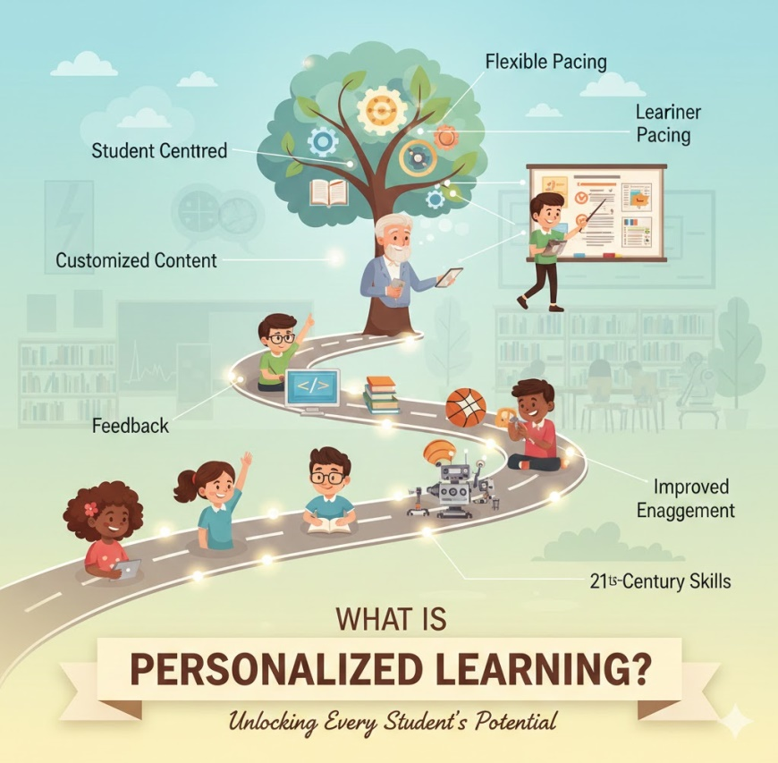
5. Learner Agency
Personalized learning encourages students to take ownership of their education, developing skills like goal-setting, self-monitoring, and self-reflection.
Benefits of Personalized Learning
Proponents of personalized learning highlight numerous potential benefits:
- Improved Engagement: Students are more motivated when learning aligns with their interests and abilities.
- Better Outcomes: Tailoring instruction can help close achievement gaps and support diverse learners.
- 21st-Century Skills: Personalized learning fosters critical thinking, problem-solving, and self-directed learning—skills crucial for success in modern society.
- Equity: When implemented thoughtfully, personalized learning can help ensure all students receive the support they need to thrive.
The Role of Technology
Technology is often a key enabler of personalized learning. Digital tools can help educators analyze data to identify student needs, deliver adaptive learning experiences, and provide interactive content that engages learners. However, experts caution that technology alone does not equal personalized learning—it’s simply one tool among many.
Challenges and Considerations
Despite its promise, personalized learning also faces challenges:
- Equity Concerns: Not all students have equal access to technology or supportive learning environments.
- Teacher Workload: Designing individualized learning plans can be time-consuming.
- Implementation: Schools may struggle with integrating personalized approaches into existing curricula and standardized testing systems.
Thus, while personalized learning offers exciting possibilities, its success depends on thoughtful planning, professional development, and a commitment to putting students’ needs first.
Looking Ahead
Personalized learning represents a significant shift in educational philosophy—from teaching a curriculum to teaching the individual. As research continues and technologies evolve, educators worldwide are exploring how to balance personalization with the demands of educational systems, aiming ultimately to create learning experiences that help every student reach their full potential.

4.2 How AI Enables Personalized Learning
Here are some keyways AI is transforming personalized education:
1. Adaptive Learning Systems
AI-driven adaptive learning platforms analyze how a student interacts with educational content. For example, if a student struggles with a math concept, the system can automatically provide extra practice problems, alternative explanations, or different teaching methods until the student masters the skill.
These platforms adjust in real-time, ensuring that learners don’t get stuck or bored and can move ahead when ready.
2. Personalized Recommendations
Similar to how streaming services suggest shows you might like, AI can recommend learning resources tailored to each student. Whether it’s videos, interactive exercises, readings, or games, AI curates materials that fit individual learning paths and interests.
3. Data-Driven Insights for Teachers
Teachers gain valuable insights from AI systems that analyze data from assessments, assignments, and classroom interactions. These insights help educators identify:
- Students at risk of falling behind
- Specific topics that need reteaching
- Opportunities to challenge advanced learners
This empowers teachers to focus their efforts where they’re most needed.
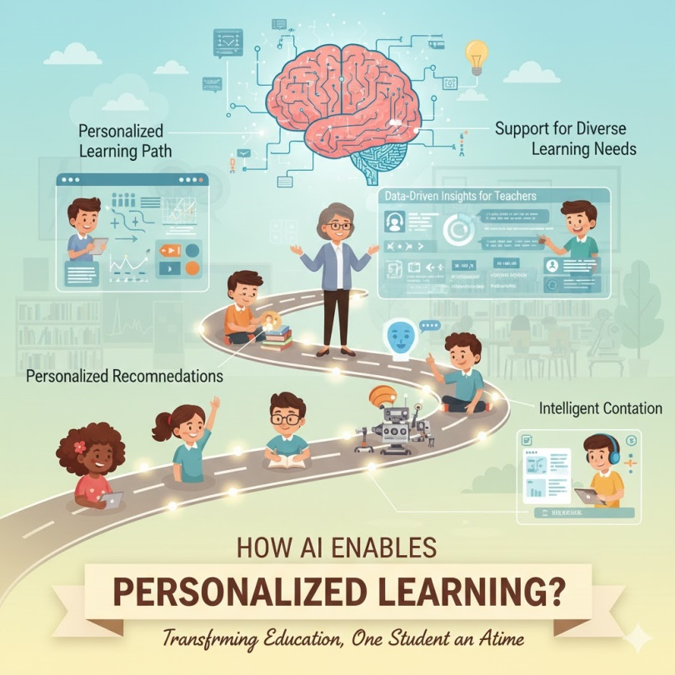
4. Natural Language Processing (NLP)
AI’s language processing abilities enable tools like chatbots and virtual tutors to interact with students in human-like conversations. For instance, an AI tutor can answer questions, provide explanations, or guide students through problem-solving steps, offering instant support outside traditional class hours.
5. Intelligent Content Creation
AI can help generate new learning materials, including quizzes, summaries, or interactive simulations tailored to a student’s level. For example, AI might simplify complex text for younger readers or generate practice questions based on classroom content.
6. Support for Diverse Learning Needs
AI tools can help accommodate diverse learners, including students with disabilities. Text-to-speech, speech-to-text, translation services, and adaptive interfaces make learning more accessible for everyone.
Real-World Examples
- Duolingo: The popular language learning app uses AI to adapt lessons to each learner’s progress, helping users focus on the words and skills they struggle with most.
- DreamBox Learning: This math platform adjusts the difficulty and style of math lessons in real-time, ensuring personalized support for every student.
- Knewton (now part of Wiley): An adaptive learning platform that tailors educational content based on individual learning patterns.

4.3 Benefits of AI-Driven Personalized Learning
Artificial Intelligence (AI) is rapidly transforming the way education is delivered, and one of its most significant impacts is in enabling personalized learning experiences for students. Unlike traditional teaching methods that often follow a one-size-fits-all approach, AI-driven personalized learning adapts instruction to fit the unique needs, abilities, and interests of each learner. This brings a range of important benefits for students, teachers, and the education system as a whole.
• Tailored Learning Paths
One of the most significant advantages of AI-driven personalized learning is its ability to create tailored learning paths for each student. AI systems can analyze data from quizzes, assignments, and interactions with educational platforms to understand a student’s strengths and areas that need improvement. Based on this data, the system can adjust the difficulty level of content, recommend additional resources, or present concepts in different ways to enhance understanding. This ensures that learners are neither bored with material that’s too easy nor overwhelmed by content that’s too advanced.
• Increased Student Engagement
When learning content aligns with a student’s interests and learning style, they are far more likely to stay engaged and motivated. AI can suggest topics, videos, articles, or interactive exercises that match a student’s preferences. This personalized approach makes learning more relevant and enjoyable, fostering curiosity and a love for learning that can last a lifetime.
• Timely Feedback and Support
AI-powered platforms can provide immediate feedback on student work, helping learners identify mistakes and correct them in real-time. Unlike traditional classrooms, where feedback may be delayed due to teacher workload, AI offers constant guidance and support. For example, an AI tutor can explain a math problem step-by-step or clarify a confusing concept as soon as a student encounters difficulty. This instant assistance helps prevent frustration and encourages continuous progress.
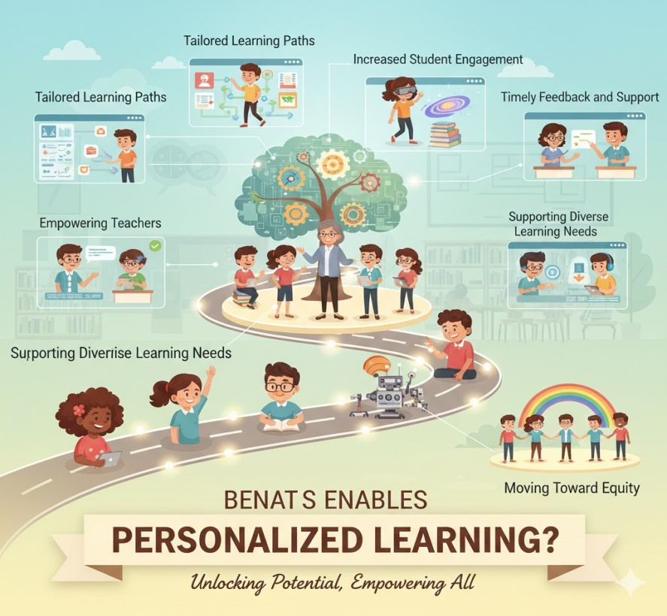
• Empowering Teachers
Rather than replacing teachers, AI acts as a powerful assistant. Educators receive valuable insights into student performance through detailed reports and analytics generated by AI systems. These insights help teachers identify students who are struggling, detect learning gaps, and understand which teaching methods are most effective. As a result, teachers can focus their time and energy on providing personalized support and building meaningful relationships with their students.
• Supporting Diverse Learning Needs
AI-driven personalized learning is particularly beneficial for students with diverse learning needs. For instance, AI tools can offer text-to-speech features for students with reading difficulties, translate content for English language learners, or adjust lesson formats for students with attention challenges. This adaptability ensures that all learners have access to educational content in a way that works best for them, promoting inclusivity and equity in education.
• Efficient Use of Learning Time
By customizing the learning experience, AI helps students use their time more efficiently. Learners can skip over material they already understand and spend more time on challenging concepts. This focused approach enables faster progress and reduces the frustration often associated with traditional, uniform teaching methods.
• Scalability and Access
One of the challenges of personalized learning is the time and effort it demands from teachers, especially in large classrooms. AI makes it possible to scale personalized learning across many students without overwhelming educators. Even in resource-constrained schools, AI tools can help deliver high-quality, individualized instruction, making personalized learning more accessible than ever before.
• Fostering Lifelong Learning Skills
AI-driven personalized learning encourages students to take ownership of their education. By engaging with adaptive learning systems, setting their own goals, and receiving tailored feedback, students develop critical skills such as self-direction, problem-solving, and resilience—skills that are essential for success in both academic and professional environments.
• Moving Toward Equity
Perhaps one of the most powerful benefits of AI-driven personalized learning is its potential to reduce educational inequalities. By identifying and addressing individual learning gaps early, AI can help prevent students from falling behind, regardless of their background or starting point. This creates a more level playing field where every student has a fair chance to succeed.

4.4 Challenges and Considerations of Personalized Learning
While personalized learning holds great promise for transforming education, it also comes with significant challenges and considerations. Schools, teachers, and policymakers must carefully navigate these issues to ensure that personalized learning is effective, fair, and sustainable.
• Equity and Access
One of the biggest challenges is ensuring equitable access to personalized learning tools and resources. Many personalized learning models rely on technology, but not all students have reliable internet access or devices at home. This “digital divide” can widen existing educational gaps if not addressed through proper planning and support.
• Data Privacy and Security
Personalized learning systems collect large amounts of student data, including performance records, learning behaviors, and personal information. Protecting this data is critical. Schools and edtech companies must ensure strong data privacy policies, comply with laws like GDPR or FERPA, and maintain transparency about how student data is used.
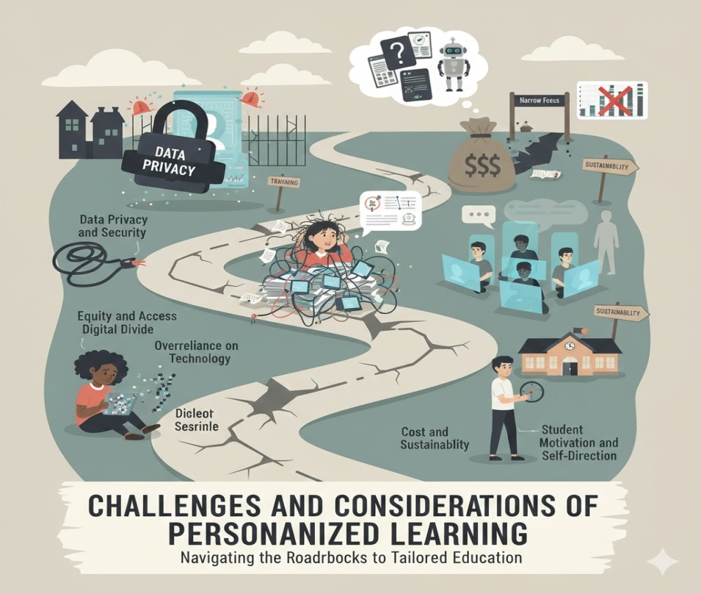
• Teacher Workload and Training
Personalized learning often requires teachers to design individual learning paths, analyze data, and adapt instruction continuously. This can significantly increase teacher workload. Additionally, educators need proper training to effectively use new technologies and interpret data insights. Without adequate support, teachers may feel overwhelmed or resistant to adopting personalized approaches.
• Overreliance on Technology
Technology is a powerful enabler of personalized learning, but it is not a replacement for human connection and good teaching. Overreliance on digital platforms can reduce opportunities for social interaction, discussion, and collaborative learning, which are essential for developing communication skills and critical thinking.
• Quality and Effectiveness of Tools
Not all personalized learning tools are created equal. Some may lack high-quality content, evidence-based instructional design, or proper alignment with curriculum standards. Schools must carefully evaluate edtech products to ensure they truly support learning rather than simply offering flashy features.
• Cost and Sustainability
Implementing personalized learning can be expensive, requiring investments in technology infrastructure, software licenses, professional development, and ongoing maintenance. Schools must consider whether these costs are sustainable in the long term, especially in districts with limited budgets.
• Student Motivation and Self-Direction
While personalized learning empowers students to take charge of their education, not every student is naturally self-directed. Some may struggle with time management, setting goals, or staying motivated without more structured guidance. Personalized learning models should balance independence with appropriate support and oversight.
• Risk of Narrow Focus
Personalization can sometimes lead to a narrow focus on individual preferences, potentially limiting students’ exposure to new ideas and experiences outside their comfort zones. Education should still challenge learners to explore unfamiliar topics and develop broad knowledge and skills.
• Measurement and Accountability
Traditional education systems often rely on standardized tests to measure progress, which may not fully align with personalized learning approaches. Schools face the challenge of assessing individualized progress in ways that are fair, consistent, and meaningful for all students.
In summary, personalized learning offers many benefits, but it is not without significant challenges. Successful implementation requires thoughtful planning, strong support for teachers and students, careful attention to equity and privacy, and a balanced approach that combines technology with human interaction. By addressing these considerations, educators can harness the full potential of personalized learning to create engaging and effective learning experiences for every student

4.5 The Future of Personalized Learning
Education is at a crossroads, driven by rapid technological advances, shifting social needs, and a deeper understanding of how people learn. As these forces converge, personalized learning is poised to play an even more significant role in shaping the classrooms of tomorrow. But what might the future of personalized learning look like, and how can it best serve students, teachers, and society as a whole?
Greater Use of Artificial Intelligence
Artificial intelligence (AI) will be central to the next wave of personalized learning. Future AI systems will become even more sophisticated at analyzing learning data, understanding student emotions and engagement, and adjusting content in real time. Instead of merely recommending resources, AI could offer interactive, conversational learning experiences tailored to each student’s needs and preferences.
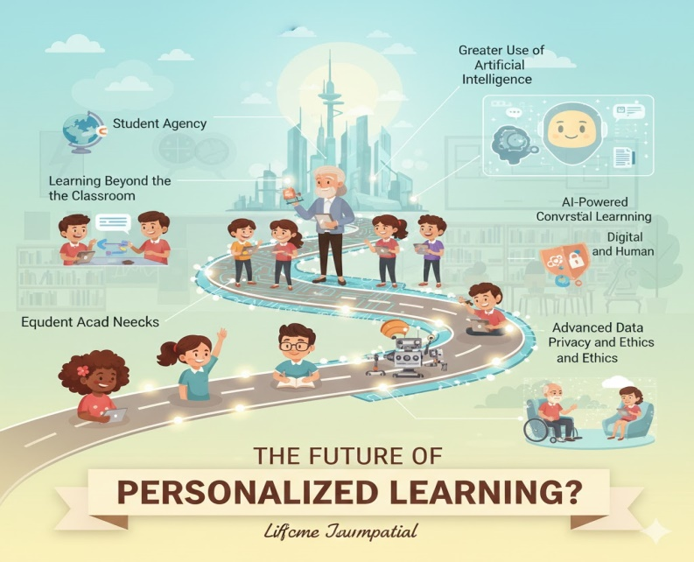
Integration Across Subjects and Skills
Today, personalized learning tools often focus on core subjects like math and reading. In the future, we can expect broader integration across a wide range of subjects, including the arts, sciences, social-emotional learning, and life skills. Personalized learning will help students develop not only academic knowledge but also creativity, problem-solving, collaboration, and adaptability.
Blending Digital and Human Interaction
Technology will remain important, but the future of personalized learning will not be purely digital. The human connection between teachers and students will remain essential. Educators will increasingly act as mentors, coaches, and facilitators who guide students through personalized pathways, combining digital tools with meaningful, face-to-face support and relationship-building.
Learning Beyond the Classroom
Personalized learning will extend far beyond traditional classrooms. Learning platforms will connect students with global resources, virtual field trips, industry experts, and collaborative projects with peers worldwide. Students will have more opportunities to learn anytime, anywhere, turning the entire world into a classroom.
Emphasis on Student Agency
Future personalized learning models will emphasize student agency—giving learners more voice and choice in their education. Students will be encouraged to set their own goals, pursue individual interests, and reflect on their progress, becoming active participants rather than passive recipients of knowledge.
Advanced Data Privacy and Ethics
As personalized learning becomes more data-driven, protecting student privacy will be paramount. The future will bring stricter ethical standards and innovative technologies to safeguard personal data while still allowing for meaningful personalization.
Equity and Inclusion
A key priority for the future will be ensuring personalized learning benefits all students, regardless of background or resources. Efforts will focus on closing the digital divide, providing accessible technology, and designing inclusive learning tools that support diverse needs, cultures, and languages.
Measuring Personalized Progress
Traditional assessments may no longer suffice in a highly personalized system. The future will bring new ways of measuring learning progress—such as performance-based assessments, digital portfolios, and real-time analytics—that capture individual growth rather than standardized benchmarks alone.
Lifelong Learning
Personalized learning won’t stop at school graduation. As careers and skills evolve rapidly, people of all ages will rely on personalized learning platforms to reskill, upskill, and explore new interests. The future promises lifelong learning pathways tailored to individuals’ personal and professional goals.

Conclusion
AI is not just enhancing how students learn — it is redefining the learning experience itself. Personalized learning with AI turns education into a responsive, engaging, and individualized journey. From smart tutors to adaptive lessons and predictive analytics, AI is making education more human by treating each learner as unique.
As schools, educators, and edtech companies continue to innovate, AI will play a crucial role in shaping a more inclusive, effective, and personalized future of learning.

5. Interactive classroom activities with AI

5.1 Introduction
The digital transformation of education is gaining new momentum with the introduction of Artificial Intelligence (AI) in the classroom. Among the many contributions of AI to education, one of the most notable is its potential to foster interactive activities that enhance student engagement, personalise learning, and improve pedagogical effectiveness. In this chapter, we explore how teachers can use AI tools to create interactive, motivating, and learner-centred activities, transforming the classroom into a more participatory and student-focused environment.

5.2 The Interactive Potential of AI
Interactive activities involving AI go far beyond the mere use of screens or cutting-edge technology. True interactivity happens when the student is no longer a passive recipient of knowledge, but actively engages with the content, with peers, and with the teacher. AI enhances this capability through algorithms that respond to students' actions, providing personalised feedback, suggestions, appropriately levelled challenges, and opportunities for collaboration.
Well-integrated AI tools enable educational experiences in which students can:
- Solve problems in real time with immediate feedback.
- Engage in conversations with virtual assistants on curriculum topics.
- Explore content through games, simulations, or adaptive storytelling.
- Learn collaboratively based on analysis of their performance.

5.3 Types of Interactive Activities with AI
1. Adaptive Quizzes and Games with Real-Time Feedback
Platforms such as Kahoot, Quizizz, Edpuzzle, and Socrative have begun to incorporate AI mechanisms that adapt content according to students’ performance. AI enables:
- Adjusting the difficulty level of questions.
- Suggesting new topics based on mistakes made.
- Providing personalised explanations after incorrect answers.
These activities can be used to introduce new content, review material, or consolidate learning prior to formal assessments.
Practical example: In a Natural Sciences lesson, the teacher creates a quiz with questions about the respiratory system. The AI detects that some students are struggling with the function of the pulmonary alveoli and presents short videos or simulations on that topic specifically for those students.
Create Kahoot Quizzes Automatically with AI 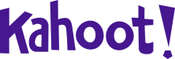
ChatGPT can generate the questionnaire in a format that Kahoot directly recognizes for the free version.
In the example below, the topic of the questions is indicated directly in the prompt, but you can also send a file (PDF, Word, PowerPoint, etc.) with the study material for ChatGPT to create the questions based on that content.
Step 1- Template prompt (to copy and adapt):
I want to create a Kahoot quiz on the topic: Photosynthesis,
for 8th grade students.Use the Kahoot Excel import model with the following columns,
exactly in this order:
Question
Answer 1
Answer 2
Answer 3
Answer 4
Time limit (20)
Correct answer(s)
Rules for the questions:
- Create 20 questions in total.
- Mix multiple-choice questions (4 options) with True/False questions.
- Difficulty level: medium.
- The questions must be suitable for 8th grade students.
- Each question must have less than 120 characters.
- Each answer must have less than 75 characters.
- For True/False questions use only:
- Answer 1: True
- Answer 2: False
- Answer 3: (leave empty)
- Answer 4: (leave empty)
- Always set 20 seconds in the "Time limit (20)" field.
- In “Correct answer(s)” indicate the number of the correct option (1, 2, 3 or 4).
First:
1) Show the data in table format with the indicated columns.
Then:
2) Create an .XLSX file with these questions, with:
- the first row as a header with the exact column names,
- one question per row.
3) Provide the .XLSX file so I can download it and import it directly into Kahoot.
Step 2 - Generate The Quiz
- Paste the prompt into ChatGPT
- Press Enter
- Wait for the table and file to be generated
Step 3 – Download the Excel File
- Click on the provided .xlsx file
- Save it to your computer
Step 4 – Import Into Kahoot
- Go to kahoot.com
- Log in
- Click Create - Kahhot
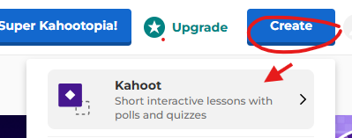
- Choose Blank Canvas
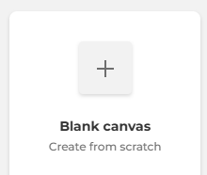
- Select Add - Import - Import Spreadsheet
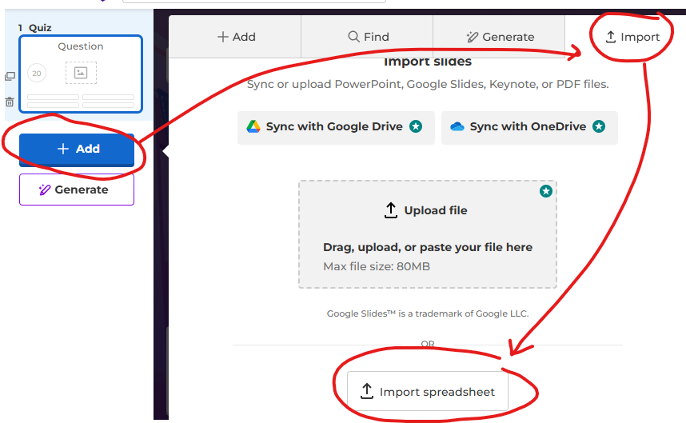
- Select the Excel file - Upload

- Select Add questions and Success!
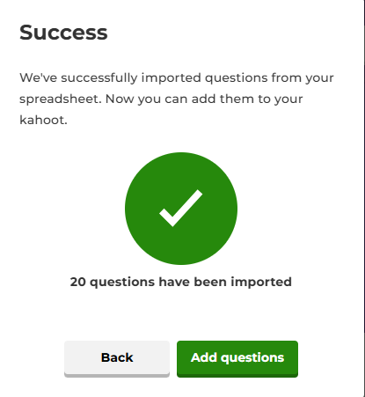
Final Note
Always review the questions and answers before using them with students.
2. Simulations and Virtual Labs with AI
Tools such as Labster, PhET, and PraxiLabs offer virtual or augmented reality simulations, enabling students to carry out scientific experiments in a safe and interactive way. AI monitors students’ actions, suggests corrections, and adapts the challenges according to their progress.
Benefits:
- Eliminates the physical risks associated with experiments.
- Allows activities to be repeated as many times as needed.
- Encourages discovery-based learning.
Practical example: In a Physics lesson, students use a simulation to investigate Ohm’s Law. The AI monitors the values used in the virtual experiments and suggests adjustments to help students better understand the relationship between voltage, current, and resistance.
3. Educational Chatbots and Virtual Assistants
Educational chatbots such as ChatGPT, Khanmigo (from Khan Academy), or customised bots created with Dialogflow or Microsoft Power Virtual Agents, allow students to interact with virtual characters or tutors on curriculum content.
Typical features:
- Step-by-step explanations of complex concepts.
- Immediate answers to questions.
- Suggestions for additional resources or exercises.
Practical example: In Foreign Languages, students interact with a chatbot in English that asks them questions on the topic of “Daily Routines”. The bot corrects grammatical and vocabulary errors, adapting to each student’s level of fluency.
4. Interactive Storytelling with AI
Interactive storytelling is a powerful strategy for engaging students, particularly in primary education. Tools such as Storybird, Twine, or Narrative AI use AI to create branching stories where students’ choices influence the course of the narrative.
Educational objectives:
- Develop critical thinking and creativity.
- Improve written and oral expression.
- Stimulate reading comprehension through dynamic stories.
Practical example: In a History lesson, students choose to represent different characters during the French Revolution and, with the support of AI, make decisions that shape historical events in an interactive way, leading to a deeper understanding of the causes and consequences of each action.

5. Block-Based Programming Activities with AI
Tools such as Scratch, Machine Learning for Kids, or Teachable Machine allow students to programme simple applications, games, or AI models without the need for advanced coding skills.
Educational benefits:
- Promotes computational thinking.
- Develops STEM skills (Science, Technology, Engineering, and Mathematics).
- Encourages problem-solving.
Practical example: Lower secondary students use Teachable Machine to train a model that recognises facial gestures. They then integrate it into an educational game that responds to facial expressions such as smiling or frowning.

5.4 Strategies for Implementing AI Activities in the Classroom
To make the most of AI tools, it is important for teachers to adopt a structured pedagogical approach. Here are a few suggestions:
1. Start with Clear Objectives
The use of AI should serve a clear educational purpose. The teacher should define:
- What they want students to learn or practise.
- How AI can support this process.
- How learning will be assessed.
2. Select Accessible Tools
Not all schools have advanced technological infrastructure. Web-based, free tools that are compatible with mobile devices help to promote digital inclusion.
Tip: Create a repository of AI tools tested by the teaching team, with tutorials and suggestions for use by subject area.
3. Ensure Inclusion and Diversity
AI can support inclusion, but it may also create inequalities if not used sensitively. Some measures include:
- Ensuring that all students have access to devices.
- Adapting activities to meet special educational needs.
- Promoting collaboration rather than focusing solely on individual performance.
4. Encourage Co-Creation with Students
Student engagement increases when they are involved in creating their own activities. Teachers can invite students to:
- Create quizzes for their classmates.
- Programme a chatbot to explain a topic.
- Develop an interactive story as a group.
5. Use Formative Assessment
AI can provide a wealth of data on student progress, but the focus should remain on learning, not simply on performance. The teacher can:
- Analyse reports generated by the platforms.
- Use the most common mistakes as a starting point for review.
- Ask students to self-assess their interactive experience.

5.5 The use of robots MBOT
Educational robotics has become a powerful ally in promoting computational thinking, problem-solving and creativity in the classroom. Among the available tools, the mBot robot stands out as an accessible and versatile resource that allows students to engage with programming in a tangible and meaningful way. By combining sensors, motors and visual programming environments, mBot helps learners understand abstract coding concepts through hands-on experimentation, immediate feedback and real-world challenges, making programming more approachable for beginners.
When integrated with digital tools supported by artificial intelligence, mBot can further enrich learning experiences by encouraging adaptive problem-solving, data-driven decision-making and reflective learning processes. Students can design, test and refine programs while interacting with intelligent systems that support debugging, personalization and inquiry. In this way, mBot not only introduces the foundations of programming but also fosters essential 21st-century skills, bridging the gap between coding, robotics and AI-enhanced learning in an engaging and pedagogically meaningful manner.
The mBot robot can be programmed using the mBlock web-based platform (https://ide.mblock.cc/), an intuitive environment that allows students to learn programming through visual, block-based coding. By dragging and connecting blocks, learners can control the robot’s movements, sensors and behaviours, making abstract programming concepts such as sequencing, loops and conditionals easier to understand. The platform also supports a gradual transition to text-based coding (such as Python), enabling differentiated learning and progression over time. Using mBlock with mBot helps students develop computational thinking, problem-solving skills and creativity through hands-on, meaningful interaction with technology.
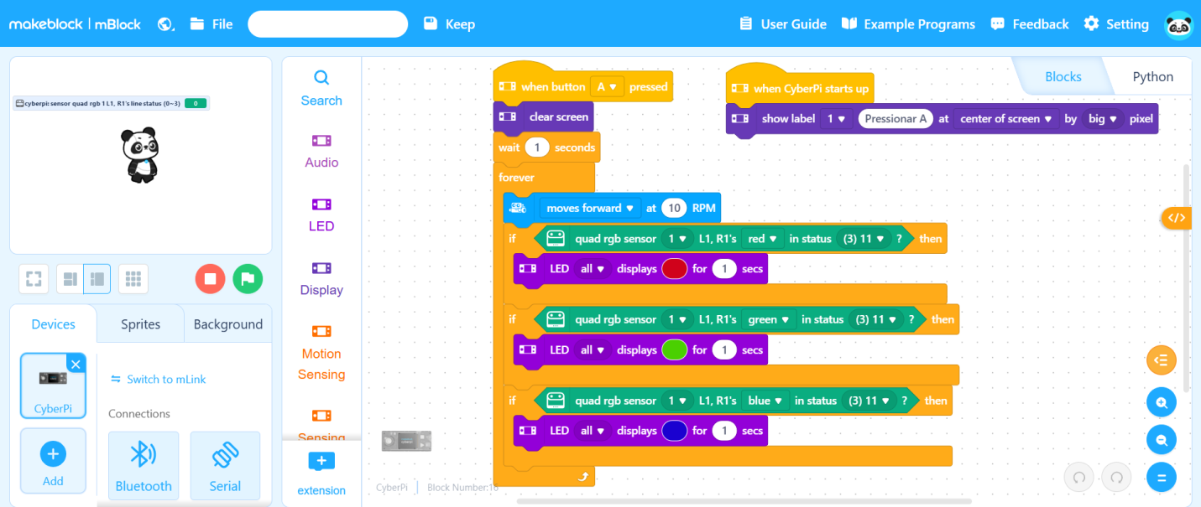
Programming environment for the MBot 2 robot in the mBlock application.
Teachers can challenge students to program the robot to solve a maze without touching any objects.
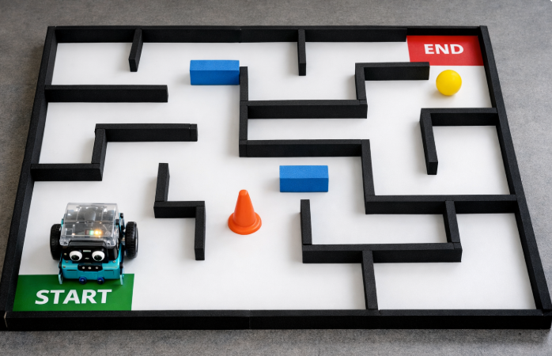
Example of a maze
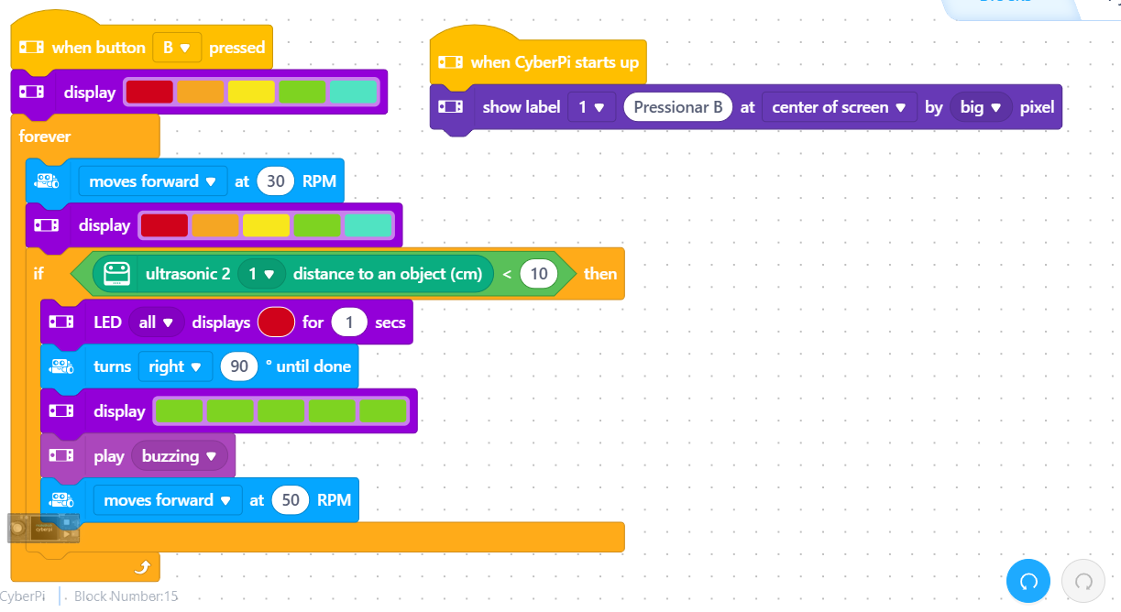
The code in mblock.
Using educational robots and programming platforms such as mBlock in the classroom is highly valuable for teachers, as it promotes active, hands-on learning and helps students develop essential 21st-century skills. Through robotics and block-based programming, learners engage in problem solving, logical reasoning, creativity and collaboration, while making abstract concepts more concrete and meaningful. The mBlock environment is particularly accessible, allowing teachers to introduce programming in an intuitive and motivating way, even with younger students or beginners. By integrating robots into their teaching practices, teachers can foster computational thinking, support interdisciplinary learning, and encourage students to learn through experimentation, error and reflection, creating more dynamic, inclusive and engaging learning experiences.

5.6 Challenges and Considerations in Using AI for Interactive Activities
Although promising, the use of AI in the classroom requires careful attention to certain risks and limitations:
1. Technological Dependence
There is a risk that students may become overly reliant on automated tools to think or solve problems. The teacher’s role is to ensure a balance between the use of AI and the development of independent thinking.
2. Quality and Reliability of Responses
Some generative AI tools still produce factual errors. Therefore, students should be guided to verify sources and maintain a critical mindset.
Solution: Incorporate digital literacy and critical thinking as an integral part of AI-based activities.
3. Privacy and Data Protection
Many AI tools collect user data. Teachers should:
- Use platforms with clear privacy policies.
- Obtain consent from parents or guardians where necessary.
- Avoid sharing sensitive data.

5.7 Success Stories and Best Practices
Case 1: Primary School Using Interactive Storytelling
At a primary school in Portugal, Portuguese and History teachers collaborated on an interactive storytelling project supported by AI. Students created stories based on historical events, with branching narratives, and shared them with other classes. Student engagement increased significantly, along with their understanding of the content.
Case 2: Biology Lesson with Disease Simulation
At a secondary school, a Biology teacher used an AI tool to simulate the progression of infectious diseases in a controlled environment. Students tested variables such as vaccination, social distancing, and mutations. The activity sparked debate and interest, with many students independently researching topics related to epidemiology.
Case 3: Chatbot as a Virtual Maths Tutor
A school cluster used a chatbot developed with Dialogflow to answer lower secondary students’ questions in Mathematics. The bot provided explanations of concepts, guided students through exercises, and suggested videos and summaries. Teachers used the generated reports to adjust their pedagogical strategies.

Final Considerations
Interactive activities with AI represent a golden opportunity to revitalize classroom dynamics, placing students at the center of the learning process. Far from replacing the teacher, AI serves as a pedagogical partner that enables a greater variety of strategies, adaptive content, and a more engaging and effective educational experience.
To achieve this, it is essential that teachers:
- Are trained in the pedagogical use of AI.
- Experiment with, adapt, and evaluate the tools.
- Share good practices and work collaboratively.
The school of the future will increasingly be a hybrid space, where technology and pedagogy work hand in hand to develop critical, creative citizens who are prepared for the challenges of the 21st century. And the teacher’s role, as a mediator of learning, will be more relevant than ever.

6. AI in Student Assessment and Feedback
Introduction: A new paradigm in assessment and the redefined role of the teacher
The entry of artificial intelligence (AI) into education is not just the introduction of another technological tool; it is a catalyst that forces us to re-evaluate the very foundations and principles of assessment. Artificial intelligence does not replace the teacher but fundamentally transforms their role. From the position of the primary provider of information and the final arbiter of assessment, the teacher moves into the role of an architect of educational experiences, a mentor, and an ethical guide in an increasingly complex digital world.
This chapter deals with the use of AI in assessment and providing feedback, drawing on a humanistic approach also emphasized by international organizations like UNESCO. The goal is for technology to serve to enhance human capabilities, support autonomy and critical thinking, and not to replace or weaken them. AI must contribute to fair, inclusive, and equitable education for all.
The current situation is defined by a fundamental tension. On one hand, AI offers enormous potential for efficiency and personalization that we could only dream of in the past. It allows for the automation of routine tasks, providing instant feedback, and creating individualized learning paths for each student. On the other hand, it brings serious pedagogical and ethical challenges. These include new forms of academic dishonesty, the risk of eroding key cognitive skills, and the threat of systemic discrimination through algorithmic bias.
The main task of the modern educator is thus not just to passively accept new tools, but to actively and consciously navigate this tension. The advent of generative AI, such as ChatGPT, changes the dynamics of the relationship between the teacher, the student, and technology. AI is no longer just a fast calculator for grading tests; it is becoming a partner capable of conducting dialogue, generating content, and analyzing arguments. This shift requires a fundamental change in approach - from assessing finished products to assessing the thinking process and teaching students how to work with this new technological "partner" effectively, critically, and ethically. This chapter serves as a guide for teachers on how to maximize the benefits of AI while consciously and actively minimizing its risks.

6.1 The potential of artificial intelligence to transform assessment
The integration of artificial intelligence into assessment processes opens the door to fundamental changes that can increase the efficiency, fairness, and personalization of education. The potential of AI lies in three key areas: automation, which frees up teachers' time; personalization, which adapts feedback to the needs of the individual; and data analysis, which provides valuable information for improving instruction itself.
Automation and efficiency: More time for what matters
One of the most immediate and visible benefits of AI in assessment is the ability to automate routine and time-consuming tasks. Teachers spend a significant portion of their working time correcting tests, checking homework, and grading written assignments. AI can significantly streamline these processes. Tools like Google Forms with integrated AI extensions can automatically grade tests with closed-ended questions, giving the teacher an immediate overview of the class's results. Applications like Grammarly or LanguageTool can provide students with instant feedback on the grammatical and stylistic correctness of their texts, thus relieving the teacher of correcting basic errors.
The initial benefit of "time-saving" is obvious, but the deeper meaning lies in how this saved time is reinvested. The goal is not to work less, but to work differently and more meaningfully. The time a teacher would have spent grading multiple-choice tests can be strategically invested in activities that AI cannot replace. These include conducting an empathetic conversation with a student struggling with the material, moderating a complex class discussion, providing nuanced feedback on a creative project, or simply giving more individual attention to those who need it most. Automation is thus not an end in itself, but a means to strengthen the irreplaceable human dimension in teaching.
Personalization in practice: Immediate and targeted feedback
The traditional assessment model is often based on a "one-size-fits-all" approach, where all students receive the same tasks and are assessed by the same criteria at the same time. AI allows for a transition to a truly individualized approach. Modern educational platforms can analyze each student's performance, identify their strengths and weaknesses, and adapt further content and tasks accordingly.
Platforms like Century Tech or Cognii use algorithms to provide the student with personalized recommendations and real-time feedback, adapting learning to their individual pace. If the system detects that a student is having trouble with a specific mathematical concept, it can automatically offer an additional explanation, a video, or an exercise focused precisely on that area. Conversely, for a student who masters the material without problems, the system can assign a more challenging task to deepen their knowledge.
This approach goes beyond the traditional differentiation that teachers have always tried to apply, but which was extremely difficult in practice with a larger number of students in the classroom. AI offers the possibility of scalable individualization. Virtual assistants and chatbots are also available 24/7, meaning a student can get help or an answer to their question at any time, even outside of school hours. This personalized approach is particularly beneficial for students with special educational needs, for whom AI can provide adaptive tools and targeted support tailored to their needs.
Using data to support learning (Learning analytics)
In addition to assessing individual students, AI can also analyze aggregated data on the performance of an entire class or school. These analyses, known as learning analytics, provide teachers with a valuable diagnostic tool for reflection and improvement of their own teaching.
For example, if an AI testing tool shows that 80% of students in a class made a mistake on the same question concerning a specific chemical formula, it is not just a signal of the students' lack of knowledge. It is, above all, valuable information for the teacher that their original explanation of this concept may not have been clear or illustrative enough. Based on this data, the teacher can adapt subsequent lessons, choose a different teaching approach, or focus on reviewing problematic topics.
In this way, the role of the teacher also changes. From the position of an external evaluator who assigns grades, they become a data-informed diagnostician of the entire educational process. AI provides them with evidence on which they can make better pedagogical decisions. However, using this data also requires new competencies from teachers, especially basic data literacy and the ability to correctly interpret the pedagogical data that the systems provide.

6.2 A practical guide to tools and strategies for teachers
Moving from theory to practice requires knowledge of specific tools and strategies that teachers can realistically use in their work. This section offers an overview of available technologies and suggests specific methods for integrating AI into formative assessment and adapting assignments to the new reality.
Overview of key tools for assessment and feedback
There is a wide range of tools on the market with different focuses. For better orientation, they can be divided into several categories:
- Automated assessment tools: These include platforms like Quizizz and Kahoot!, which allow for the creation of interactive quizzes with immediate evaluation. More advanced systems like Gradescope can assess not only tests with closed-ended questions but also more complex tasks, such as mathematical calculations or short written answers, with AI intelligently grouping similar answers for faster correction by the teacher. Even common Google Forms can be turned into a powerful tool for automatic assessment with the help of AI extensions.
- Feedback tools for written expression: Applications like Grammarly or LanguageTool provide instant feedback on grammar, style, and punctuation in Slovak and foreign languages. Students can use them to check their work before submission.
- Originality and AI detection tools: Platforms like Turnitin are known for their ability to compare student work with an extensive database of sources and detect plagiarism. Newer versions also try to detect text generated by artificial intelligence, but it is important to approach their results with great caution, as their reliability is often low.
- Comprehensive educational platforms: Some systems, such as Century Tech or SchoolHub.ai, offer integrated solutions that combine content creation, personalized learning, automated assessment, and data analysis for teachers on a single platform.
The following table provides an overview of selected tools with specific examples of their use.
Tool | Main Functions | Subject Suitability | Example of Use in the Classroom | Important Notes (GDPR, language, accuracy)
ChatGPT/Gemini | Text generation, summarization, question creation, dialogue simulation. | All subjects, especially languages, social sciences, ethics. | The teacher gives a prompt: "Create 3 different scenarios on the topic of cyberbullying for a discussion in ethics class." | Generates convincing but not always factually correct text. Requires verification. Consider GDPR when entering sensitive data.
Gradescope | Automated and semi-automated assessment of tests, projects, homework. AI groups similar answers. | STEM subjects (mathematics, physics, chemistry), but also written assignments. | The teacher scans paper tests, AI groups all answers to question no. 3. The teacher corrects one answer, and the grade is applied to the entire group. | Requires initial setup. May be part of paid university licenses; availability for primary/secondary schools should be verified.
Grammarly / LanguageTool | Checks grammar, style, punctuation, and clarity of text. | Languages (Slovak, English), any subject requiring written work. | Students use the tool to check a draft of their essay before submission, receiving immediate formative feedback. | Free versions have limitations. The tool focuses on formal correctness, not on evaluating content and ideas.
Quizizz / Kahoot! | Creation of interactive quizzes and competitions with automatic evaluation. | All subjects. | At the end of the lesson, the teacher launches a short quiz to check understanding of key concepts. The results are seen immediately. | The gamification element can be motivating but also distracting. It mainly assesses memorization of facts, less so complex skills.
Table 1: Overview of selected AI tools for assessment
Strategies for using generative AI (ChatGPT, etc.) in formative assessment
Generative AI opens up new possibilities for formative assessment that go beyond simple correctness checking. Instead of worrying about how students use AI to answer questions, teachers should focus on how they can use AI to design better questions and tasks. AI thus becomes a partner in pedagogical design.
Here are some specific strategies:
- Co-creating assessment rubrics: The teacher can use AI together with students to generate a draft of an assessment rubric for an upcoming project. The subsequent discussion about the criteria and their adjustment leads students to a deeper understanding of what is expected of them and increases the transparency of the assessment.
- Generating case studies and scenarios: AI can create complex and relevant model situations for problem-based learning in seconds, which would otherwise take the teacher hours to prepare.10 For example, for a history lesson, AI can generate a fictional dialogue between two historical figures, which students then analyze.
- AI as a "critical friend": Students can be guided to ask AI for feedback on a draft of their work. For example, they can enter the prompt: "Act as an experienced literary critic and give me feedback on this analysis of a poem. Focus on the strength of my arguments and suggest where I could improve them."
- Differentiating tasks: The teacher can ask AI to adapt an assignment for different student levels. For example: "Create three variants of a word problem for calculating percentages. Let the first be basic, the second moderately difficult, and the third for advanced students."
Redesigning tasks and assessment methods in the AI era
The most effective response to the challenges that AI brings in the area of academic integrity is not its prohibition or the pursuit of perfect detection. It is the thoughtful redesign of what and how we assess. If AI can easily generate an essay on a given topic, then assessing such an essay as a final product loses its meaning.
The logical consequence is that assessment must shift from the product to the process and focus on skills that AI (for now) cannot fully replace: critical thinking, creativity, complex problem-solving, and ethical reasoning. This approach leads to the rise of metacognitive assessment - the assessment of thinking about thinking.
Practical strategies include:
- Assessing the process, not just the result: Teachers can assess different versions and edits of a document, thereby seeing how the student's work has evolved. Tools like Google Docs or Microsoft Word with the track changes feature are ideal for this.
- Oral defenses and discussions: Even if the work was partially created by AI, the student must be able to defend its content, explain their thought processes, and answer follow-up questions.
- Requiring reflection: Part of the assignment can be a mandatory reflection in which the student describes how they proceeded in creating the work, what tools (including AI) they used, how they verified the information obtained from AI, and how they critically evaluated its outputs.
- Integrating AI into the assignment: Instead of banning it, AI can be directly incorporated into the task. Example assignment: "Use ChatGPT to summarize the main arguments for and against nuclear energy. Then, find two expert sources and write your own analysis in which you compare the AI's output with these sources and evaluate its accuracy and objectivity."
Tasks designed in this way not only reduce the risk of cheating but also develop key 21st-century competencies in students - the ability to critically work with information from various sources, including those generated by artificial intelligence.

6.3 Ethical challenges and responsible use in the school environment
Alongside its enormous potential, the integration of AI into assessment also brings serious ethical challenges that require attention and a proactive approach from teachers and school management. The most pressing issues include academic integrity, the risk of algorithmic bias, and the protection of sensitive student data.
Academic integrity and new forms of cheating
The availability of generative AI has created new and easy ways for students to cheat, for example, by generating entire essays or reports. The instinctive reaction of many schools is to try to introduce detection tools. However, these tools are often unreliable and can produce false positives, leading to wrongly accused students, a breakdown of trust between teacher and student, and unnecessary anxiety.
The pursuit of perfect technological detection resembles an "arms race" that schools cannot win. AI models are constantly improving to make their outputs increasingly indistinguishable from human ones. A more sustainable and pedagogically meaningful solution is therefore to shift energy from repression to prevention. The key is to:
- Establish clear rules: The school should have developed and clearly communicated rules that define under what conditions the use of AI in creating assignments is acceptable and when it is considered academic misconduct. These rules must be understandable to students and parents.
- Focus on pedagogical solutions: As described in the previous chapter, the best defense is to redesign tasks to assess the process, critical thinking, and the student's unique contribution, making simple copying of AI output ineffective.
The risk of algorithmic bias and ensuring fairness
Algorithmic bias is one of the most serious, yet least visible, risks of AI in assessment. AI systems learn from vast amounts of data that often reflect existing societal prejudices - whether racial, gender, socioeconomic, or cultural. The algorithm not only reproduces these prejudices but can also amplify them.
Imagine, for example, an essay-grading system trained predominantly on texts written by native speakers from a specific cultural background. Such a system could systematically disadvantage students for whom the language of instruction is a second language, or who use different stylistic devices typical of their culture. Algorithmic bias is thus not just a technical error; it functions as a form of hidden curriculum. When the system repeatedly gives lower scores to students from a certain group, it not only teaches them that their answer was "incorrect" but also implicitly communicates that their way of expression or thinking is less valuable. This can have a devastating impact on their self-confidence and motivation.
Furthermore, the General Data Protection Regulation (GDPR) explicitly prohibits discrimination based on automated processing of personal data. Teachers should also be aware that most current AI systems are designed to assess measurable knowledge and do not evaluate key skills such as collaboration, creativity, or social competencies. The teacher's role is therefore to become an advocate for fairness and to ask critical questions of AI tool providers: "On what data was your model trained? How do you ensure that it does not discriminate against different groups of students?"
Protecting sensitive student data and GDPR compliance
The use of any online tool in school involves the processing of students' personal data—from their name and email address to the very content of their work, which speaks to their abilities, knowledge, and thoughts. This data is sensitive, and its processing is subject to the strict rules of the GDPR.
A lack of trust from parents and students regarding the potential misuse of data is one of the main barriers to the wider adoption of AI in schools. It is therefore essential that the teacher, when selecting and using AI tools, assumes the role of a responsible data controller. In practice, this means:
- Vetting the tool: Before a teacher recommends a tool to students, they should check its terms of use and privacy policy to ensure they comply with GDPR.
- Being transparent: Teachers should openly communicate with students and their legal guardians about what tools are used in class, for what purpose, and what data is collected and processed.
- Teaching students digital hygiene: It is important to instruct students never to enter sensitive personal information about themselves or others into publicly available AI models (like the free version of ChatGPT).
- Respecting age restrictions: Many tools have minimum age limits for use. UNESCO recommends a general age limit of 13 for using generative AI and emphasizes the need to ensure data protection for minors.
A responsible approach to data protection is a fundamental prerequisite for building trust and the ethical use of AI in education.

Conclusion: The teacher as an architect and ethical guide for education in the AI era
Artificial intelligence is not a passing trend but a transformative force that is changing not only the tools we use but also the very essence of our work. This chapter has shown that AI in assessment and feedback is neither a panacea nor a threat to be feared and avoided. It is a powerful tool whose impact depends entirely on how we handle it.
A summary of the key messages reveals a new, strengthened, and irreplaceable role for the teacher in the digital age. The teacher ceases to be merely a conveyor of knowledge and an assessor of results. They become:
- A critical evaluator of technologies: Capable of judging which tool is pedagogically appropriate, ethically safe, and aligned with educational goals.
- A designer of meaningful learning tasks: Who designs assignments that develop critical thinking, creativity, and collaboration - skills that AI cannot replace.
- An ethical guide: Who leads students towards the responsible, safe, and honest use of technology and helps them navigate the complex information environment.
This shift is fully in line with the human-centered approach advocated by UNESCO: technology should serve humanity, support its autonomy and dignity, not weaken it.
Fear, ignorance, or bans are not sustainable strategies. The way forward is through curiosity, openness, and responsible experimentation. Teachers should be encouraged and supported to familiarize themselves with AI, test it on a small scale in their classes, and share their experiences and best practices with colleagues.
Ultimately, the most important competencies in the age of artificial intelligence remain human judgment, empathy, and the ability to build relationships. AI can grade a test and provide data, but it cannot inspire, motivate, and guide a young person on their journey of discovery. Artificial intelligence is a powerful tool, but its direction, meaning, and purpose will always be given by a wise, courageous, and ethically grounded educator.

7. Creating Simple AI Tools

7.1 Creating Simple AI Tools Without Coding
The world of Artificial Intelligence (AI) might sound complex and reserved for programmers and data scientists — but that's no longer the case. Thanks to the emergence of no-code platforms, anyone can now create simple AI tools without writing a single line of code.
Whether you're a teacher designing an intelligent quiz app, a business owner automating customer service, or a student exploring machine learning, you can harness the power of AI using intuitive, drag-and-drop tools.
What Is No-Code AI?
No-code AI refers to platforms and applications that allow users to develop AI models and tools through graphical user interfaces (GUIs) instead of traditional programming. These tools abstract away the technical details and provide simplified workflows for training, testing, and deploying AI models.
Popular No-Code AI Tools
1. Teachable Machine (by Google)
A beginner-friendly tool to create image, sound, and pose detection models.
- Upload data (images, sounds, poses)
- Train a custom model with just a few clicks
- Export to TensorFlow.js or integrate into web apps
Use Case: A teacher can create an AI that recognizes different plant species from student-uploaded photos.
Visit Teachable Machine
2. Lobe (by Microsoft)
Lobe lets users build image classification models using visual workflows.
- Drag-and-drop interface
- Real-time feedback
- Export models for use in apps or devices
Use Case: A small business owner builds an app that sorts recycling materials using webcam input.
Visit Lobe
3. Peltarion
A more advanced no-code platform for deep learning, designed for professionals and organizations.
- Offers end-to-end AI lifecycle management
- Supports structured data and NLP
- Easy API deployment
Use Case: A marketing team predicts customer churn using historical CRM data — no coding required.
Visit Peltarion
4. Chatbot Builders (Tidio, Landbot, Chatfuel)
Create smart chatbots that use decision trees, NLP, and third-party integrations.
Use Case: An online store deploys a 24/7 chatbot to answer FAQs, guide customers, and collect feedback — all built via drag-and-drop logic.

7.2 What Can You Build With No-Code AI?
Here are a few projects you can create without coding:
- Voice-controlled apps using voice recognition
- Image classifiers (e.g., distinguish cats vs. dogs)
- Spam detection for emails
- Chatbots for customer service or education
- Emotion recognition from facial expressions
- Handwriting recognition tools for educational use

7.3 Educational Example: AI for the Classroom
Scenario: A teacher wants to create an app that recognizes geometric shapes from a webcam feed.
Solution:
- Use Teachable Machine to upload images of circles, squares, and triangles.
- Train a model with labeled examples.
- Export and embed the model into a Scratch or HTML5 application.
- Students use the tool to explore geometry in a fun and interactive way.

7.4 Limitations of No-Code AI
While no-code tools are powerful, they have some constraints:
- Limited customization compared to full-code solutions
- May not handle large datasets or complex AI tasks
- Privacy and security concerns if using cloud-based training
- Dependency on platform support and export options

7.5 Why Use No-Code AI?
- Accessibility: No technical background required
- Speed: Build and deploy prototypes quickly
- Creativity: Focus on ideas, not syntax
- Empowerment: Allows teachers, students, and entrepreneurs to experiment with AI

Conclusion
Artificial Intelligence is no longer locked behind the gates of programming. With the rise of no-code platforms, anyone can start building intelligent tools that solve real-world problems — whether it’s in the classroom, workplace, or creative studio.
The future of AI is not just about algorithms. It’s about ideas, accessibility, and empowering more people to innovate. So, if you’ve ever thought AI was out of your reach — now is the perfect time to start building.

8. AI in Different School Subjects
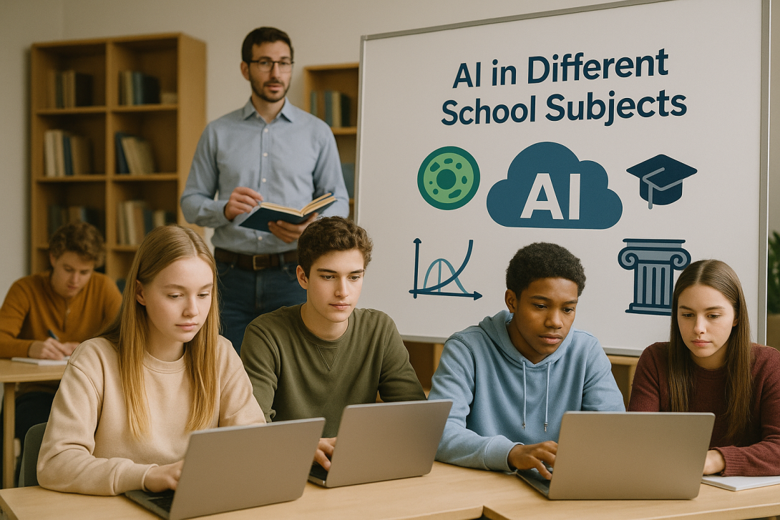

8.1 Introduction
The integration of Artificial Intelligence (AI) into the education system is reshaping not only how content is taught, but also how teachers interact with students, identify difficulties, and promote meaningful learning. One of the areas where this transformation is most evident is in the application of AI across different school subjects.
Artificial Intelligence is profoundly transforming the educational landscape, going well beyond personalised learning and task automation. Its application now extends across various school subjects, adapting to the specifics of each area of knowledge. From Mathematics to Languages, from Natural Sciences to the Arts, AI is being integrated into tools that support both teachers and students in teaching and learning, with proven impact on performance, motivation, and pedagogical efficiency.
Historically, educational technologies were implemented in a generic way, with little adaptation to the specifics of different areas of knowledge. However, AI has introduced the possibility of deep personalisation, adapting not only to the student profile but also to the demands and methodologies of each subject.
The great value of AI lies in its ability to analyse data in real time, generate adapted content, identify learning difficulties, and recommend personalised learning pathways. When used wisely, AI becomes an educational ally that respects the autonomy of teachers and values their irreplaceable role in the mediation of knowledge.
This chapter aims to explore how AI is being used in different school subjects, highlighting specific tools, real examples, and the associated pedagogical benefits. In all approaches, it remains a key principle to value the role of the teacher, not as a mere technical facilitator, but as a critical and ethical mediator of this process.

8.2 Mathematics
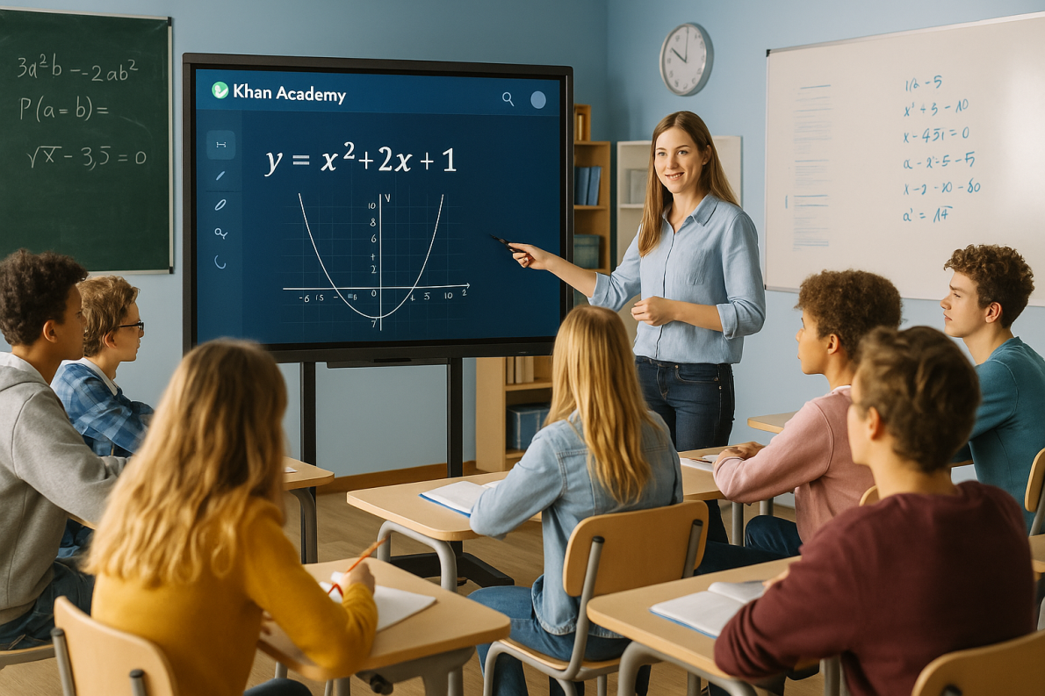
Tools and examples
Mathematics is one of the subjects where AI has quickly demonstrated pedagogical impact. Tools such as:
- Photomath: allows students to take a photo of a maths problem and view the step-by-step solution, clearly explained.
- Microsoft Math Solver: recognises handwritten or typed problems and provides solutions with visual explanations and learning suggestions.
- Socratic (Google): uses AI to identify the type of problem and suggest resources, videos or tailored explanations.
- Khanmigo: acts as a virtual tutor guiding the student's reasoning.
Advantages
- Support for autonomous problem-solving.
- Visual and interactive explanations, tailored to the student’s level.
- Diagnosis of recurring difficulties.
- Reinforcement of learning outside lesson time.
- Immediate feedback.
- Personalised visual explanations.
- Diagnosis of specific difficulties.
Real example
- A pilot study in Finnish secondary schools showed that students who used Photomath for homework significantly improved their understanding of algebra, especially those with learning difficulties.
- In a project in Estonian schools, the use of Microsoft Math Solver reduced algebra test errors among 8th-year students by 25%.

8.3 Languages
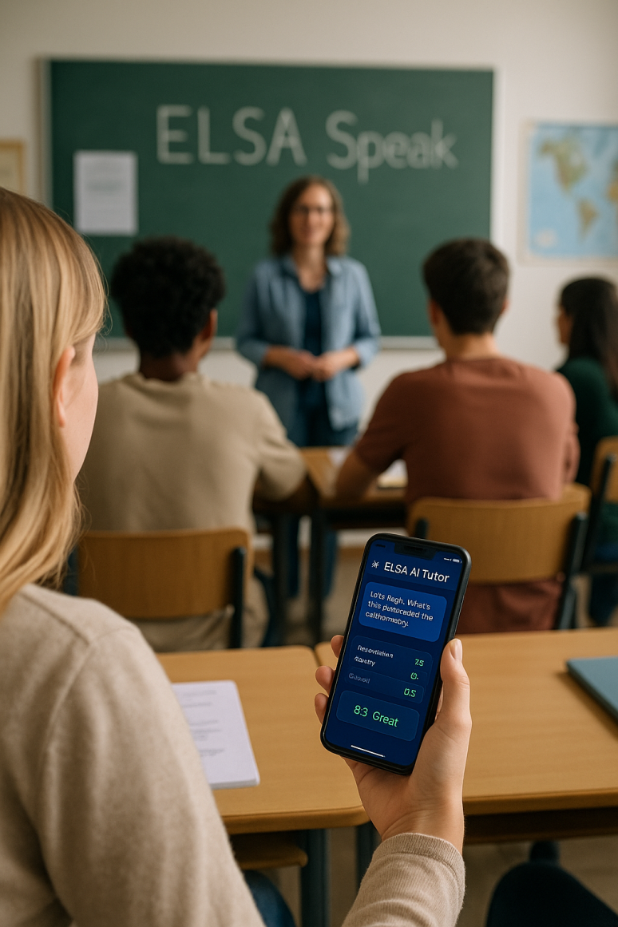
Tools and examples
Natural Language Processing (NLP) technologies have revolutionised language teaching, supporting writing, reading, listening, and speaking. Among the most used tools:
- Grammarly: offers suggestions for grammar, spelling, and style correction, promoting self-regulation in writing.
- QuillBot: rewrites sentences while maintaining meaning, ideal for teaching paraphrasing and linguistic variation.
- ChatGPT (OpenAI): can simulate dialogues, correct essays, generate personalised exercises, and explain language rules.
- Elsa Speak: uses AI to train English pronunciation with immediate and personalised feedback.
Advantages
- Immediate and explained error correction.
- Speaking and writing practice with formative feedback.
- Personalisation by level and linguistic objectives.
- Increased learning autonomy.
- Pronunciation monitoring with personalised feedback.
- Simulation of authentic conversations.
- Increased confidence and fluency.
Real example
- At an international school in Belgium, the introduction of Grammarly as a support tool for English writing reduced grammar errors by 30% in non-native students' essays within a semester.
- In bilingual schools in Germany, the use of Elsa Speak increased students’ phonetic accuracy by 35% after two months of regular practice.

8.4 Natural Sciences (Physics, Chemistry, Biology)
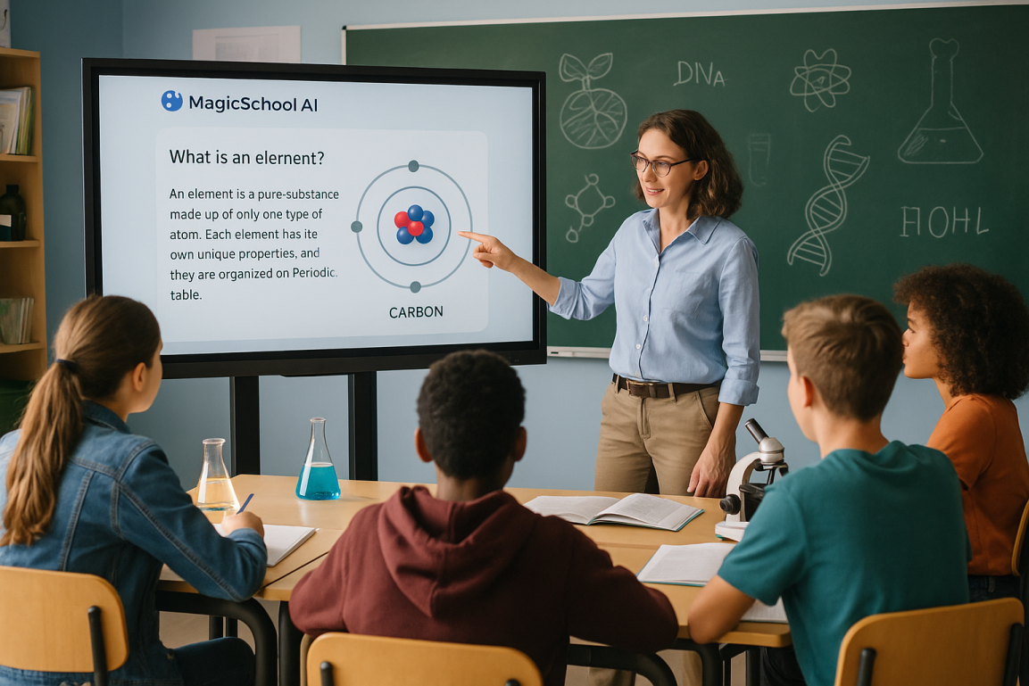
Tools and examples
Sciences benefit from AI through simulations, virtual tutoring, and data analysis. AI enables simulation of experiments, reinforcement of concepts, and diagnosis of difficulties. Tools such as Labster, Google Science Journal and Curipod bring lab experiences into the digital environment.
- Labster: simulates virtual Physics, Chemistry, and Biology labs using AI to adapt the experience to the student's performance.
- Curipod: creates interactive presentations and quizzes with AI support, promoting active learning.
- Khan Academy with AI (Khanmigo): offers personalised tutoring based on performance in subjects such as Physics and Chemistry.
Advantages
- Overcoming physical or laboratory resource limitations.
- Interactive visualisation of abstract concepts.
- Safe training in complex experiments.
- Automatic feedback and formative guidance.
- Access to lab experiences without physical materials.
- Visualisation of microscopic or dangerous processes.
- Formative and adaptive feedback.
- Integration of gamification and interactivity.
Real example
- In Danish schools, using Labster in Biology reduced by 40% the time required to understand cellular processes such as mitosis, compared to purely theoretical methods.
- In French secondary schools, Labster reduced by 40% the time needed for students to understand complex chemical reactions.

8.5 History and Social Sciences
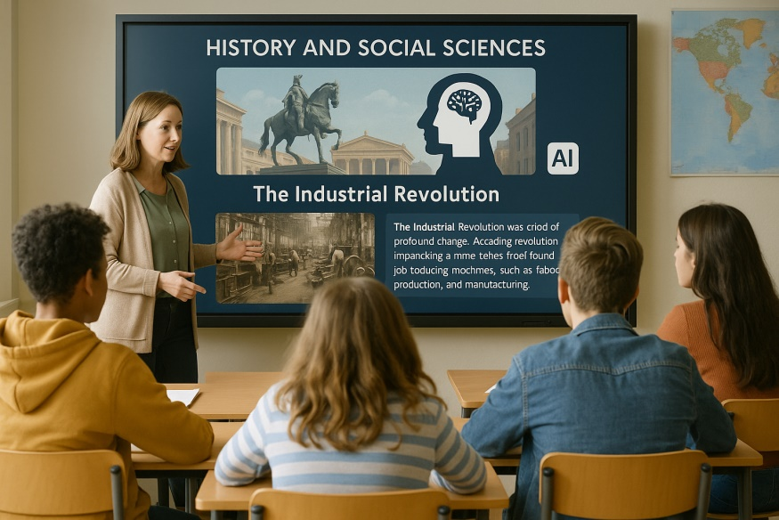
Tools and examples
Though less explored, these subjects also benefit from AI. AI applied to Social Sciences has evolved, focusing on content creation, historical document analysis, and narrative construction. Tools such as ChatGPT, SlidesAI, and DebateAI are particularly useful.
- ChatGPT and similar tools: can simulate dialogues with historical figures, generate timelines, or suggest document source analyses.
- Canva with AI: allows the creation of infographics, maps and visual presentations with design assistant support.
- Curipod and SlidesAI: rapidly create interactive content based on curricular themes.
- DebateAI: generates arguments for and against historical events or sociopolitical topics.
Advantages
- Creation of interactive narratives.
- Increased engagement through simulations and storytelling.
- Stimulation of critical thinking.
- Recreation of historical contexts for greater engagement.
- Analysis of sources with technical support.
- Production of richer and more diverse content.
Real example
- In a pilot project in Brazilian schools, Year 9 students used ChatGPT to create fictional interviews with historical figures, which promoted better retention of content and understanding of the socio-political context of events.
- In a São Paulo secondary school, students used ChatGPT to write speeches as historical figures from the French Revolution, promoting deep understanding of the ideologies involved.

8.6 Visual and Technological Education

Tools and examples
AI applied to the arts has revealed enormous creative potential. AI-powered creative tools are transforming visual and technological arts lessons. Applications like DALL•E, Canva with AI, and Autodraw are increasingly common.
- DALL•E (OpenAI): generates images from text descriptions, useful for creative exercises and visual interpretation.
- Autodraw (Google): recognises drawings and suggests stylised versions using AI (turns freehand drawings into more polished illustrations based on pattern recognition).
- Canva with design assistant: allows creation of posters, logos and other materials with intelligent support in composition and colour palette.
Advantages
- Stimulation of creativity and artistic experimentation.
- Access to varied visual styles without advanced technical knowledge.
- Immediate visual feedback on design and composition.
- Easy graphic production without advanced design knowledge.
- Exploration of new forms of artistic expression.
Real example
- At an art school in Barcelona, DALL•E was integrated into a graphic design module, enabling students to explore historical visual styles and create compositions based on literary themes.
- Students on a technical design course in Madrid used DALL•E to illustrate group-created stories, fostering collaboration between arts and language students.

8.7 Physical Education
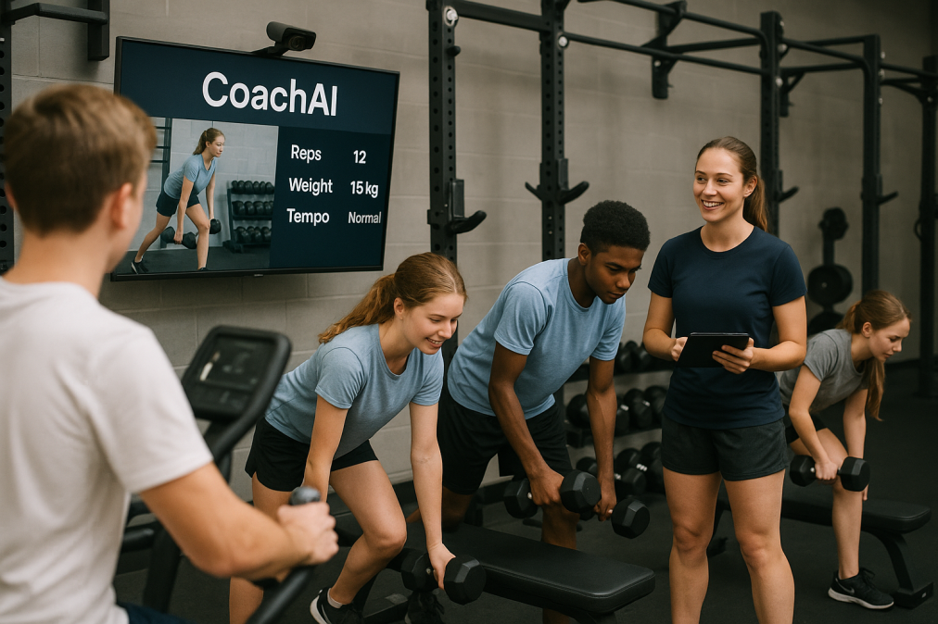
Tools and examples
Though less traditionally technological, Physical Education also benefits from AI for performance monitoring, movement analysis, and physiology.
Still at an early stage but with promising applications:
- CoachAI: analyses videos of physical movements and provides feedback on posture and performance.
- MyJump2: uses AI to measure vertical jump height from videos with high precision.
- Wearables with AI (e.g., Whoop, Fitbit): monitor heart rate, effort, and recovery, useful for teaching exercise physiology.
Advantages
- Personalised monitoring of physical performance.
- Promotion of body awareness.
- Objective data for assessment and improvement.
- Accurate monitoring of physical progress.
- Integration of sports science into basic education.
- Promotion of self-assessment.
Real example
- In Dutch schools, MyJump2 enabled precise monitoring of students’ progress in vertical jumping during an athletics module, supporting differentiated teaching.
- In Swedish schools, using MyJump2 was associated with improvements in jump performance and students’ understanding of their own physical limits.

8.8 Music Education
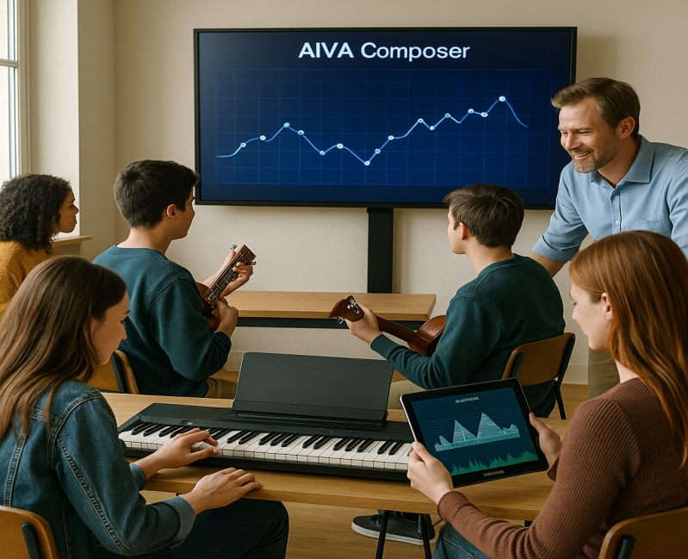
Tools and examples
AI is starting to enter this creative field. Music is a subject where AI supports both instrumental practice and music creation.
- AIVA and Soundraw: create musical compositions based on genres and instructions provided by students, generating compositions in various styles from text or melodic input.
- Yousician: uses AI to listen to instrument performances and provide immediate feedback.
- Chrome Music Lab: explores musical concepts with visual and auditory support, enabling exploration of sound, rhythm, and harmony through interactive experiences.
Advantages
- Immediate feedback on musical performance.
- Creative exploration of styles and composition.
- Support for auditory and rhythmic training.
- Technical feedback on performance.
- Stimulus for composition.
- Interactivity and playfulness.
- Support for autonomous musical expression.
Real example
- At a secondary school in Lisbon, students used AIVA to compose original pieces based on poems by Fernando Pessoa, in an interdisciplinary project with the Portuguese subject.

8.9 Philosophy and Citizenship Education
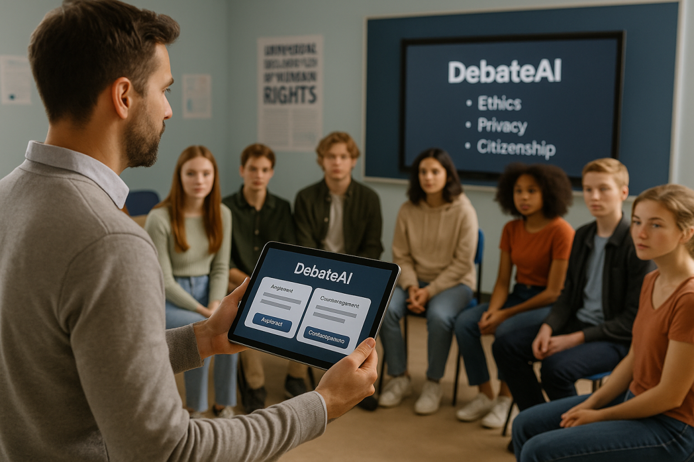
Tools and examples
These subjects value critical thinking, debate, and analysis of dilemmas. AI can be used to simulate discussions and generate ethical scenarios.
- ChatGPT: simulates argumentative discussions, presents divergent philosophical viewpoints, or creates moral dilemma scenarios.
- DebateAI: enables debates on current issues by generating automatic counter-arguments, organising discussions with divergent perspectives on ethical or social topics.
Advantages
- Stimulation of critical and argumentative thinking.
- Structured discussions with multiple perspectives.
- Exploration of ethical dilemmas related to AI itself.
- Promotion of well-founded debate.
- Exploration of modern ethical dilemmas.
- Creation of role-play argumentative scenarios.
Real example
- In French secondary schools, students used DebateAI to prepare debates on digital privacy and surveillance, fostering critical awareness and argumentative expression.
- In a secondary philosophy course in Porto, students used ChatGPT to explore the moral limits of AI use, generating deep discussions on ethics and technology.
Subject | AI Benefits | AI Tools Used
Mathematics | Step-by-step solutions, immediate feedback, autonomy reinforcement | Photomath, Microsoft Math Solver, Khanmigo
Languages | Automatic correction, pronunciation & writing practice, simulated dialogue | Grammarly, Elsa Speak, ChatGPT
Natural Sciences | Safe experiment simulation, concept visualisation | Labster, Curipod, Khan Academy AI
History & Social Sciences | Narrative creation, historical simulations, source analysis | ChatGPT, DebateAI, SlidesAI
Visual & Technological Arts | Assisted creation, creativity stimulation, aesthetic feedback | DALL·E, Canva with AI, Autodraw
Physical Education | Movement analysis, individual monitoring, data-based evaluation | CoachAI, MyJump2, AI wearables
Music | Technical training support, creative composition with AI | AIVA, Yousician, Chrome Music Lab
Philosophy/Citizenship | Argumentative discussion, simulation of ethical dilemmas, critical thinking | ChatGPT, DebateAI
Summary of AI Benefits by Subject

Conclusion
The introduction of Artificial Intelligence across different school subjects is not merely a matter of technological innovation but of pedagogical transformation. By adapting to the specific characteristics of each area of knowledge, AI contributes to more inclusive, motivating, and effective methodologies, always maintaining the teacher as the fundamental mediator of learning.
However, it is essential that the adoption of these tools be undertaken with a critical mindset, proper training, and attention to ethics, ensuring that AI complements — and never replaces — the human dimension of teaching.
The future points towards education increasingly interlinked with AI, where interdisciplinarity, creativity, and critical thinking will be as important — or more so — than the memorisation of content. The role of teachers, trained and aware of AI's possibilities, will be central to this process.
The presence of AI in different school subjects represents a unique opportunity to reinvent pedagogical practices and offer more personalised, engaging, and effective learning experiences. However, this transformation must be accompanied by ongoing teacher training, attention to ethical issues, and reinforcement of teachers’ critical role in selecting and mediating these tools.
Far from being replaced by technology, teachers become even more necessary as human guides in an increasingly automated educational context. It is their sensitivity, ethics, and pedagogical experience that ensure AI serves education — and not the other way around.

9. The Future of education with AI

9.1 Introduction: A new partner in the staff room – AI and its arrival in education
Artificial intelligence (AI) is no longer just a concept from science fiction novels; it is becoming a tangible reality that is actively shaping our world. From the way we work and communicate to the functioning of entire industries, its impact is undeniable.1 Education, as a key pillar of society, cannot and does not remain aloof from this transformative process. The arrival of AI in classrooms and staff rooms represents one of the most significant changes in modern pedagogy, comparable to the advent of the internet or personal computers.
For educators in Slovakia, this new era brings a mix of opportunities and justified concerns. On one hand, surveys show that many teachers perceive AI positively – as a tool that can facilitate work, help, and solve problems. On the other hand, there is a natural respect for the unknown, coupled with fears of the absence of clear rules, a lack of qualified instructors, and the potential overburdening of an already demanding school system. This chapter is designed as a practical and supportive guide aimed at demystifying artificial intelligence and providing teachers with the tools and knowledge needed for its confident and meaningful use. The goal is not just to react to technological changes, but to actively shape them in line with pedagogical objectives, including in the context of national initiatives by the Ministry of Education, Research, Development, and Youth of the Slovak Republic, which plans the systematic integration of AI into education.
The emerging market for AI education is proof of this. A number of commercial entities offer courses and training focused on the practical mastery of specific tools like ChatGPT or DALL-E. While these offers are often useful for acquiring basic skills, they also signal a deeper need – the need for systematic, pedagogically grounded, and critical support that goes beyond simple user manuals. Teachers need to know not only how to click, but above all, to understand why and under what conditions they should use a given tool. This chapter aims to fill this gap and serve as an authoritative pedagogical compass.
The fundamental argument of this chapter is that artificial intelligence does not replace the teacher. On the contrary, it becomes a powerful partner that, by automating routine tasks, frees up time and space for what is irreplaceable in pedagogy: building relationships, mentoring, developing critical thinking, and supporting the emotional and social growth of students. The goal is not digitization for the sake of digitization, but the humanization of education through intelligent technologies.
To use artificial intelligence effectively and ethically, it is essential to understand its basic concepts. These terms are often used interchangeably, but each refers to a specific area with different capabilities and applications.
Relevance for EU education
The integration of AI into education is not just an optional add-on but is becoming a necessity for preparing students for the future. The Ministry of Educations of EU countries are aware of this fact and plan to introduce AI into the curriculum in the next school years with the aim of ensuring that AI literacy becomes a basic skill on par with reading and writing. Slovakia is not alone in this and follows the examples of countries like Finland, Estonia, the United Kingdom, and the USA, which are already actively incorporating elements of AI into their educational systems. The goal is to raise a generation that not only passively understands technology but can also use it actively, critically, and ethically.

9.2 AI as a teacher's assistant: Tools to streamline work
One of the greatest promises of artificial intelligence in education is its potential to significantly reduce the administrative burden and free up teachers' time for the work that has the greatest impact – direct interaction with students. AI can function as a tireless personal assistant, helping with preparation, planning, and administration.
Creation and differentiation of educational content
AI tools dramatically simplify and speed up the process of creating and adapting teaching materials. A teacher no longer has to start with a blank page.
- Generating Text Content: Tools like ChatGPT or Gemini can, based on a simple command (prompt), create drafts of worksheets, test questions with both open and closed answers, quizzes, or summaries of extensive texts. They can generate examples for practicing grammatical phenomena, word problems in mathematics, or discussion questions for a literary work.
- Differentiating Materials: One of the biggest challenges in a heterogeneous classroom is adapting materials to different student levels. AI can do this in a matter of seconds. A teacher can ask AI to simplify a technical text for students with weaker reading skills, create a more challenging version of a task for gifted students, or rephrase an assignment for students with special educational needs (SEN).
- Creating Visual Materials: Visual aids are key to understanding and remembering subject matter. Tools like DALL-E, Midjourney, or AI functions integrated directly into the Canva platform allow teachers to create original and tailor-made images. They can visualize a historical event, depict an abstract scientific concept (e.g., the structure of DNA), create an illustration for a story, or design an engaging infographic.
However, it is important to approach this process strategically. AI should not be seen as the final creator, but as an accelerator of the initial draft. Its outputs can be generic, sometimes inaccurate, or may lack the necessary pedagogical touch. A proven strategy is the so-called
80/20 principle: the teacher uses AI to create 80% of the basic material, thus saving hours of work. Subsequently, they add their 20% of expertise – pedagogical context, creativity, adaptation to the specific needs of the class, and final verification of correctness.30 In this way, the teacher remains the guarantor of quality and pedagogical value, while also working much more efficiently.
Planning and administration
In addition to content creation, AI can also significantly help with organizational and administrative tasks that often take up teachers' valuable time.
- Lesson Planning: AI assistants can help create thematic plans, draft lesson structures, or find innovative activities and projects for a given topic.
- Automating Assessment: While AI cannot yet fully assess complex essays or creative works, it can effectively automate the grading of tasks with clearly defined answers. Platforms like Gradescope or Smodin AI Grader can quickly correct multiple-choice tests, fill-in-the-blank exercises, and provide initial feedback on written work, such as checking grammar, structure, or originality.
- Communication with Parents: Formulating messages for parents can be time-consuming. AI can help create drafts of informative, constructive, and professional-sounding emails, whether for weekly summaries, invitations to consultations, or information about a student's progress.
By using these tools, the teacher can free themselves from repetitive tasks and focus their energy where their presence is most valuable – in direct work with students.

9.3 Revolution in the classroom: Personalization and support for every student
After exploring the benefits of AI for the teacher, the focus now shifts to its greatest potential: the transformation of the learning process itself for the student. Artificial intelligence enables a shift from a "one-size-fits-all" model to deeply personalized and inclusive education that responds to the needs of each individual.
Personalized and adaptive learning
Every classroom is filled with students with different knowledge, learning paces, and styles. AI offers tools to effectively manage this diversity.
- Adaptive Learning Platforms: Applications like Khan Academy, Duolingo, Century Tech, or Carnegie Learning use algorithms to continuously analyze a student's performance. Based on their answers, they dynamically adapt the content, difficulty, and pace of tasks. If a student struggles with a topic, the system offers additional explanations and exercises. If, on the other hand, they master the material with ease, the system offers more challenging tasks. In this way, each student is optimally stimulated and progresses at their own pace, which is almost unattainable in the traditional model of frontal teaching.
- Hyper-personalization: This is the vision for the near future of education. It's no longer just about adapting content based on right and wrong answers. Hyper-personalized systems will be able to create unique educational paths for each student based on their interests, long-term goals, preferred learning styles (visual, auditory), and even their emotional state, which they can recognize, for example, from voice analysis or interaction with the platform.
Intelligent tutors and instant feedback
One of the biggest benefits of AI is its ability to provide continuous support.
- Tutors Available 24/7: AI chatbots and specialized tutoring systems (e.g., MathGPTPro for mathematics or Socrat for discussion topics) can help students with homework, practicing material, or explaining unclear concepts anytime and anywhere. A student can ask repeatedly without fear of appearing "stupid," which reduces anxiety and promotes independence.
- Instant Feedback: Instead of waiting for a teacher's correction, the student receives immediate information on whether their approach was correct. This allows them to correct mistakes immediately and learn more effectively from their own errors.
Support for students with Special Educational Needs (SEN)
Artificial intelligence represents a breakthrough in the field of assistive technologies and has enormous potential to create a truly inclusive educational environment.
- Text-to-Speech: Tools like Speechify or NaturalReader can read any digital text aloud. This is an invaluable aid for students with dyslexia, visual impairments, or for those who prefer auditory learning.
- Speech-to-Text: Software like Dragon or functions built directly into operating systems allow students to dictate text instead of typing. This helps students with dysgraphia, physical limitations, or simply those who find it easier to formulate their thoughts orally.
- Writing Support: Applications like Grammarly or Co:Writer provide real-time feedback on grammar, style, and sentence structure, helping students with learning disabilities or language barriers to produce higher-quality texts.
- Improving Accessibility: AI can automatically generate captions and transcripts for videos for students with hearing impairments, or convert information from color graphs into text descriptions for students with color blindness.
These tools not only compensate for disadvantages but also give students with SEN the opportunity to fully participate in the educational process and reach their full potential.
Table 1: Overview of AI tools for teachers
The following table serves as a practical reference guide to help teachers quickly orient themselves to available tools according to pedagogical needs.
Category | Tool name | Description of functions | Examples of use in class
Text Content Creation | ChatGPT, Gemini, Microsoft Copilot | Generating texts, questions, summaries, brainstorming | "Create 5 open-ended questions for the poem 'Mor ho!' focusing on character analysis and the main idea."
Visual Content Creation | DALL-E 3, Midjourney, Canva AI | Generating images and graphics based on a text description | "Create an illustration showing the water cycle in nature with descriptions of each phase."
Personalization of Teaching | Khan Academy, Duolingo, Century Tech | Adaptive platforms that adjust content and learning pace | Students individually practice math problems or English vocabulary at their own pace.
Assessment and Feedback | Gradescope, Smodin AI Grader | Automated grading of tests and providing feedback | Quick correction of a biology test with closed-ended questions, freeing up time to analyze common mistakes.
Support for SEN | Speechify, NaturalReader (Text-to-Speech) | Conversion of written text to spoken word | A student with dyslexia has the homework assignment from the textbook read aloud.
Support for SEN | Dragon, OS functions (Speech-to-Text) | Conversion of spoken word to written text | A student with dysgraphia dictates their thoughts for an essay and then edits them.

9.4 The New role of the teacher: From lecturer to facilitator and mentor
The deepest and most significant change that artificial intelligence brings to education is not just the introduction of new tools, but a fundamental transformation of the role and identity of the teacher. In an era where factual information is instantly available through AI, the traditional notion of the teacher as a "fount of wisdom" and the primary source of knowledge is losing its relevance. AI can explain a covalent bond or the rules of the past tense in English, often more patiently and adaptively than a human. However, this does not mean the teacher becomes obsolete. On the contrary, their value shifts from transmitting information to developing skills and competencies that are uniquely human.
Defining the new role
The 21st-century teacher becomes a designer, guide, and mentor. Their new role can be described through three key archetypes:
- Facilitator: The teacher is no longer an actor on a stage lecturing, but rather a director who sets the stage for learning. Their role is to design and facilitate learning experiences in which students actively construct their knowledge. They ask stimulating questions, moderate discussions, and create an environment where students collaborate, experiment, and learn to solve problems using various resources, including AI.
- Mentor: As AI takes over routine explanations, the teacher can fully focus on developing skills that machines cannot replicate. These are the so-called soft skills, which are crucial for success in the 21st century: critical thinking, creativity, complex problem-solving, collaboration, communication skills, emotional intelligence, and ethical reasoning. The teacher becomes a personal guide who helps students navigate the world of information and form their own values.
- Orchestrator: A new educational triangle is emerging in the modern classroom: teacher, student, and AI. The teacher, in the role of an orchestrator, strategically manages this dynamic. They must know when it is appropriate to use an AI tool to streamline work, when to put it in the hands of students to support their independence, and when, on the contrary, direct human intervention, an empathetic conversation, or a joint reflection is necessary.
Practical implications for teaching
This change in role is most evident in the way tasks are designed and assessed. The emphasis shifts from the product (the correct answer) to the process (the path to the answer).
Example of a Transformed Assignment:
- Traditional Assignment: "Write a 500-word essay at home on the causes and consequences of World War I." (A student can easily delegate this task to AI).
- New Assignment in the AI Era:
- Phase 1 (Individual work with AI): "Use an AI assistant (e.g., ChatGPT, Gemini) to create a timeline of key events and a list of five main causes of World War I. For each cause, have a short description generated."
- Phase 2 (Group work in class): "In groups, compare your findings. Discuss which causes you consider most important and why. Create a collaborative mind map that visualizes the relationships between the causes and consequences."
- Phase 3 (Critical thinking and verification): "The AI provided you with a list of sources. Verify the validity of at least two of them using the school database or other trustworthy sources. Is the information from the AI accurate and unbiased?"
- Phase 4 (Synthesis and presentation): "Based on your discussion and verified sources, prepare a short presentation in which you argue which cause you believe had the greatest impact on the outbreak of the war. Be prepared to defend your opinion."
This new approach represents a pedagogical inversion. Traditionally, content (history, biology) was taught with the hope that skills would also be developed along the way. In the era of AI, skills must be taught directly – how to think critically, verify information, collaborate, and argue – using content that is easily accessible through technology. These skills do not become a byproduct but the primary goal of education. This necessarily requires a change not only in methodology but also in assessment systems, which must consider the process and not just the final output.

9.5 Ethical challenges and responsible use of AI
Along with its enormous potential, artificial intelligence also brings new ethical dilemmas and risks that are a major source of concern for many educators. The key to managing them is not to ban technology, but to build a culture of responsibility, critical thinking, and digital citizenship among both teachers and students.
Academic integrity and plagiarism
The most common concern is that students will use AI to cheat, especially when writing homework and essays.
- Problem: A student has a complete work generated and submits it as their own.
- Solution:
- Education, not prohibition: Instead of blanket bans, it is more effective to teach students how to use AI ethically. This includes the obligation to acknowledge the use of AI and to cite it correctly as a tool, just as other sources are cited.
- Redesigning assignments: Assign tasks that require higher cognitive functions – analysis, synthesis, evaluation, personal reflection, or connection to one's own experience. AI cannot handle these tasks on its own.
- Assessing the process: Focus on assessing the entire work process (e.g., ongoing consultations, defense of the work, discussion of sources used), not just the final text.
Data protection and privacy (GDPR)
AI tools, especially free ones, often operate by collecting and analyzing user data.
- Problem: Student data, including their interactions and performance, can be collected and used in ways that are not transparent or secure.
- Solution:
- Careful selection of tools: Teachers should prioritize tools that comply with the European General Data Protection Regulation (GDPR), such as the SchoolHub.ai platform.
- Digital hygiene: It is crucial to teach students (and oneself) never to enter sensitive personal data, passwords, or confidential information into AI tools.
- Anonymous use: Whenever possible, use tools without requiring registration or with anonymous accounts.
Algorithmic bias and fairness
AI models learn from data created by humans, and therefore can unintentionally adopt and even reinforce existing societal prejudices and stereotypes.
- Problem: AI trained predominantly on data from the Western world may present a one-sided view of history or culture. Search results or generated images may reinforce gender or racial stereotypes.
- Solution:
- Developing critical thinking: Teach students to approach AI outputs critically. Key questions they should ask themselves are: "Is this information verifiable? What sources is it likely drawing from? Whose viewpoint or perspective is missing here?"
- Comparing sources: Guide students to never rely on a single source, especially if it is AI, and to always verify information from multiple independent and trustworthy sources.
- Ensuring equal access: Schools and their founders must actively work to ensure that all students have access to technology, regardless of their socio-economic background, to avoid deepening the digital divide.
International organizations such as UNESCO and the OECD have developed ethical frameworks for the use of AI that emphasize principles such as human oversight, transparency, security, fairness, and inclusivity. These principles should become the basis for creating school rules and guidelines.
Category | Checklist question for consideration
Pedagogical Value | Does the tool support active learning, critical thinking, and creativity, or just passive consumption of information and memorization?
 | Is the added value of the tool high enough to justify the time needed for its implementation and use?
Privacy and Data Security | Does the tool require student registration using personal data? What data does it collect about students?
 | Are the tool's privacy policies transparent and compliant with GDPR?
Fairness and Inclusivity | Is the tool accessible and usable for all students, including those with SEN or with limited access to technology at home?
 | Could the content generated by the tool contain hidden biases or stereotypes? Does it allow for critical engagement with the content?
Transparency and Accountability | Is it clear how the tool works? Does it allow me as a teacher to control, edit, and verify the content it generates?
 | Who is responsible if the tool provides incorrect or harmful information?
Table 2: Framework for the ethical use of AI in the classroom (Checklist for teachers)

Conclusion: Education for the future
The journey of integrating artificial intelligence into education is complex and full of challenges, yet it also offers unprecedented opportunities for positive transformation. As this chapter has shown, AI is not a threat that should replace teachers, but a powerful ally that can enrich and streamline their work. However, its meaningful use requires more than just technical skill; it demands the courage to rethink traditional practices, embrace the new role of facilitator and mentor, and constantly cultivate ethical vigilance.
The true potential of AI will not be unlocked simply by purchasing new software. Its arrival acts as a catalyst for deeper and long-needed systemic reforms. It challenges our dependence on memorizing facts and assessment based on reproduction, forcing us to ask fundamental questions: What is truly important for students to learn in the 21st century? How can we best develop their creativity, critical thinking, and adaptability? The teachers reading these lines are not just passive recipients of technology; they are key actors in this necessary transformation.
The vision for the future is an educational ecosystem where technology serves to enhance what is most valuable – human potential. Artificial intelligence takes over routine and administrative tasks so that teachers have more time and energy for individual approaches, building strong relationships with students, leading inspiring discussions, and supporting their socio-emotional development. To fulfill this vision, it is essential to embrace the idea of lifelong learning not only for students but also for educators themselves. The ability to learn, adapt, and critically reflect on one's own practice in a rapidly changing world is becoming the most important professional competency.
The future of education is therefore not about a choice between human and machine. It is about finding the synergy between them. The ultimate goal is not to create digital schools, but to use digital tools to raise a smarter, more curious, more resilient, and above all, more humane generation.

10. Outputs developed during the project life cycle
As part of the Erasmus+ project "AI Tools for VET schools," specific tools have been developed for the Moodle platform to help teachers create effective prompts directly within the virtual learning environment. These plugins bridge the gap between AI technology and daily pedagogical practice, following the principle that AI should enhance, not replace, the teacher's role. CNN 3D Visualization is an open-source interactive platform designed for education and research of convolutional neural networks |  | 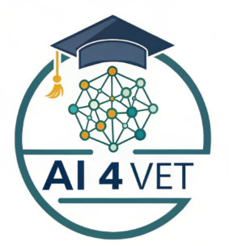

10.1 Tiny AI Prompt Generator (TinyMCE Plugin)
This plugin integrates directly into the standard text editor used by Moodle (TinyMCE). It allows teachers and students to generate structured instructions for AI models without leaving the window where they are creating content.
- Editor Integration: It appears as an icon in the editor's toolbar when creating any activity, such as a Page, Forum, or Assignment.
- Structured Prompting: It guides the user through defining the Role, Context, Task, and Output Format for the AI, reducing "hallucinations" and improving accuracy.
- Availability: The plugin is published in the official Moodle directory and is open-source.

Installation and Documentation:
- Moodle Plugins: Tiny AI Prompt Generator (https://moodle.org/plugins/tiny_aipromptgen)
- GitHub Repository and Manual (https://github.com/blagojevicboban/moodle-tiny_aipromptgen)

Overview
This plugin integrates seamlessly into Moodle’s standard text editor (TinyMCE). It encourages the use of the 80/20 principle, where the teacher uses AI to generate 80% of a draft material and then adds their 20% of expert pedagogical context and verification.
- Platform: Moodle (TinyMCE Editor).
- Purpose: To generate structured AI prompts for lesson planning, content creation, and assessment.
- Ethics: Promotes transparency by making the AI interaction a visible part of the content creation process.

Installation and configuration
- Download the Plugin: Get the .zip file from https://moodle.org/plugins/tiny_aipromptgen.
- Go to Admin: Log in as an Administrator and go to Site administration > Plugins > Install plugins.
- Upload: Drag and drop your .zip file into the box or use the "Choose a file" button and click Install plugin from the ZIP file.
- Moodle will check if the plugin is compatible. If you see a "Validation passed!" message, click Continue.
- Follow the prompts to Upgrade Moodle database now.

Configuration
- Go to Site administration → Plugins → Text editors → TinyMCE editor → AI Prompt Generator to configure your API keys (OpenAI) or Ollama endpoints.
OpenAI Setup
- Obtain an API key from OpenAI.
- Enter your API key in the plugin settings.
- Choose your preferred model (default: gpt-4o-mini).
Ollama Setup (Local AI)
- Install Ollama on your server.
- Pull a model: ollama pull llama3
- Configure the endpoint in plugin settings (default: http://localhost:11434).
- Set the model name (e.g., llama3, mistral, phi3:mini).

How to Access the Generator
- Open a Moodle Activity: Go to any activity that uses a text editor, such as a Page, Forum post, or Assignment description and open Settings.
- Position the cursor where you want to insert the generated text.
- Locate the Icon and click to lounch: In the TinyMCE toolbar, look for the Tiny AI Prompt Generator icon (typically represented by a small robot or AI-related symbol).
- Fill in the prompt details (Subject, Audience, Outcomes, etc.).
- Select your preferred AI Provider and click Send to AI.
- View the streaming response and after finish, insert generated content (raw, text, html or code) into TinyMCE editor using Add or just copy generated text to clipboard.
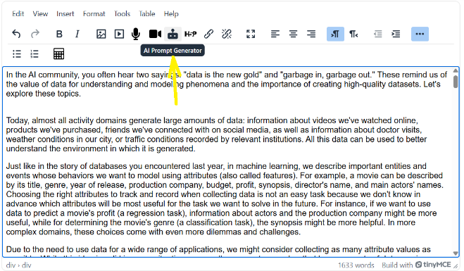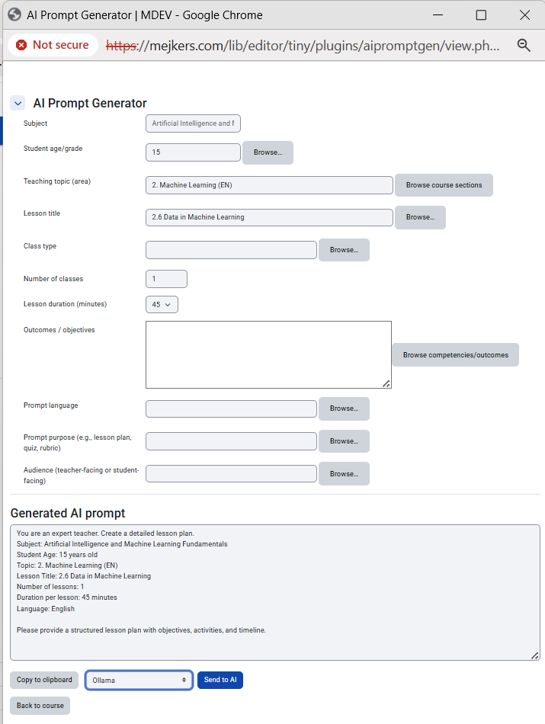

Creating a Structured Prompt
The plugin uses a framework to ensure the AI provides accurate and useful results. You will be asked to define:
- Role: Define who the AI should act as (e.g., "Act as an experienced history teacher" or "Act as a professional lab assistant").
- Context: Provide details about your students, such as their grade level (e.g., "8th grade") or specific learning needs (e.g., "SEN students").
- Task: Clearly state what you want to create, such as a quiz, a lesson plan, or a summary.
- Format: Choose the output format, such as a table, a list, or even Moodle GIFT format for easy import into the Question Bank.
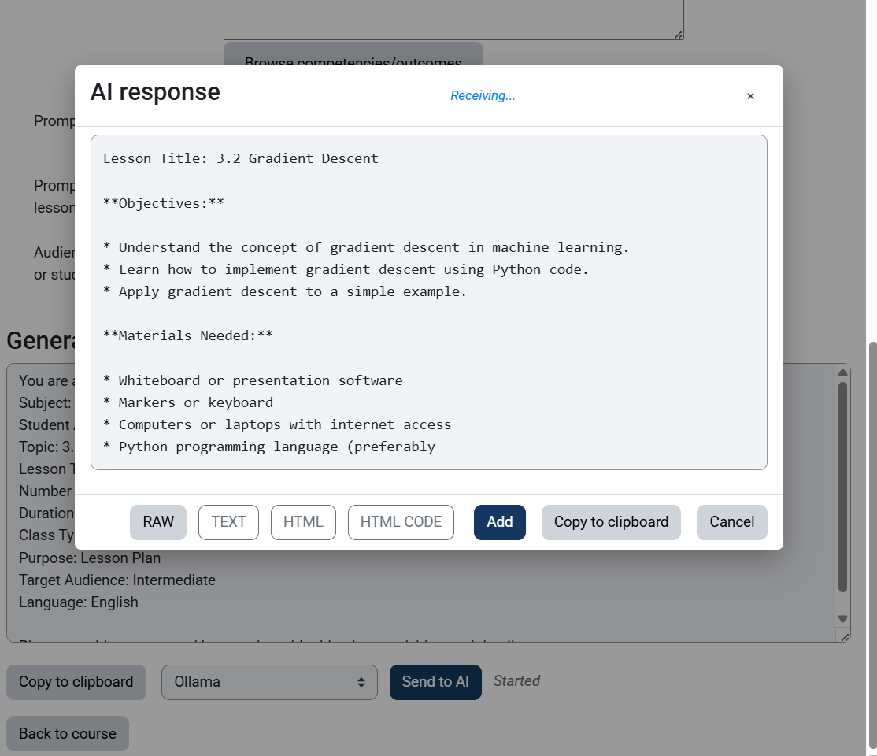

Practical Examples for VET Teachers
- For Technical Subjects: Create a prompt to "Generate a step-by-step safety checklist for operating a CO2 laser in a workshop".
- For Languages: "Rewrite this technical manual in simplified English (B1 level) for foreign students".
- For Assessment: "Create 5 multiple-choice questions in GIFT format regarding the laws of thermodynamics for 10th-grade students".

6. Best Practices & Safety
- Human Oversight: Always review the AI-generated content for "hallucinations" or factual errors before sharing it with students.
- Data Privacy: Never enter sensitive personal data about your students into the generator.
- Refinement: If the first result isn't perfect, use the generator again with more specific context to refine the output.

10.2. AI Tools for Teachers - Prompt Generator (Moodle Block)
Unlike the editor-based tool, this plugin is a Moodle "Block" that can be placed on the side of any course page or the user's Dashboard.
- Quick Access: The block remains visible while the teacher navigates the course, acting as a permanent assistant for generating ideas.
- Pedagogical Templates: It features pre-defined templates specifically for educators, such as creating lesson plans, quiz questions, or student feedback.
- User-Friendly Design: Users fill in simple fields, and the block generates a finalized prompt ready to be copied into ChatGPT, Gemini, or other AI assistants.

Installation and Documentation:
- Moodle Plugins: AI tools for teachers - prompt generator (https://moodle.org/plugins/block_aipromptgen)
- GitHub Repository and Manual
(https://github.com/blagojevicboban/moodle-block_aipromptgen)

Practical Strategies for Using Project Plugins:
- Collaborative Learning: When setting up a forum, use the Tiny AI Prompt Generator to provide students with precise guidelines on how to use AI for topic analysis while maintaining academic integrity.
- Efficient Material Preparation: While reviewing a lesson, use the AI Prompt Generator Block to quickly generate a set of summary questions or a glossary of technical terms for your students.
- Differentiated Support: Use the generated prompts to quickly adapt a single assignment for different student levels, ensuring inclusive education for those with special needs or different learning paces.
Note to Administrators: These plugins must be installed by the Moodle site administrator. Once installed, they provide a secure and integrated way for teachers to leverage AI within the school's own digital infrastructure.

Overview
This plugin exists as a Moodle Block, meaning it can be added to the side of any course page or to your personal Dashboard. It is designed to save time on administrative tasks, allowing teachers to focus more on direct engagement with students.
- Platform: Moodle (Block/Sidebar).
- Purpose: To provide quick access to pre-defined AI prompting templates tailored for educators.
- Methodology: Follows the 80/20 principle, helping you generate the first 80% of content quickly so you can focus on the final 20% of expert pedagogical refinement.

Installation and configuration
- Download the Plugin: Get the .zip file from https://moodle.org/plugins/block_aipromptgen.
- Go to Admin: Log in as an Administrator and go to Site administration > Plugins > Install plugins.
- Upload: Drag and drop your .zip file into the box or use the "Choose a file" button and click Install plugin from the ZIP file.
- Moodle will check if the plugin is compatible. If you see a "Validation passed!" message, click Continue.
- Follow the prompts to Upgrade Moodle database now.

Configuration
- Go to Site administration → Plugins → Blocks → AI tools for teachers - prompt generator to configure your API keys (OpenAI) or Ollama endpoints.
OpenAI Setup
- Obtain an API key from OpenAI.
- Enter your API key in the plugin settings.
- Choose your preferred model (default: gpt-4o-mini).
Ollama Setup (Local AI)
- Install Ollama on your server.
- Pull a model: ollama pull llama3
- Configure the endpoint in plugin settings (default: http://localhost:11434).
- Set the model name (e.g., llama3, mistral, phi3:mini).
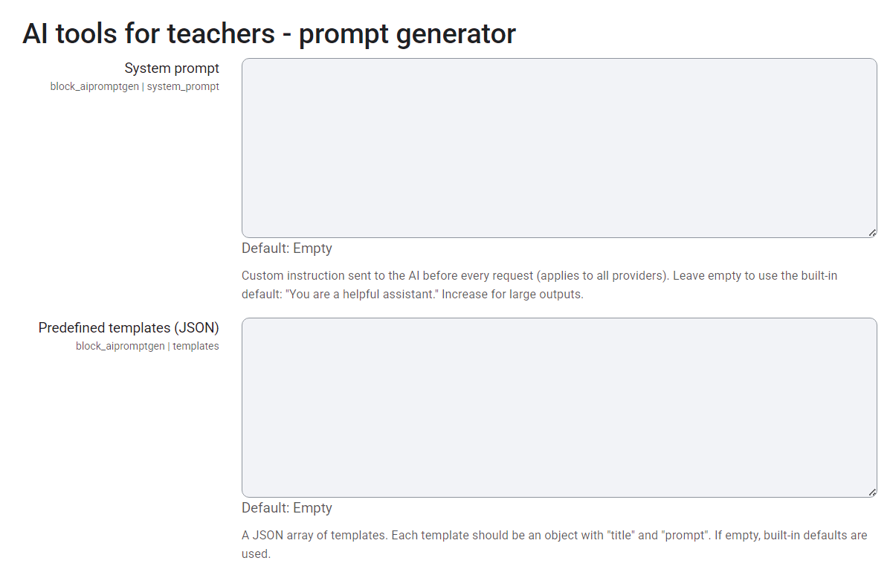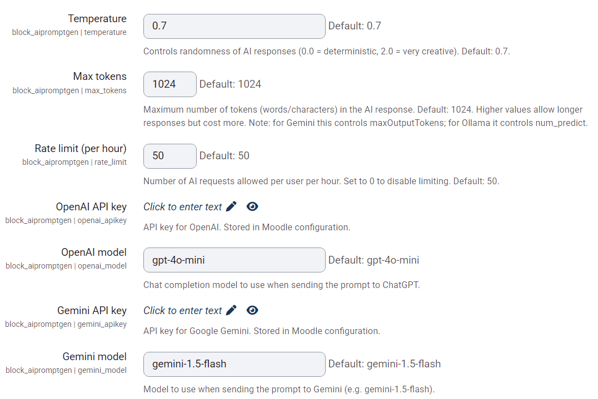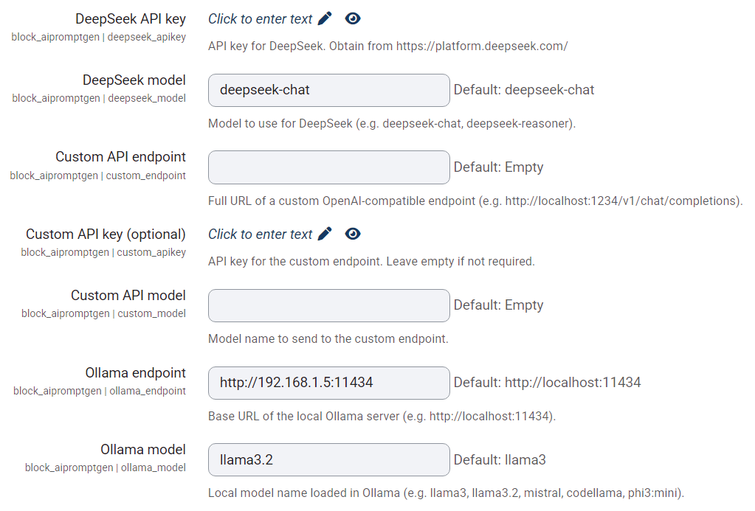

How to Add and Access the Block
- Enter Your Course: Go to the Moodle course where you want the assistant to be available.
- Turn Editing On: Click the "Turn editing on" button in the top right of your Moodle interface.
- Add the Block: Find the "Add a block" link (usually in the left or right sidebar) and select "AI tools for teachers - prompt generator" from the list.
- Positioning: You can drag and drop the block to your preferred location in the sidebar so it is always accessible while you work.
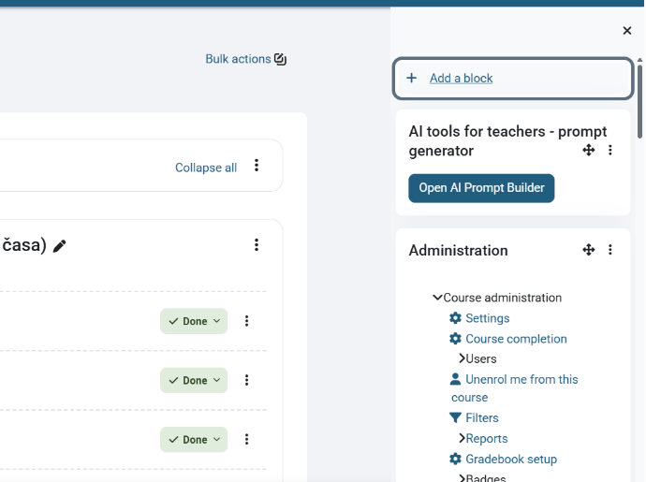

Using the Generator to Create Educational Resources
The block provides a user-friendly interface with specific fields to help you build high-quality prompts:
- Select a Category: Choose from pre-set pedagogical objectives such as Lesson Planning, Assessment Creation, Content Simplification, or Feedback Generation.
- Define Student Level: Input the target grade or specific student needs (e.g., "Vocational 11th grade" or "Students with dyslexia") to ensure the AI adapts the language complexity.
- Specify the Topic: Enter the subject matter or paste specific text you want the AI to work with.
- Choose the Output Format: Request specific formats like Multiple Choice Questions, GIFT format for Moodle, or a Summary with pictograms for inclusive learning.
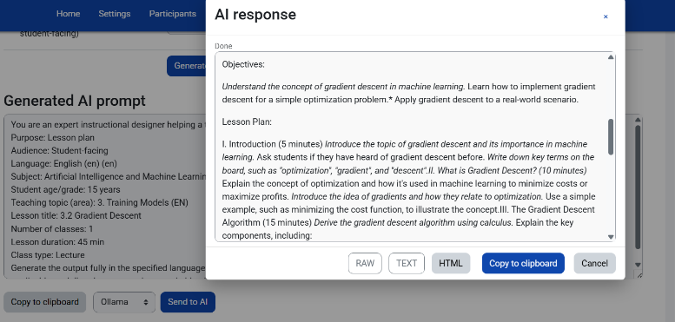

Practical Examples for the VET Classroom
- Lesson Sequences: Use the block to quickly generate a learning sequence for a new technical topic, including objectives and methodological strategies.
- Assessment Tools: Generate 10 multiple-choice questions on a technical theme, organized by difficulty levels (easy, medium, challenging).
- Inclusion Support: Use the "Simplify" template to take a complex technical manual and rewrite it for students who are still learning the language of instruction.

Ethical & Professional Reminders
- The Teacher as Mediator: AI is a "co-pilot," not a replacement. Always interpret AI-generated data through your professional experience and knowledge of your specific students.
- Verification: AI can occasionally produce factual errors ("hallucinations"). Always verify the accuracy of the generated prompt results before using them in class.
- Data Security: Do not enter sensitive personal data about yourself or your students into the generator fields.

10.3 CNN (Convolutional Neural Networks) - 3D Visualization & LIVE Training
CNN 3D Visualization is an open-source interactive platform designed for education and research of convolutional neural networks. It allows users to monitor model training in real-time directly in the browser, visualize the flow of information through a 5-layer architecture, and experiment with their own datasets.
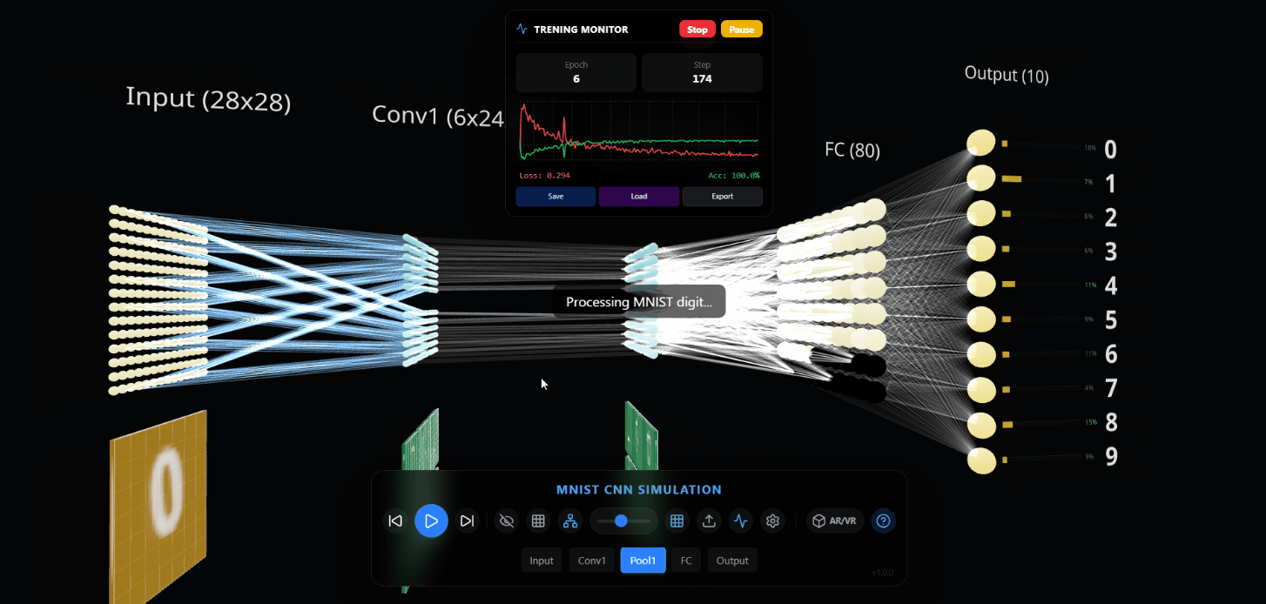
🌐 Live Demo: blagojevicboban.github.io/cnn-arvr
GitHub Repository: https://github.com/blagojevicboban/cnn-arvr?tab=readme-ov-file
This platform implements the key pillars of modern ML visualization:
✅ Result 1: Interactive 3D Ecosystem
- Layer-by-Layer Inspection: Each layer (Input, Conv, Pool, FC, Output) is displayed as a physical entity in 3D space.
- Activation Maps: Outputs of convolutional filters are rendered as dynamic textures that update in real-time during inference and training.
- Neural Glow: The light intensity of neurons in FC layers directly reflects their activation value ($0.0$ to $1.0$).
- Dynamic Connections: The thickness and color of lines between layers visualize the strength and direction of information flow.
✅ Result 2: In-Browser Training (TF.js)
- Client-Side Computing: Complete training and inference are executed within the user's browser using TensorFlow.js.
- Web Worker Parallelization: All heavy ML computations are offloaded to a separate worker thread, allowing for a fluid 60 FPS for 3D visualization even during intensive training.
- Dual-Model Synchronization: The system uses two models - one optimized for training speed and another for extracting internal activations for visualization.
✅ Result 3: 8x8 FC Matrix Representation
- Structural Alignment: The Fully Connected (FC) layer is represented as a structured 8x8 matrix (64 neurons) for better spatial organization.
- Full Connectivity Visualization: Optimized sampling algorithms ensure that every single neuron in the 8x8 matrix shows visual data flow from the pooling layer, eliminating "dead zones".
✅ Result 4: Multilingual & Visual Contrast
- EN/RS Toggle: Instant switching between English (default) and Serbian languages for all UI elements and the AI Mentor.
- Visual Contrast Mode: High-contrast toggle to enhance the visibility of active neurons and connections, making the learning process more apparent.
✅ Result 5: Dynamic Data Collection
- Dataset Builder: Users can create their own training sets by uploading images or using built-in MNIST samples.
- Interactive Labeling: A simple interface for assigning labels (0-9) and instant conversion to tensor formats.
- Real-Time Augmentation: The system automatically performs grayscale conversion, resizing (28x28), and contrast enhancement for optimal results.
✅ Result 6: Visual Performance Monitor
- Real-time Recharts: Integrated charts track Loss and Accuracy through epochs.
- Checkpoints: Automatic saving of best models to the browser's localStorage, allowing training to resume after a page refresh.
- Status Console: Detailed insight into Web Worker state and training progress.
✅ Result 7: Gemini AI Mentor
- Context-Aware Assistance: Chat with an AI that knows your current training metrics and active layer.
- Interactive Explanations: Ask technical questions like "What does a convolution layer do?" and get instant expert answers.
- Optimization Tips: Get real-time advice on how to improve your model's accuracy and reduce loss.
🚀 Key Features
- 3D Rendering: Powered by React Three Fiber and Three.js for top-tier performance.
- Synthetic Generator: Generating thousands of samples using system fonts and OffscreenCanvas.
- Responsive UI: A modern interface with a glassmorphism effect built using Tailwind CSS.
- Weight Initialization: Visual confirmation of transformation from random noise into recognizable filters.
- Gemini AI Integration: Capability to use Google GenAI for result analysis and explaining neural network concepts.
🛠 Tech Stack
- Frontend: React 19, Three.js, React Three Fiber, React Three Drei
- ML Engine: TensorFlow.js (CPU/Core backend in worker)
- Styling: Tailwind CSS 4.0
- Charts: Recharts
- Build Tool: Vite 6.0
- Icons: Lucide React
💻 Local Setup
1. Prerequisites
- Node.js (v18+)
- NPM or Yarn
2. Installation
Clone the repository and install dependencies:
git clone https://github.com/blagojevicboban/cnn-arvr.git
cd cnn-arvr
npm install
3. Configuration
Set GEMINI_API_KEY in your .env file if you plan to use Google GenAI features:
VITE_GEMINI_API_KEY=your_api_key
4. Running the Development Server
npm run dev
The application will be available at http://localhost:3000 .

